ASSESS 2006  Old Dog, Old Tricks  Using SPSS syntax to avoid the mouse trap  John F Hall |   (photo JFH 25 Dec 2005 )

1: Introduction

I was (and at heart still am) a survey researcher. From 1970 until 1992 (when I took early retirement)
this was at senior level. I specialised in advisory, design and collaborative survey work, getting value for money, and in research rescue jobs. According to the late Dr Mark Abrams, I “moved easily and widely in the world of social research”, developing subjective social indicators (“Quality of Life”) and conducting surveys (for clients or on research grants). From 1973 until 1992, and even after retirement, I provided expert advice on, and training in, the management and analysis of social survey data using SPSS.

From 1972 to 1993 I used SPSS on an almost daily basis (exclusively in syntax mode and on a range of computers (CDC 2000, ICL1900 and 2900 series, Dec10, Dec20 and finally a Vax cluster) to process and analyse dozens of surveys, either for clients or as part of professional and academic research programmes. In 1974 I organised the international conference at LSE, Social Science Data and the New SPSS (the final design exercise preparing for a new release) and in 1978 set up and chaired the UK SPSS Users’ Group (UKSUG, a predecessor of ASSESS) and edited its newsletter. I have trained or advised hundreds of researchers and students to use SPSS.

This presentation draws on my experiences of using SPSS, not only on surveys I have worked on, but also from the hands-on postgraduate course, Survey Analysis Workshop, (part-time, evening)
which I developed and taught at the then Polytechnic of North London (PNL) from 1976 to 1992. Most students, at least in the early days, came with little or no previous experience of statistics or computers: many of them could not even type!. I have lived in France since 1994, but maintain an active interest in the development of, and training in, social research methods in the UK, and in the Mark Abrams Prize, awarded annually by the Social Research Association for the best piece of work linking survey research, social theory and/or social policy.

In 2001 the Social Research Association, in return for a 300 word review, offered a copy of Julie Pallant’s SPSS Survival Manual which, motivated in equal measure by curiosity, vanity and greed, I duly requested. Apart from a short consultancy in 2000 for the Institute of Employment Studies, I had been out of serious SPSS action since 1993. All my previous experience of SPSS had been on mainframes in batch mode (with some interactive on the Vax) using VMS and EDT: my PC experience was limited to DOS, VPPlanner and WordStar4 (keyboard only, no mouse). I had barely got the hang of using a mouse for email with Outlook Express and had never used Word, Windows or SPSS for Windows. Imagine my absolute horror (and panic!) when I opened the Pallant book and found it was about SPSS for Windows using nothing but drop-down menus and point-and-click. (It also had practically nothing on data checking, data entry, manipulation or tabulation, but that’s another story.) My first ever search of the web was for SPSS for Windows tutorials!.
Through the web, I located a number of university staff teaching SPSS as well as dozens of course outlines and several down-loadable tutorials, the most useful of which was from computer services at Bogazici University in Turkey. To help me get started, Jane Fielding (University of Surrey) kindly sent me her entire course notes (and had to explain how to open a blank syntax file!). To help with the review, SPSS France provided an evaluation version of SPSS11 for Windows. After much frustration (and a very steep and rapid learning curve) my first version of the Pallant review ran to 3,500 words, more than 10 times the required size, but was eventually whittled down to around 1,700 and was published in SRA News in November 2002.

On the strength of this review (plus the extensive additional comments trimmed from the original) and with an undertaking not to use SPSS for personal gain, I was awarded a 5-year licence to the full version. This has allowed me not only to restore several of my early surveys as SPSS portable files, but also to convert and update extensive training materials from my PNL courses for SPSS for Windows.

In return, all such training materials have been, or will be, made available to SPSS Inc.: they will also be made freely available to members of ASSESS or any other bona fide colleagues, teachers and students using SPSS. Some are already posted on the Market Research Portal site, but this site has problems with tabular formats, colour text and graphics and an alternative site is currently under development for the more complex offerings.

1.1: Before SPSS

Between 1965 and 1968, when I was a young interviewer/researcher at Salford University, I contributed to a series of one-off computer programs for data entry and tabulation, some of which were later generalised for multiple sets of tables. They were written in Algol for an English Electric KDF9 computer (all of 64K!! RAM) which occupied a room the size of a small terraced house and took anything up to 40 minutes c.p.u. time to produce a single table: all data and programs had to be punched on, and all output produced on, and read from, 8-hole paper tape. You couldn’t see what you were typing (but you got very good at reading the hole-patterns!. To get printout you had to put both program and output tapes through a special tape-reader.

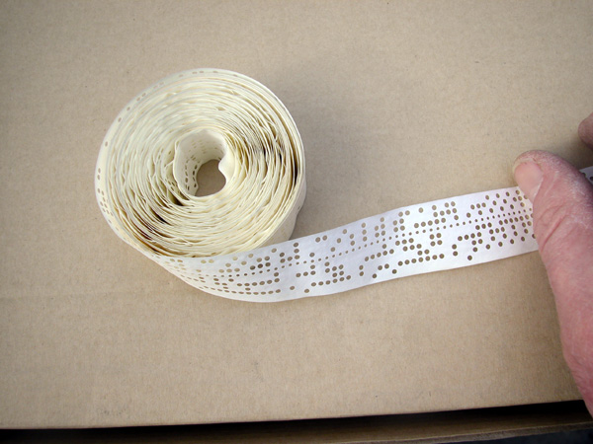
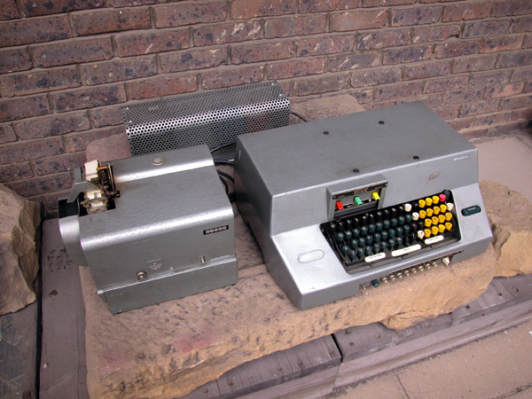

8-hole paper tape Paper tape punch
Basically these programs were for tabulation only, but with some extra programs for specific tasks (e.g. error checking, data transformation, percentages, chi-square calculation at both table and cell level), but little else apart from table titles and no row or column labelling at all. At the University of Birmingham I modified them for the departmental PDP11 (everything still on paper tape). At Salford, they survived as the Salford Survey Suite until 1979 when I advised maintenance be discontinued in view of the widespread availability of SPSS. The experience of writing this suite gave me a unique programming insight into the handling of arrays and other computing processes which was later invaluable in assessing the capabilities and facilities (or lack thereof) in other software. It also gave me a lifelong belief in the value of cultivating good working relations with computer staff.

In 1966, the only other piece of technology available was a manual typewriter with a limited character set, but at least it was portable and had a wide carriage to take foolscap paper sideways. In those pre-Tippex days, all corrections and amendments to questionnaires and reports had to be retyped and copies made using carbon paper. This machine still exists, but was last used in February 1973 (by me) to type the questionnaire for a “quickie” survey of attitudes of senior pupils in a girls’ public school.

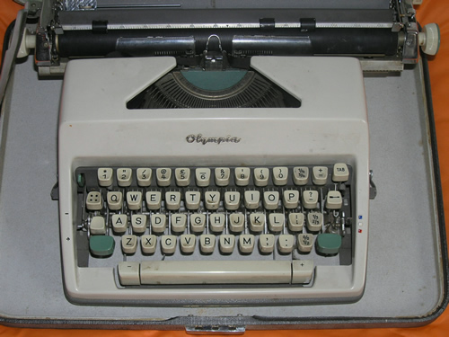  Manual (portable) typewriter | 80-column Hollerith card  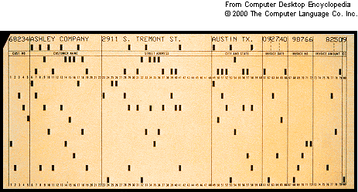

Elsewhere, data from questionnaire surveys were typically transferred to 80-column Hollerith cards
and then counted on card-sorters or tabulators or processed by computer using proprietary software (eg Donovan Data Systems) or by software packages for statistical analysis (most of which were written in Fortran on 80-column cards) which were complex and difficult to use, especially by social scientists, even if there was a manual. Boxes of cards were very heavy and cards could easily be damaged by repeated processing or by being dropped.

IBM 026 Card punch  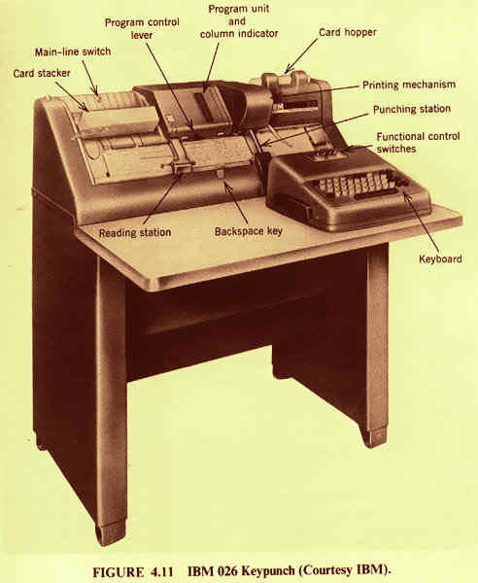 | Card-sorter  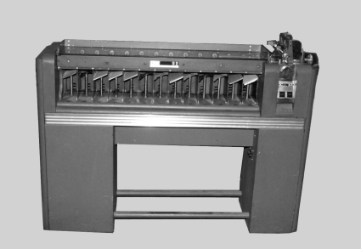

You also needed some kind of printed guide to data layout, such as the blank sheets used by the SSRC Survey Unit, indicating which data were stored in each of the 80 columns.

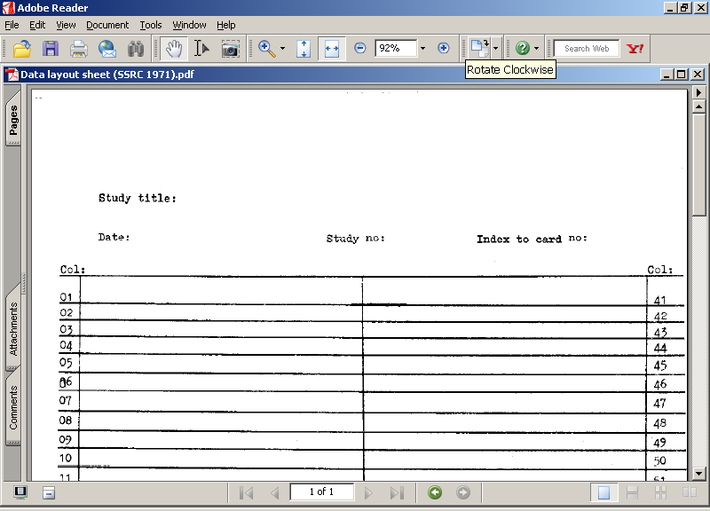  SSRC Survey Unit 1971 (2 x 40) | 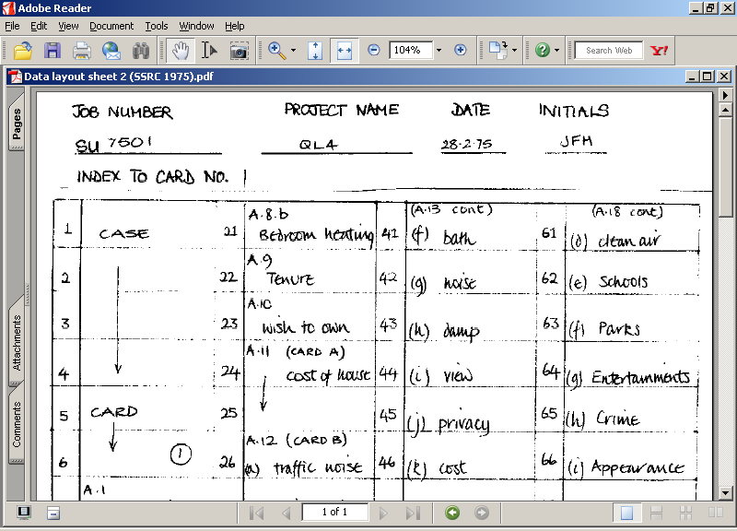  SSRC Survey Unit 1975 (4 x 20)

This early technology placed severe limits on the design and conduct of survey research, although it made for high-powered thinking and very careful work! That’s why, in card-based systems, much early statistics was developed on 2 x 2 tables. It also affected what was possible, in the time available, for the provision of practical training and courses.

1.2: The origins of SPSS

SPSS first appeared in 1968, and was written in Fortran IV for an IBM 360 by three postgraduate students. It came from Chicago to Edinburgh via Tony Coxon and was implemented in 1970 at Edinburgh Regional Computer Centre (one of the few places with an IBM) by David Muxworthy and the late Marjorie Barritt, thereby scotching university plans to commission a survey processing facility at great expense from scratch. When first installed it was reputedly called more times than the Fortran compiler, but that could well have because of all the user-errors!

  Tony Coxon |   David Muxworthy

Conversions to ICL followed later, but those with CDC and DEC machines got SPSS sooner.
In next to no time SPSS was everywhere. Why? Because it had an easily understood manual you could buy in any university bookshop, was relatively straightforward to use (with English-language like instructions), had amazing file manipulation facilities, could print labels for variables and values, and was implemented UK-wide in many, if not most, academic and local government environments so that users moving between sectors could rapidly adjust with only minor adjustments to job control language (JCL) for different machines. It became so successful and made so much money that it threatened the charitable status of the National Opinion Research Center (NORC) at the University of Chicago and was hived off as SPSS Inc.

David Muxworthy has kindly provided the following account:

Norman Nie and Dale Bent were political science postgrads at Stanford in the late 1960s and, fed up with the 'put a 1 in column 72' type command language of the programs at the time, they devised a language that a political scientist would want to write to specify an analysis. They scraped together some funds and hired Tex Hull to help with coding the program, which was in Fortran IV for the 360.… Norman and Tex both moved to Chicago, Norman to the National Opinion Research Center, Tex to the Computing Center. Dale went back to Alberta and, apart from having his name on some of the manuals, dropped out of SPSS.
People got to hear about the program, which was superior in user interface to much that was available at the time, and requested copies. This led to Patrick Bova, a librarian at NORC, being hired 25% of his time to act as distribution agent and Karin Steinbrenner being hired as full time programmer. When I visited Chicago in the summer of 1972 this was the total staff. I thought I was going to a large software house. It was surprising to find it not much bigger than a one man and a dog in a bedroom outfit (at that time at least). Tex acted largely as advisor but was busy as associate director of the computing center.
As I remember it, Jean Jenkins was hired as programmer later in 1972 or in 1973. She was certainly around at the SCSS planning meetings in the summer of 1973. The program was so successful that NORC became wary of losing their non-profit status and strongly encouraged Norman to form a company and move out. This happened sometime between 1974 (when I worked with them at NORC) and 1977 (when they had moved to an office block in downtown Chicago).
In Edinburgh the program grew to be so popular there were demands to move it to the ICL system 4 and later the ICL 2980, the IBM having been removed by higher authority. This led to PLU organising conversions to some other platforms in UK universities, notably the ICL 1900. SPSS themselves arranged conversions to other series, notably the CDC 6600 at Northwestern University, just up the road from Chicago.

Amongst other things SPSS was also used for the Annual Voter Registration survey in Cheshire (it even printed the address labels), applications in concrete technology (!!) and at the Greater London Council it was faster on the Census than specially commissioned software. Central government, constrained by a requirement to buy British computers, took much longer, but eventually succumbed.

From its very first days, social scientists loved SPSS, but it was received less than enthusiastically by some programmers (inefficient coding) and some statisticians (some errors, but mostly because it let people like me bypass them and do their own analysis). Anyway, where were they all when we were struggling on our own and wanted time on their precious computers or advice on statistical procedures?

1.3: Quantitative Sociology Group

A parallel development in the late 1960’s was the setting up of the British Sociological Association (BSA) Maths and Computing Applications Group, the inaugural colloquium of which was called by Tony Coxon et al. and held at the University of East Anglia in April 1968. Delegates to this colloquium (many now retired, or close to retirement) were later to figure prominently in computing and statistical applications in the social sciences in the UK. The group later became the BSA Mathematics, Statistics and Computing Applications Group and eventually (including Survey Research) the Quantitative Sociology Group which published Quantitative Sociology Newsletter throughout the 1970’s and the early 1980’s. I was editor 1973-74 and from 1975 until it ceased publication in 1984 for lack of material to publish. The residual funds were invested and used later to set up the Mark Abrams Prize in 1986.
.
1.4: SSRC Survey Unit (1970-1976)

In April 1970 the then Social Science Research Council (SSRC) set up its Survey Unit with the late Dr Mark Abrams as (part-time) Director. The Unit was “attached to, but not of, the LSE” for computing and sundry other purposes. Its brief was to offer advice and assistance in survey methods to academics and others doing surveys on public funds. I was appointed Senior Research Fellow (University Reader level: the unit’s first full time post) in October 1970 and, in addition to general research and advisory duties, was given overall responsibility for Unit computing. When the computing load grew too much for one person, Jim Ring was appointed in 1972 (on graduation from his MSc in Operational Research at LSE) to be responsible for the technical side of all Unit computing. Jim contributed various specialist programs for processes and analyses which were not then available in SPSS. Indeed, we together found ways to make SPSS do things that weren’t in the manual such as handling and analysing multiple response, hierarchical files and longitudinal data.

My first experience of SPSS was at the month-long SSRC Summer School on Survey Methods, held at St Edmund’s College, Oxford, in 1972. I was working with the students on a live survey of “Quality of Life in Oxford” which had been designed from scratch (a real scissors and Sellotape job). The students did all their own typing, copying, printing, collating, sampling, interviewing and coding: Clive Payne (Nuffield College) arranged data preparation and analysis (with newly arrived SPSS). Some initial processing and analysis was done, but for students’ own reports there were various delays and, on the final evening, when Clive, who had often worked late into the night to get jobs run, had to leave for a pressing social engagement, leaving me with the (only) SPSS manual, but no training, and no further results. I was thus left alone trying unsuccessfully for several hours to get SPSS to work until, just after midnight, I was finally ejected from the computer centre when the operator, who had been extremely patient and helpful all evening, had completed his shift and wanted to go home. (Remember this was in the days of punched cards, but at least there was a line-printer on site for all the error messages, none of which made sense to me or to the operator!) Subsequent Summer Schools ran without a problem, but for a shorter period of three weeks (at St Catherine’s College, Oxford) with myself teaching SPSS, and without the live survey.

My memory is a bit vague here as to what machines (ICL1900 and 2900 series, CDC2000) were at ULCC, and when, but until SPSS arrived we used Peter Wakeford’s (LSE) survey data tabulation program SDTAB for analysis and a utility program MUTOS for spreading out multi-punched data. As surveys began to come in thick and fast, and since we wouldn’t be the only ones working on them, especially if they were by academics and others needing advice and assistance on their own surveys, and since there would be several of us working on the same survey at the same time, we developed various standard conventions (naming, labelling, file names and structures) for use with SPSS together with appropriate documentation.

In 1970 the University of London Computing Centre (ULCC) had a small Survey Analysis Working Party (SAWP) comprising Beverley Rowe (ULCC, chair), Andrew Westlake (LSHTM), myself (SSRC) and Peter Wakeford (LSE) which, with the addition of Tony Cowling (Taylor Nelson) and Nona Newman (Newcastle Univ.), became the Study Group on Computers in Survey Analysis (SGCSA), which in turn became the current Association for Survey Computing. By 1973, working to a brief from SGCSA, and (justifying the use of my time as survey methodology) I had compiled, and persuaded SSRC to publish, the first UK register of software for survey analysis and also co-authored a report to the SSRC Computer Panel on their survey of computer use in social science departments in UK universities (the questionnaire for which was based heavily on my previous technical and professional experiences).

Another SSRC Survey Unit initiative was an exercise in SPSS error-trapping. The printouts from all failed SPSS runs at ULCC were filtered out and a questionnaire attached for users to list the reported and actual cause(s) of errors they had made and to check whether SPSS had correctly identified them: a short article was published in the ULCC Newsletter.

1.5: Polytechnic of North London (1976-1992)

In September 1976, amid great controversy, the SSRC closed the Survey Unit and all staff were made redundant, but (in reverse order of age) all found new posts before then. I ended up at the Polytechnic of North London (PNL) taking with me Jim Ring (one day a week) and a grant to develop a computer program for Interactive Path Analysis compatible with the SPSS Conversational Statistical System (SCSS). In 1978, in view of the research funds I was attracting, the Polytechnic agreed to set up a Survey Research Unit with myself as Unit Director and with a brief closely based on that of the old SSRC Survey Unit. Through the new Unit, I used SPSS to process and analyse dozens of surveys. On the training side I simply split the SSRC Summer School course into two part-time postgraduate evening courses, Survey Analysis Workshop (taught initially by myself and colleagues, latterly by myself alone) followed by Survey Research Practice (taught entirely by senior practitioners from research institutes and agencies outside PNL). Both courses ran with great success from 1976 until 1992, but closed after I retired. There was no-one else to teach my course and, given the circumstances of my retirement, my professional colleagues outside PNL refused to continue teaching the other course.

In 1976 there were no on-site computing facilities in Ladbroke House (the base for the Faculty of Social Studies). Indeed, since it was the very first course to be held in the evenings, there were no facilities for anything else either. Each week, coffee, biscuits and plastic cups were brought in by teaching staff, a couple of kettles commandeered, and on the first evening a case of Bulgarian Cabernet Sauvignon (from the first Majestic Wine Warehouse in Tottenham) served to stimulate student exchanges at the end of the introductory session.

For the first few years, student exercises in SPSS had to be written on coding sheets and sent to PNL Computer Services in Holloway Road to be punched on 80-column Hollerith cards, then run without being checked. Results were handed out the following week. The error rate was high and resulted in frustrating losses of time and consequently of motivation. When Computer Services later supplied a surplus ICL card-punch, it was possible (for me) to correct and resubmit student jobs in time for the following week. With the installation at Ladbroke House of a computer laboratory equipped with 16 VDU terminals, 4 servers and a fast link to the mainframe on the Holloway campus, and with Jim Ring’s highly user-friendly SPSS front-end (as Jim put it, “Hall-proof = idiot-proof!") which made it much easier to use the Vax, edit, run, correct and resubmit SPSS setup files (and avoid exceeding disk quotas!) and to print up results, the whole course was transformed. Moreover, with the advent of personal computers, there was a remarkable improvement in the previous skills of students, particularly at undergraduate level, and this made the courses even more productive and enjoyable.

Much less time needed to be spent on basic technology and keyboard skills, and much more could be devoted to hands-on data management and analysis, with a consequent benefit to work-rates and motivation. Errors could be corrected and results checked on-screen, but printout was not delivered by courier until the next day, which meant students got them only a week later. When the courier service was supplemented by two fast line-printers, no student left empty handed even from the first session.

From 1976 to 1981 the course comprised a formal statistics element taught by the late John Utting (then Deputy Director (Research) at the National Children’s Bureau, previously Deputy Director of the SSRC Survey Unit) and an SPSS element taught by myself. For the first two years, Maureen Ashman (Senior Programmer with special reponsibility for SPSS) provided technical liaison with Computer Services (including limited correction and resubmission of SPSS jobs). John Utting retired in 1981 and Jim Ring took over the statistics teaching. When Jim was unable to continue, he provided an early draft of his statistical notes for distribution to students and I revamped the evenings into one hour of SPSS presentation (covering the statistical elements as and when appropriate, but not to the same depth) followed by a two hour hands-on session in the computer laboratory and ending with discussion of results. From 1990, as SR501: Survey Analysis Workshop under the Post-Qualifying Scheme, students could gain 15 points towards a CNAA Masters’ degree, provided they took the assessment.

An undergraduate version of the course was originally taught (from 1980 onwards) to 4th year students on the Social Research and Planning option of the 4-year BA Hons Applied Social Studies, but was moved to the second semester of the second year of the revalidated course and continued into the modular degree scheme for BSc (Hons) Social Science as SR206: Data Management and Analysis. It was compulsory for the Social Research pathway and strongly recommended for Sociology. Each year, to the dismay of their Course Tutor, a handful of Sociology students opted to switch to Social Research.

For BSc Social Research students this not only complemented their Statistics course (some claimed greater understanding of statistics from the SPSS course than from the official one!) but also prepared them for effective professional placements in their 3rd year. Many of them were involved in survey based projects and, as registered students, could use PNL facilities without charge: this arrangement resulted in several publications with our students as sole or joint authors. On graduation, many obtained appointments as researchers with their placement agencies or won funded post-graduate studentships, often, in the former case, ahead of candidates with higher degrees from other universities. Several previous staff and students of PNL/SRU are now to be found in senior positions in UK social research.

Between 1976 and 1992, around 700 students were trained in the use of SPSS to process and analyse data from their own survey-based projects and/or from major questionnaire surveys in the public domain. The courses were great fun: the students enjoyed them. They gained a basic understanding of statistics, some practicalities and politics of social research, and acquired technical skills in handling and analysing survey data. The courses closed after 1992 when no-one could be found to continue the teaching. Courses with training in SPSS were later offered elsewhere, and still are (e.g. Surrey, Essex, Lancaster)

1.6: Training materials

The original course handouts were mostly written direct to a mainframe computer or in WordStar4 on a PC (Amstrad 8256 or 8512 and Euromicro) and refer to successive releases of SPSS installed on a range of machines, from the ICL2900 and CDC2000 at ULCC (via LSE) through ICL1900S, DEC-10 and DEC-KL20 and finally the Vax cluster at PNL. My current undertaking is to convert and update the course leaflets and handouts from WS4 to MS-Word and to modify the examples of setup, output and saved files for use with SPSS for Windows. Because conversion of tabular output from Vax lineprinter format and WS4 to MSWord is tedious and complicated, and also because some original data has been irretrievably lost (and thus not available to regenerate tables in Windows format), some files retain tables and figures in the original lineprinter format of output from earlier versions of SPSS. The following documents (only the naming one is specific to SPSS) are already posted on:

http://www.marketresearchworld.net/index.php?option=com_content&task=category&sectionid=15&id=74&Itemid=60

Introduction to Survey Analysis (96kb)

Introduction to Tabulation (34kb)
Conventions for Naming Variables in SPSS (56kb)

This site cannot handle colour text or graphics, and has problems with tabular formats: an alternative is being developed. Meanwhile the original versions with colour-coded text, clearer tables and full colour graphics can be obtained from the author on johnfhall@orange.fr . Also available from the author are:

Introduction to the use of computers in survey analysis (1981: annotated 2006, 83kb)
[General notes not specific to SPSS, but the tables are from various releases of SPSS]

Survey Analysis Workshop - Syllabus & specimen assessment (Final version 1991-92, 65kb)

Survey Analysis Workshop - Stage 1: From questionnaire to data file (2006, 364kb)
Survey Analysis Workshop - Stage 2: Completing your data dictionary (2006, 167kb)
[Newly written for SPSS for Windows: step-by-step process from completing a fun questionnaire, coding on to a data sheet, entering data and setting up first (data list) and second (variable labels, value labels, missing values) editions of saved files, with screen dumps of each stage]
Survey Analysis Workshop - Derived variables 1a – COUNT (2006, 355kb)
[Part 1 of a section on the use of count and compute to generate scores, analysis of scores using frequencies with associated statistics and graphics, crosstabs and graph: example uses items measuring attitudes to women from a survey of fifth formers]
Survey Analysis Workshop - Derived variables 1b – COMPUTE
[not quite ready, but in an advanced stage of preparation]

Survey Analysis Workshop - Statistical notes 1-7 (1992, 288kb)
Survey Analysis Workshop - Statistical notes 8-13 (1992, 108kb)
[Original documents as distributed to students: specially written by Jim Ring, and edited by myself, as a supplement to the standard texts referred to in the notes.]

Analysing multiple response with SPSS – an introduction (1992, updated 2006, 76kb)

Pallant 2001 review (1st edition 2001, full original review, 2002, 3557 words, 51kb)
Pallant 2005 review (2nd edition 2005, short review, 2007, 838 words, 32kb)
[Reviews of Julie Pallant, SPSS Survival Manual. This book is heavily biased towards inferential statistics for budding psychometricians and statisticians. It is not suitable for students in sociology and related subjects, who tend to use percentage tables. Short on file construction, data checking and completely lacking tabulation, it exclusively uses the drop-down menus and drop-down menus throughout, which is pointless for me, an ardent syntax fan, and incidentally explains why some useful commands are not mentioned at all, since they are not available in the drop-down menus. Apart from a new chapter on Loglinear Regression and a couple of paragraphs on Visual Bander, the second edition is virtually identical to the first, hence the short review]

Remaining materials to process include detailed introductions to, and explanations of, SPSS commands and syntax for data transformation and analysis, including tricks of the trade, worked examples, class exercises and homework exercises. They will eventually constitute a self-contained Teach-Yourself package and form a logical progression with integrated and repeated use of data from the fun questionnaire completed by students at the beginning of the course, from the 1989 British Social Attitudes survey and from a 1981 survey of fifth-formers at a comprehensive school in North London. Exercises using data from later surveys (eg European Social Survey) are also likely to be added. For training purposes everything needs breaking up into bite-sized chunks, with plenty of repetition for common tasks. Nowadays speed and quality of surveys and courses have greatly improved, but one other constraint persists, even in this paper: the constant need to fit everything on one side of A4.

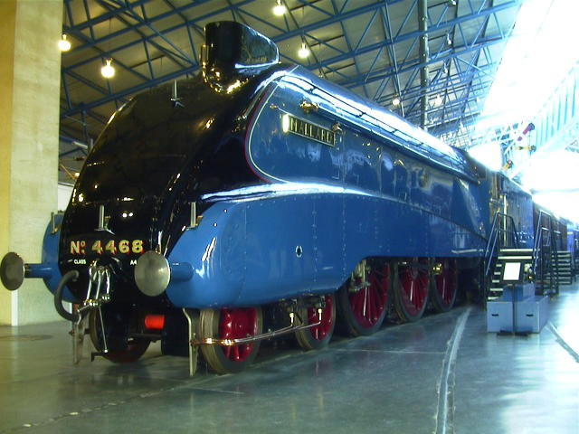

One side of A4!

Photograph © 2001 by Len Schwer

2: Layout, usage and changes

Throughout the 1970s and 1980s survey data was normally supplied by fieldwork agencies on 80-column cards or, with later computer developments, as card images on magnetic tape.

Each column had 12 punching positions. At the top were two “zones” and below them digits 0 to 9. There could be up to three holes punched in each column. Digits 0 through 9 used a single punch, letters of the alphabet were indicated by two holes (combinations of the upper zone with 1 to 9 for A to I, lower zone with 1 to 9 for J to R and 0 with 2 to 9 for S to Z). Special characters were represented by 3-hole combinations of upper, lower or 0 with 3,4 or 8. The upper and lower zones (known in the trade as 12 and 11, Y and X, or + and -) could also be single-punched and were often used for “Don’t know” or “Not applicable” responses.

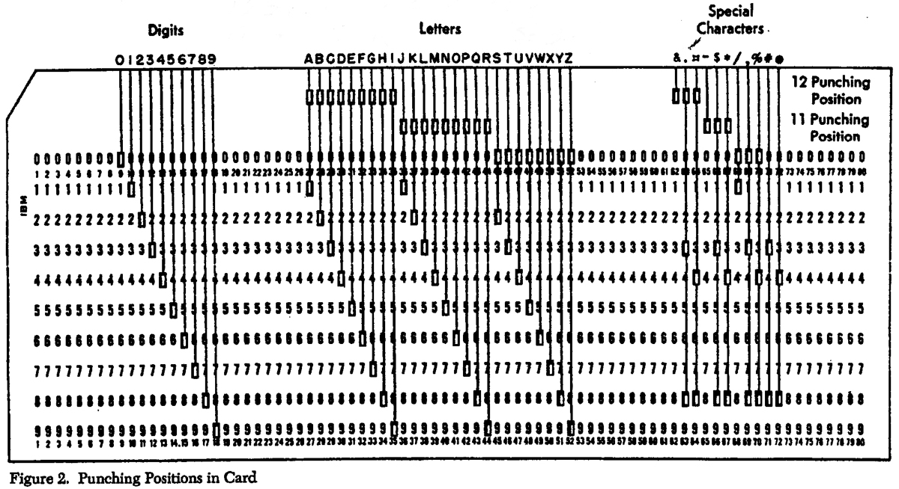

Unless otherwise specified, the cards usually contained at least some data in multi-punched format (column binary) either to code multiple responses to the same question, or to get more than one variable, in the same column). For example, the raw data from the first pilot of the SSRC Survey Unit Quality of Life survey in 1971 was supplied on 80-column cards (two cards per case): the listing (printout) of the data looked like this (first three cases only: multipunches highlighted as red $ signs).

001110204+57462235696172244322232422- 2O- 322K2- 3$62$$5 05902-- 89564$-147321
0012$$$% 1 23 0 19$0$78$$6110$Q31111010 23463110 4113+2211207637321
002119051-44689428858-45242524431442324T31$3823+84$8354$77 158-5-7M$6$O6$$417321
0022$$$$ 2 1 3 1$1$$$$22F$11222-41010011022113100 310002220107637321
003114202+355-953273--3324454341415591+N91238-2+8257$$55+- $- 4-7$$5$$5$2137321
0032$$$$ 1 32 0 12$$$26N$11222$51111011012122010 310122215127637321

Although some multipunching could be interpreted as alphabetic or special characters, much of it could not, and was printed up as a dollar sign $. For this reason, at SSRC, we always ran SPSS on new data using alphanumeric format, partly because some data would be multipunched and partly because we were never quite sure what the raw data might contain (some numeric data was occasionally mis-punched as alphabetic, even after verification). Attempting to read such data as numeric would result in an error. Multipunched data were later spread out (using the LSE program MUTOS), in this case on to four additional cards to yield a final raw data set with 6 cards per case e.g. (first case only):

001110204+57462235696172244322232422- 2O- 322K2- 3$62$$5 05902-- 89564$-147321
0012$$$% 1 23 0 19$0$78$$6110$Q31111010 23463110 4113+2211207637321
00139000000101000090000001001000101000110100009000000009000000001010010001007321
00140001001011000001010001000000000001000010000000000001010000009000000000017321
00150000000100100001000100000100100110010000011112222222222222212900000000017321
0016000000001011100000010000000101 7321

The original layout of the SPSS language was determined by the use of 80-column Hollerith cards on which columns 1-15 were reserved for commands, columns 16-72 for sub-commands and specifications, and columns 73-80 for numbering of the cards (a necesary precaution when decks could contain hundreds, if not thousands, of cards: imagine dropping a trayful!). We never needed numbering for raw data since case and card numbers were always punched at the beginning of each card and the survey identification code at the end. Since SPSS was easy to read and the card contents were printed across the top of each card, we very rarely needed to number SPSS setup jobs either. What we did use was a standard 80-column data-preparation sheet, modified for SPSS. Each sheet had 25 rows, allowing up to 25 lines of code to be written, and had a heavy line drawn between cols 15 and 16 as a visual aid to keeping subcommands and specifications out of the field reserved for commands.

SSRC Survey Unit coding sheet for 80-column Hollerith cards (c.1973) for use with SPSS

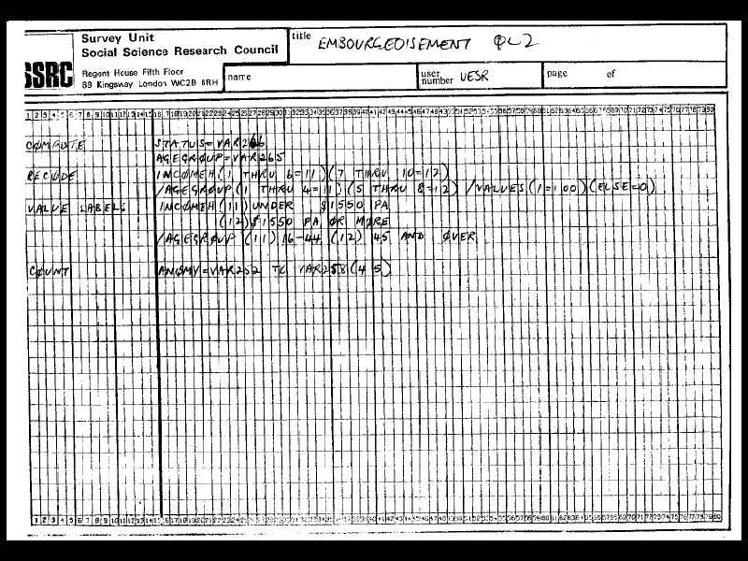

Cards were later replaced by card-images on magnetic tape or disk (and by lines on VDU screens). As SPSS has become more “intelligent”, layout restrictions have gradually been lifted, but commands still have to start in column 1, must be followed by at least one space and there must be at least one space at the beginning of any continuation lines. However, for teaching purposes (and even for experienced researchers) it is still useful to start with a visually distinct layout as it makes the files easier to read and the logic easier to follow. Hence the extensive use, in PNL training and research materials, of tabs to separate SPSS commands from sub-commands and specifications.

2.1: Evolution of SPSS syntax

Since 1972, when I was first exposed to SPSS, there have been many subsequent releases and updates, not just mainframe versions, but also SPSS PC+ and more recently SPSS for Windows. SPSS11.0 (the version made available to me) has most, but not all, facilities of mainframe release 4 of SPSS-X. Examples of changes over the years include:

VARxxx TO VARyyy  Vx to Vy (Qx TO Qy)

UPPER CASE only in labels  Any printing characters in primes

Limits to characters in labels
40 for variables  Removed, theoretically 255,
20 for values but printout constraints apply

VARIABLE LIST
INPUT FORMAT DATA LIST
(Fortran format statement)  FILE =
INPUT MEDIUM RECORDS =

BREAKDOWN  MEANS

Because of these changes, many setup jobs from the 1970s and 1980s will no longer work.

For example, the original SPSS setup file for the 2-card Quality of Life data set (1st pilot survey, 1971) included the following data definition, following the positional variable naming convention developed at the SSRC Survey Unit and reading most of the data as alphanumeric in the Fortran format statement:

File definition 1973: (Quality of Life: 1st pilot survey 1971, SSRC Survey Unit)

RUN NAME QL1UK1 - PILOT 1 FIRST SYSTEM FILE
FILE NAME QL1UK1 QUALITY OF LIFE PILOT I UK
VARIABLE LIST VAR101 VAR105 VAR109 TO VAR137
VAR141,VAR144,VAR145,VAR148
VAR149 VAR152 VAR155 VAR158 VAR159
VAR162 VAR165 VAR166 VAR169 VAR172
VAR175,VAR176,
VAR209 TO VAR223 VAR225
VAR230 VAR234 TO VAR237 VAR240 TO VAR256
VAR263 VAR264 VAR266 TO VAR268 VAR270
INPUT MEDIUM INDATA
INPUT FORMAT FIXED
(F3.0,1X,A4,F1.0,13A1,
14F1.0,A1,3X,A1,2X,F1.0,A1,
2X,2A1,2X,A1,2X,A1,2X,2A1,2X,A1,
2X,2A1,2X,A1,2X,A1,2X,2A1,4X/
8X,15A1,1X,1A1,4X,A2,2X,A1,
F1.0,2A1,2X,17A1,6X,A1,A2,2A1,A2,A4)
NO. OF CASES 213

In the original version of SPSS it was possible to define variables in alphanumeric format and then recode the alpha values to numeric using (convert) to keep the same variable names. Recodes for values other than the digits 0-9 and the two zone punches had to be defined separately.

Variables read in as alpha from card 1 were later recoded to numeric with:

RECODE VAR105 ('++++'=9999)
(CONVERT)/
VAR110 ('+'=2)('-'=1)('0'=88)
(CONVERT)/
VAR111 TO VAR122 VAR137 VAR141 VAR145
VAR149 VAR152 VAR155 VAR158 VAR162
VAR166 VAR169 VAR172 ('-'=10)('+'=99)
(CONVERT)/
VAR144 (1=2)/
VAR148 VAR165 ('+'=1) ('-'=2)
(CONVERT)/
VAR159 (' '=1) ('-'=0)
(CONVERT)/
VAR175 ('+' ' '=88) ('4'=3)
(CONVERT)/
VAR176 (' ','+'=99)
(CONVERT)

[NB: Remember this was all on 80-column cards. Keeping the (CONVERT)/ on a separate line was the result of making several copies of that card and inserting them as appropriate. It may seem wasteful of cards, but it saved a lot of keypunching. The same applies to typing in lines in syntax today.]

However, string variables (as they are now called) can only be converted into new variables. In order to recreate the file it was necessary, not only to use data list, but also to use dummy variable names. These were later recoded into the original names (to tally with the user manual) and dropped when the file was saved. Thus, reading from the original data set, but with dummy variable names:

data list
file ‘f:qluk1.dat’ records 6
/1 serial 1-3
v105 to v180 5-80 (a)
/2 v209 to v280 9-80 (a).

to produce an intermediate display:

Data List will read 6 records from the command file

Variable Rec Start End Format

SERIAL 1 1 3 F3.0
V105 1 5 5 A1
V106 1 6 6 A1
V107 1 7 7 A1
~ ~ ~ ~ ~ ~ ~ ~ ~ ~ ~ ~ ~ ~ ~ ~ ~ ~ ~ ~
~ ~ ~ ~ ~ ~ ~ ~ ~ ~ ~ ~ ~ ~ ~ ~ ~ ~ ~ ~
V278 2 78 78 A1
V279 2 79 79 A1
V280 2 80 80 A1

[NB: This example illustrates the advantage of the positional convention for variable names: they can be checked visually against the record number and start column.]

The conversion from dummy variables with alpha values back into the original (user-manual) variables with numeric values can then be effected by:

RECODE V209 TO V222 (' ','+','-'=0) ('1'=2) ('2'=1) ('3'=-2) (CONVERT)
into VAR209 TO var218 xvar219 var220 to VAR222 /
V223 V225 V234 ('+'=88) (CONVERT)
into VAR223 VAR225 VAR234 /

V230 ('99'=98) ('++'=99) (CONVERT) into var230/
V236 V237 ('+'=99) (CONVERT) into var236 var237/
V240 ('+'=88) ('1' '2'=3)(CONVERT) into xvar240/
V241 TO V252(' '=88)(CONVERT) into VAR241 TO VAR252/
V253 (' '=88) ('4' '5'=3)(CONVERT) into var253/
V254 TO V256(' '=88)(CONVERT) into VAR254 TO VAR256.
RECODE V263 ('+'=88) (CONVERT) into var263
/ V264 ('++'=88) (CONVERT) into var264
/ V266 V267 ('+'=1) ('-'=2) ('0'=3) ('1'=4) ('2'=5) ('3'=6) ('4'=7)
('5'=8) ('6'=9) ('7'=99) (' '=99)(CONVERT) into var266 var267
/V268 (CONVERT) into var268
/ V270 ('++++'=88) (CONVERT) into var270.

SAVE OUT ‘F:QL1.SAV’
/KEEP VAR209 TO VAR270.

[NB: There’s a switch mid-job to putting slashes before the variable names! Much easier to check.]

Modifications were subsequently needed for the variable labels and value labels to get rid of apostrophes and full stops (which SPSS interpreted as beginning a label or ending a command). These were tedious rather than complicated and took several runs as they were quite difficult to spot, but with the sheer speed of SPSS it was quicker to run jobs, check the error reports, amend the setup syntax and then delete the output file without saving it.

2.2: Other developments in SPSS

Blue (later maroon) manual  Norusis (1988)
(in A-Z order of commands) (in user-friendly
research process order)

..but for SPSS13 ???

Batch only  Interactive
(on 80-column cards) (via VDU keyboard)

Output on line-printer only  VDU with on-screen scrolling

Mainframe only  SPSS PC+
SPSS for Windows

UPPER CASE only  lower case

Full syntax only  Abbreviated syntax
Drop-down menus

[NB: For some purposes, the switch from syntax to drop-down menus may well be a retrograde step]

2.3: Variable Names

Now let’s have a look at some examples from surveys conducted and processed by other people, and using conventions derived direct from the original SPSS manuals, but modified as restrictions on layout were lifted. The first is an extract from the SPSS setup file written by John Curtice and Andrew Shaw at Liverpool University for the 1987 survey of British Social Attitudes conducted by Roger Jowell and colleagues at Social and Community Planning Research (SCPR, now NatCen). The questionnaire consisted of a main section (interviewer administered) plus one of two alternative sub-sections A or B (also interviewer administered) and its related self-completion section.

Variable names can be up to 8 characters in length and must start with a letter of the alphabet. Curtice and Shaw used mnemonic names, which were supposed to look something like the variables they represented and therefore be meaningful and easier to understand and remember. We shall see!

An alternative convention, developed at the SSRC Survey Unit and derived from the LSE Survey Data Tabulation program SDTAB, makes it easier to work direct from a questionnaire (provided it has data layout printed on it). This uses positional variable names of the form Vddd (or Vdddd if there are 10 or more cards) in which the last pair of digits indicates the start column of a field and the first digit(s) the card/record number. Data from record 2 (of 23) were specified in mnemonic form on the data list by:

(British Social Attitudes 1987)

/2 VERSION 8

READPAP 9 WHPAPER 10-11 SUPPARTY CLOSEPTY 12-13 PARTYID1 14-15
IDSTRNG CNTLCNCL RATES RENTS EEC NATO NATION USANUKE OWNNUKE UKNUCPOL DEFPARTY PEACE NIRELAND TROOPOUT 16-29
PRICES UNEMP UNEMPINF CONCERN INDUSTRY ECOHELP1 TO ECOHELP9 STATEOWN TAXAVOID TAXSNEAK INCOMGAP TAXHI TAXMID TAXLOW SRINC

HINCDIFF HINCPAST HINCXPCT 31-55

RECONACT 56-57

RFTEDUC RTRAING RPAIDWRK RWAITWRK RREGISTD RSEEKWRK RNTLOOK RSICK RRETIRD RATHOME RELSE REMPLOYE 58-69 EJBHOURS 70-71

EJBHRCAT WAGENOW PAYGAP WAGEXPCT NUMEMP EMSMEWRK EMSEXWRK EMWOMCLD EMWOMWLD 72-80

…which is more easily written using the positional convention as:

/2 version 8
v209 9 v210 10-11 v212 v213 12-13 v214 14-15 v216 to v229 16-29 v231 to v255 31-55
v256 56-57 v258 to v269 58-69 v270 70-71 v272 to v280 72-80

…and has the advantage, when SPSS is run, of enabling a visual check on whether each variable has been read from the correct field (the name should match the record and start column for each variable).

Data List will read 23 records from F:\bsa87.dat

Variable Rec Start End Format

VERSION 2 8 8 F1.0
V209 2 9 9 F1.0
V210 2 10 11 F2.0
V212 2 12 12 F1.0
~ ~ ~ ~ ~ ~ ~ ~ ~ ~ ~ ~
V278 2 78 78 F1.0
V279 2 79 79 F1.0
V280 2 80 80 F1.0

This convention is especially useful for sections of the questionnaire which have no question numbers. For example household information collected by means of a grid (as in the facsimile below of part of the questionnaire for the British Social Attutudes survey 1986).

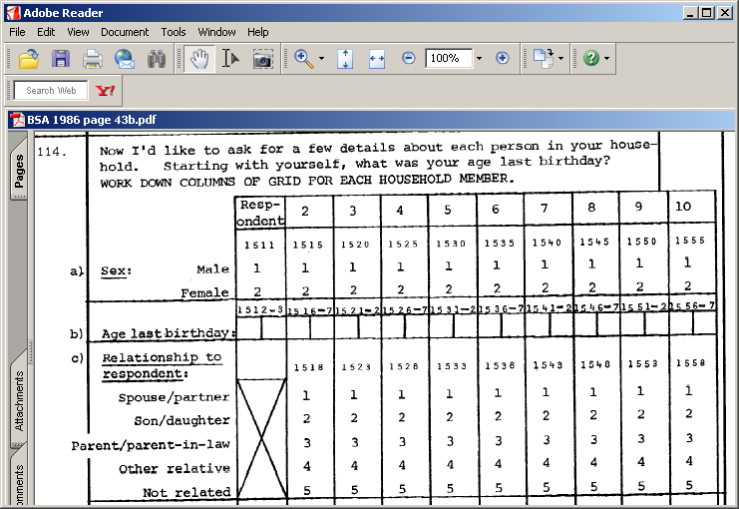

…for which instead of using:

/15 sexpers1 11 agepers1 12-13
sexpers2 15 agepers2 16-17
~ ~ ~
~ ~ ~
sexpers0 55 agepers0 56-57 [0, not 10, to keep to 8 characters]

. . . (which will later be difficult to find in the data file) it’s much better to use:

/15 v1511 11 v1512 12-13
v1515 15 v1516 16-17

~ ~ ~
~ ~ ~
v1556 56-57

. . .which relate directly to the questionnaire and will be easier to find in the file. Properly written variable labels (with question number at beginning where appropriate) will indicate the nature of the variable.

V1511 ‘Q114: Sex of respondent’
V1512 ‘Q114: Age of respondent’
V1515 ‘Q114: Sex of 2nd person’
V1516 ‘Q114: Age of 2nd person’

V1511 and V1512 can be changed later to SEX and AGE [ rename (v1511 v1512 = sex age) ], but for demographic variables used frequently for analysis it is preferable to create new variables in another section of the file to make later analysis quicker (eg: cros sex to incgroup by v213 to v227 /cel row. )

compute sex = v1511.
compute age = v1512.

2.4: Variable Labels

In 1973, we had to write variable labels in UPPER CASE only (40 characters maximum), use commas to separate names from labels, and keep label specifications separated from each other by slashes (at the end of the line as per the manual). We also kept each variable on a separate line.

1973a: (SSRC Quality of Life Survey 1st Pilot 1971)
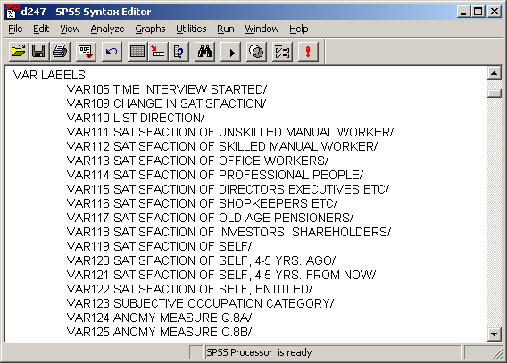

However, it was easy to forget the slash at the end of the line (a common cause of error messages) so we moved it to the beginning of the next variable (and SPSS still worked!).

1973b: (SSRC Quality of Life Survey 1973)
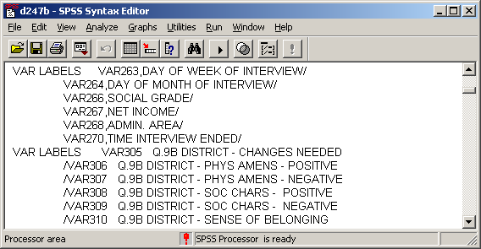

[Note change of format mid-setup! ]
Later, lower case was allowed, for variable names as well as labels, but we kept upper case for variable names. The labels did not need to be enclosed in primes, and full stops could be used in the label.

1981: (Survey of fifth form pupils in a North London comprehensive)
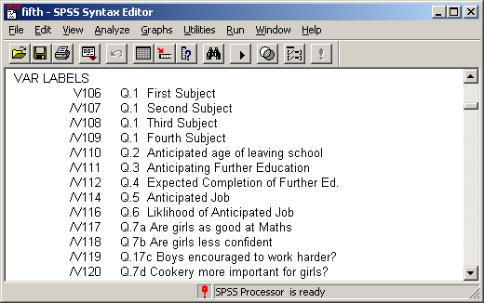

Later still, labels had to be enclosed in single primes (or double primes if there was an apostrophe in the label). People started using lower case, even for variable names (which appeared on output in upper case) and a single space instead of tabs on new continuation lines.

1989: (NUS Student Finance Survey 1989)
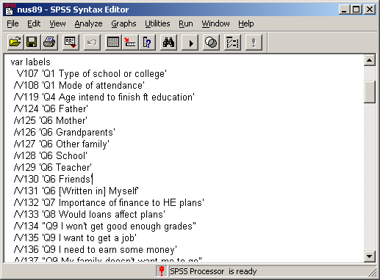
Returning to the 1987 British Social Attitudes survey, the extract below defines the variable labels for the first seven variables in the file. Commas were no longer needed to separate names from labels because SPSS now treated the space after the variable name as a delimiter. Variable labels could by then be written in upper and lower case (enclosed in primes) yet Curtice and Shaw were still using UPPER CASE for everything! They also put the slash at the end of each label specification, but it is better to put it before the second and subsequent variable names. It was very easy to forget the final slash, a common cause of SPSS error messages, and it was also difficult to find the culprit later.

British Social Attitudes 1987

VARIABLE LABELS
VERSION QUESTIONNAIRE VERSION ADMINISTERED/
READPAP Q1A R READS NEWSPAPER 3+ TIMES PER WEEK/
WHPAPER Q1B [IF READS 3+ TIMES] WHICH PAPER/
SUPPARTY Q2A POLITICAL PARTY SUPPORTER/
CLOSEPTY Q2C [IF NOT SUPORTR] CLOSER TO ONE PARTY/
PARTYID1 Q2B & 2D & 2E PARTY IDENTIFICATION[FULL]/
IDSTRNG Q2F HOW STRONG PARTY IDENTIFICATION/

It is not easy to find your way around inside this setup file (although the question number helps). It would have been better to use tabs to align the labels and lower case labels to make the file easier to read. It’s a very large file to do this piecemeal, but there is a quick way of doing it. By copying the set of variable label commands into Word and using Format.. Change Case (to change everything to lower case) and then Find.. Replace [ / with ‘] [ v2 with /v2 ] and [ q with ‘Q ] (in that order!), do some manual editing, then copy the result back into the SPSS syntax file we get this:

variable labels
version ‘Questionnaire version administered’
/readpap ‘Q1a R reads newspaper 3+ times per week’
/whpaper ‘Q1b [if reads 3+ times] which paper’
/supparty ‘Q2a Political party supporter’
/closepty ‘Q2c [if not suportr] closer to one party’
/partyid1 ‘Q2b & 2d & 2e party identification [full]’
/idstrng ‘Q2f How strong party identification’

This is much easier to read than the original, but the following is nicer to look at and is much easier to work with direct from the questionnaire.

variable labels
version ‘Questionnaire version administered’
/v209 ‘Q1a R reads newspaper 3+ times per week’
/v210 ‘Q1b [if reads 3+ times] which paper’
/v212 ‘Q2a Political party supporter’
/v213 ‘Q2c [if not suportr] closer to one party’
/v214 ‘Q2b & 2d & 2e party identification [full]’
/v216 ‘Q2f How strong party identification’

How was this done? No, I didn’t rewrite the entire setup file, I used the rename facility.

rename variables
(readpap to idstrng = v209,v210,v212 to v214,v216).

… and if you’re worried about putting things back as they were:

rename variables
(v209,v210,v212 to v214,v216 =
readpap whpap supparty closepty partyid1 idstrng).

Easy when you know how!

To do this with the whole file would be very tedious in SPSS syntax or Word (unless there’s a way of doing it with the Tables format), but in WordStar and EDT you could strip out whole columns of text and paste them back on the other side of the = sign, another reason for using tabs in the layout. In fact it’s easier these days to save both versions and keep both mnemonic and positional camps happy. Note the need in the second rename command to write out the list of original variable names in full. Using to would cause an error as the original names have been changed and SPSS won’t be able to find them in the file. In fact it’s probably easier for editing (and safer) to keep both lists in full on separate lines and a line between with the = sign, eg.

rename variables
(v209,v210,v212 to v214,v216
=
readpap whpap supparty closepty partyid1 idstrng).

Best to play safe and save the new file with a different name.
2.5: Value Labels

In 1973 value labels were permitted in UPPER CASE only and, on printout, were limited to 20 characters for rows and 16 characters for column headings (in 2 blocks of 8): anything longer would either cause an error or be truncated. This made for some contorted spelling, tortuous abbreviations and additional packing spaces, especially in column headings: otherwise the output, already awful, looked even worse. As today, a list of variables could have the same value labels.

Each value had to be in round brackets followed by the value label. Variable lists were supposed to be separated by slashes at the end of the line, but (long before Norusis appeared) we always put them before the variable name on continuation lines: this way they were easier to see and less likely to be forgotten. At first VALUE LABELS had to be in col 1-16 and the specification in cols 16-72. The requirement to start in col 16 was later dropped and eventually lower case was introduced. By the late 1980s labels had to be in single primes (double primes if there was a prime in the label). However for ease of use and training purposes it is still best to use tabs to inset specifications and continuation lines.

(Attitudes and Opinions of Senior Pupils: St Paul’s School for Girls)

VALUE LABELS FORM(1)LOWER FIFTH(2)UPPER FIFTH(3)LOWER SIXTH (4)UPPER SIXTH
/YEARBORN(1)1954(2)1955(3)1956(4)1957(5)1958
/MONTH(1)JANUARY(2)FEBRUARY(3)MARCH(4)APRIL(5)MAY(6)JUNE(7)JULY
(8)AUGUST(9)SEPTEMBR(10)OCTOBER(11)NOVEMBER(12)DECEMBER
/VAR111 TO VAR119(1)MOST IMPORTNT(2)NEITHER(3)LEAST IMPORTNT
/JOB1 TO JOBAT25(1)ACCNTNCY,FINANCE(2)ARCHIT- ECTURE
(3)CIVIL ENGINEER(4)CREATIVE ARTIST(5)DOCTOR, DENTIST
(6)FASHION(7)GOVNMNT,ADMIN.(8)HOUSE -WIFE(9)INDUST. TECH.
(10)JOURN- ALISM(11)MILITARY SERVICE(12)NURSING
(13)OUTDOOR,ATHLETIC(14)OWN BUSINESS(15)PERFORM-ING ARTS
(16)PERSONN-EL MNGMT(17)POLITICS(18)PUBLISH -ING
(19)SALES + MARKETNG(20)SCIENCE-MATHS(21)SCIENCE-BIOLOGY
(22)SCIENCE-SOCIAL(23)SECRET -ARY(24)SOCIAL WORK
(25)SOLICTR,BARRISTR(26)TEACHER-PRIMARY(27)TEACHER-SECNDARY
(28)TOWN PLANNING(29)TV,FILM PRODUCER(30)UNIVSTY LECTURER
(31)LIBRAR -IAN(32)PUBLIC RELATNS(33)COMP- UTERS(34)OTHER

This is very crowded (I didn’t write it!) but cards and disk space (at least in the UK) were free, so we used to put each label on a separate line:

1973 (SSRC Quality of Life: 1st pilot survey 1971)

VALUE LABELS VAR109 (1) LOT MORE
(2) LITTLE MORE
(3) SAME
(4) LITTLE LESS
(5) LOT LESS
/VAR110 (1) FORWARDS
(2) BACKWRDS
/VAR123 (1) UNSKILLDMAN WKRS
(2) SKILLDMAN WKRS
(3) OFFICE WORKERS
(4) PROFES- SIONAL
(5) COMPANY DIRECTRS
(6) SHOP KPRS ETC
(7) OAP'S
(8) INVESTRS ETC
(9) NOT KNOWN

Applying this to the St Paul’s survey, by inserting carriage returns and tabs, and spaces after the brackets we can improve it, but it’s even better with lower case, although finicky to edit:

(Attitudes and Opinions of Senior Pupils: St Paul’s Girls’ School)

Before

VALUE LABELS FORM
(1) LOWER FIFTH
(2) UPPER FIFTH
(3) LOWER SIXTH
(4) UPPER SIXTH
/YEARBORN
(1) 1954
(2) 1955
(3) 1956
(4) 1957
(5) 1958
/MONTH
(1) JANUARY
(2) FEBRUARY
(3) MARCH
(4) APRIL
(5)MAY
(6)JUNE
(7)JULY
(8)AUGUST
(9) SEPTEMBR
(10) OCTOBER
(11) NOVEMBER
(12) DECEMBER
/VAR111 TO VAR119
(1) MOST IMPORTNT
(2) NEITHER
(3) LEAST IMPORTNT
/JOB1 TO JOBAT25
(1) ACCNTNCY,FINANCE
(2) ARCHIT- ECTURE
(3) CIVIL ENGINEER
(4) CREATIVE ARTIST
(5) DOCTOR, DENTIST
(6) FASHION
(7) GOVNMNT,ADMIN.
(8) HOUSE -WIFE
(9) INDUST. TECH.
(10) JOURN- ALISM
(11) MILITARY SERVICE
(12) NURSING
(13) OUTDOOR,ATHLETIC
(14) OWN BUSINESS
(15) PERFORM-ING ARTS
(16) PERSONN-EL MNGMT
(17) POLITICS
(18) PUBLISH -ING
(19) SALES + MARKETNG
(20) SCIENCE-MATHS
(21) SCIENCE-BIOLOGY
(22) SCIENCE-SOCIAL
(23) SECRET -ARY
(24) SOCIAL WORK
(25) SOLICTR,BARRISTR
(26) TEACHER-PRIMARY
(27) TEACHER-SECNDARY
(28) TOWN PLANNING
(29) TV,FILM PRODUCER
(30) UNIVSTY LECTURER
(31) LIBRAR -IAN
(32) PUBLIC RELATNS
(33) COMP- UTERS
(34) OTHER

After

val lab form
(1) Lower fifth
(2) Upper fifth
(3) Lower sixth
(4) Upper sixth
/yearborn
(1) 1954
(2) 1955
(3) 1956
(4) 1957
(5) 1958
/month
(1) January
(2) February
(3) March
(4) April
(5) May
(6) June
(7) July
(8) August
(9) Septembr
(10) October
(11) November
(12) December
/var111 to var119
(1) Most importnt
(2) neither
(3) Least importnt
/job1 to jobat25
(1) Accntncy,finance
(2) Archit- ecture
(3) Civil engineer
(4) Creative artist
(5) Doctor, dentist
(6) Fashion
(7) Govnmnt,admin.
(8) House -wife
(9) Indust. tech.
(10) Journ- alism
(11) Military service
(12) Nursing
(13) Outdoor,athletic
(14) own business
(15) Perform-ing arts
(16) Personn-el mngmt
(17) Politics
(18) Publish -ing
(19) Sales + marketng
(20) Science-maths
(21) Science-biology
(22) Science-social
(23) Secret -ary
(24) Social work
(25) Solictr,barristr
(26) Teacher-primary
(27) Teacher-secndary
(28) Town planning
(29) Tv,film producer
(30) Univsty lecturer
(31) Llbrar -ian
(32) Public relatns
(33) Comp- uters
(34) Other

3: European Social Survey 2002

3.1: Variable names and labels

As long as questionnaires were printed with data location information, positional naming of variables was fine, but modern developments such as CAPI and BLISS have now made life more difficult for the secondary researcher. For example, the questionnaire for the 2002 European Social Survey has no data information (other than response codes) printed on it.

Extract from questionnaire: European Social Survey 2002

A1 CARD 1 On an average weekday, how much time, in total, do you
spend watching television? Please use this card to answer.
00GO TO A3
01
02
03
04ASK A2
05
06
07
88
No time at all
Less than ½ hour
½ hour to 1 hour
More than 1 hour, up to1½ hours
More than 1½ hours, up to 2 hours
More than 2 hours, up to 2½ hours
More than 2½ hours, up to 3 hours
More than 3 hours
(Don’t know)

A2 STILL CARD 1 And again on an average weekday, how much of
your time watching television is spent watching news or
programmes about politics and current affairs? Still use
this card.

No time at all 00
Less than ½ hour 01
½ hour to 1 hour 02
More than 1 hour, up to 1½ hours 03
More than 1½ hours, up to 2 hours 04
More than 2 hours, up to 2½ hours 05
More than 2½ hours, up to 3 hours 06
More than 3 hours 07
(Don’t know) 88

[NB No information on data layout or location in data set]
European Social Survey 2002 - GB respondents only

Data Editor as initialised:

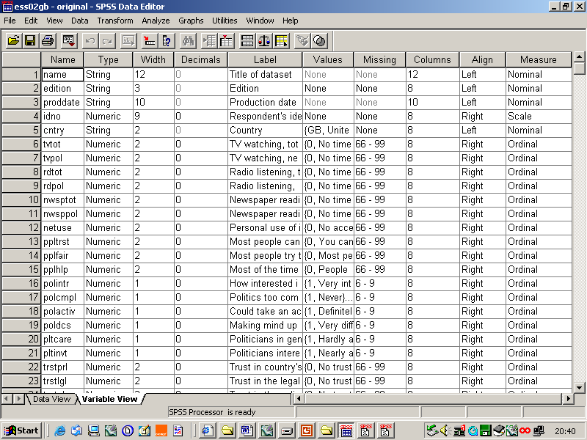

Data Editor after modification (to include question number at beginning of variable labels)

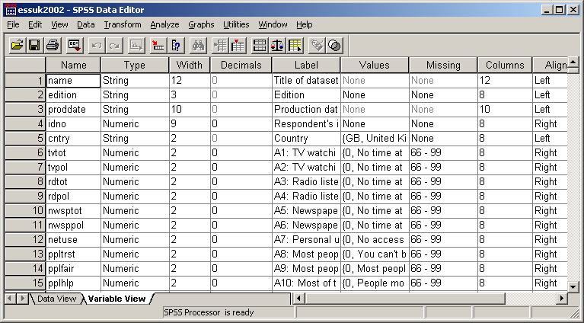

This version is fine for those who prefer, or need, to work with the original variable names, and the labels are now a little clearer in the Data Editor. However, to find our way round the file with the original questionnaire in front of us, we can make things even easier by using question numbers for some variable names. First we need to use rename:

rename variables
(tvtot to pplhlp = a1 to a10)
(polintr to vote prtvtgb = b1 to b13 b14gb)
(contplt to ilglpst clsprty prtclgb = b15 to b24 b25a b25gb)
(prtdgcl mmbprty prtmbgb = B25c b26 b27GB)
(lrscale to scnsenv = b28 to b50)
(happy to dscrgrp = c1 to c16)
(dscrrce to dscroth = c17_1 to c17_10)
(dscrdk to dscrna = c17_dk, c17_ref, c17_nap, c17_na)
(ctzcntr to livecntr = c18 to c22)
(lnghoma lnghomb = c23_1, c23_2)
(blgetmg to mocntn = c24 to c28)
(imgetn to imbghct = d1 to d31)
( ctbfsmv to stimrdt = d32 to d44)
( lwdscwp to blncmig = d45 to d58)
(hlpppl to imprwct = e20 to e43)
(hhmmb gndr yrbrn = f1, f2, f3)
(domicil edulvl eduyrs = f5, f6, f7)
(emplrel wkhct wkhtot = f12 f19 f20)
(uemp3m to brwmny edulvlp = f25 to f32 f34)
(edulvlf emprf14 occf14 occm14 = f45 f46 f51 f56)
(marital to chldhhe = f58 to f65).

..to change the variable names as well. [NB: The lines in red are for variables used in later examples]
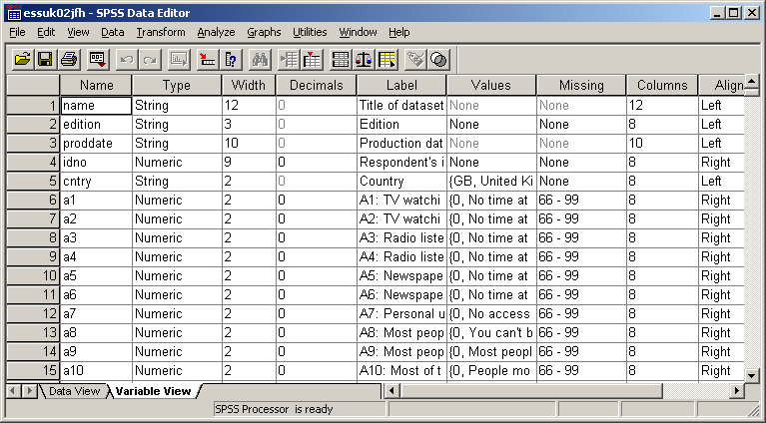
..on which you can’t see everything properly, especially the labels.
You don’t really need it all anyway, so once you’ve checked the file over, it helps to adjust the column widths to get rid of the redundant spaces in the Type, Width, and Decimals columns and maximise the text displayed for the variable labels (and increase it a bit for the value labels) to hide the other columns.
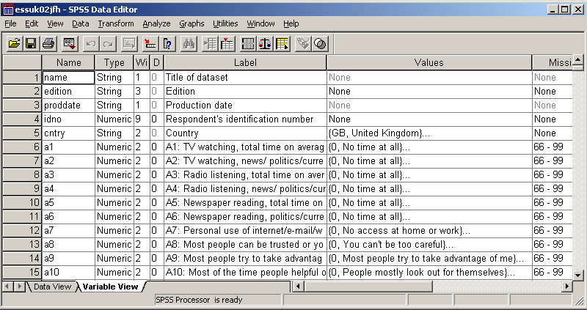

3.2: An example of awkward labelling

The following section of the questionnaire seems clear enough:

ASK ALL

C16 Would you describe yourself as being a member of a
group that is discriminated against in this country?
Yes 1 ASK C17
No 2
GO TO C18
(Don’t know) 8

C17 On what grounds is your group discriminated
against? PROBE: ‘What other grounds?’

CODE ALL THAT APPLY
Colour or race 01
Nationality 02
Religion 03
Language 04
Ethnic group 05
Age 06
Gender 07
Sexuality 08
Disability 09
Other (WRITE IN)___________________________ 10

(Don’t know) 88

This is a simple filter question followed by a multiple response question for those who answered, “Yes”. However, a secondary researcher wishing to analyse data from this question is faced with a problem. First, there is no indication of data layout; second, the variable names and labels in the original SPSS saved file distributed by ESS) illustrate the separate problems of using mnemonic variable names (so you don’t know where they are in the file or to which question they relate) and long variable labels with no question number, redundant information at the beginning and all the useful information at the end, so it’s masked unless you widen the Labels column). After I pointed this out, the European Social Survey now puts the question number at the beginning of variable labels, but has retained mnemonic variable names.

[NB: The ESS data file has a separate variable for each response, but although the responses are precoded 01 to 10 on the questionnaire, the valid responses for each variable have been entered as binary (0,1) and the value labels as (0 = not marked, 1 = marked) and the missing values as 6-9. Now there’s confusion for you! For some analysis, these binary values will need to be changed to sequential (you’ll see why later).]

It takes a while to find the associated variables for the above questionnaire extract, and when you do find them it’s not immediately clear what they are.

Here’s what I mean

Data Editor as initialised
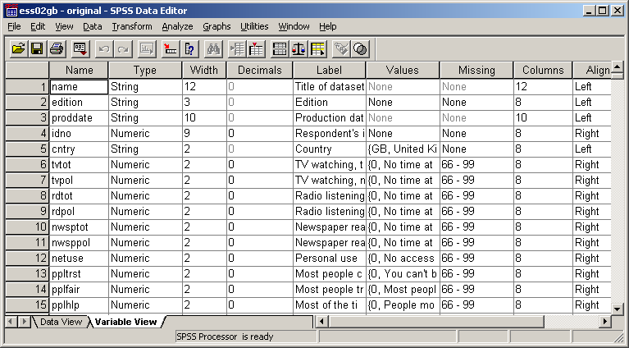

How do you find the relevant variables in this lot? Well, you can scroll down to see if there are any possible candidates, but you might not find them first time:

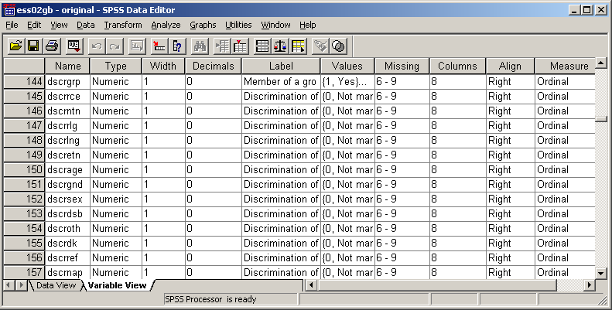

It’s better to start by adjusting the column widths as before, but this time widen the Labels column to reveal all the labels in full: then scroll down to search for likely variables. The first one is in row 144.

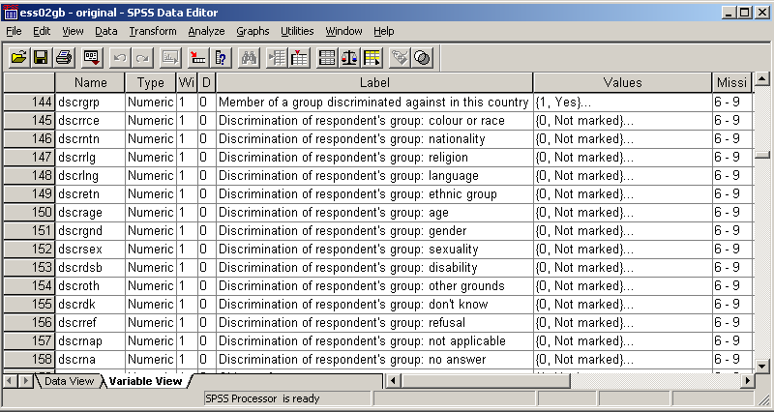
Data Editor after widening Labels column and scrolling down

You can make things a little easier by inserting the question number and response code at the beginning of the label. It looks a bit messy, but makes the variables easier to find.

Data Editor after adding question number and response code to the beginning of the label, but still with mnemonic variable names:

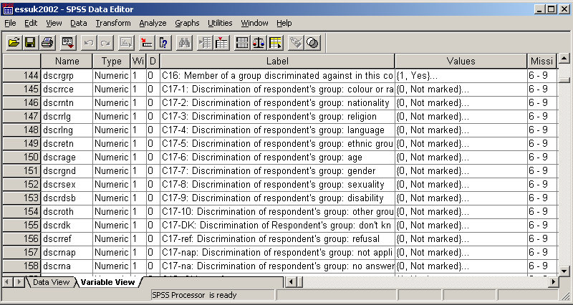

You can use rename variables to change the variable names to match the question numbers, but there’s still far too much redundant information at the beginning of the variable labels.
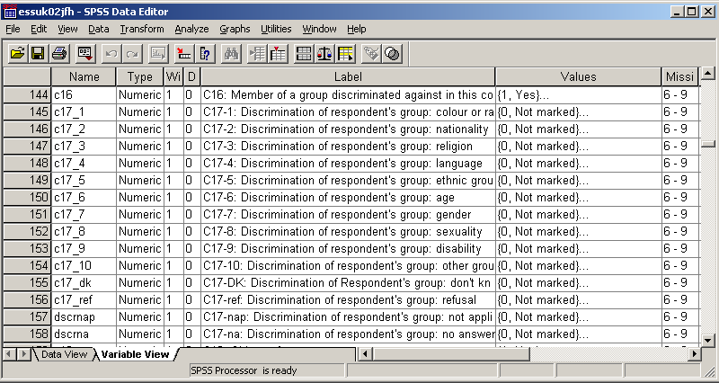

An alternative solution (which would match the positions of variables in the file) would be to use variable names derived from the row they are on ie V144 to V158 The row numbers will change if you start selecting variables to save in another file, but at least they’ll be in same order and easier to find.

Now chop out redundant information at the beginning of the variable labels to yield:

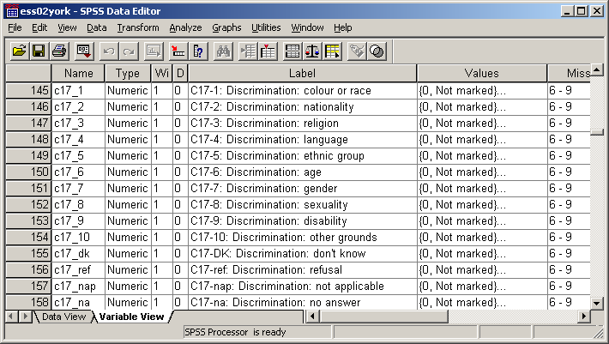

It looks a bit messy, but at least you can now find them more easily.

How do we analyse this question?

3.3: Multiple response

You could run separate frequency counts for each variable, and then add them all up, but it’s far better to use the SPSS command MULT RESPONSE

Question C17 allows for more than one response and most analysis will therefore need to use the SPSS procedure mult response. On the questionnaire the coding for question C17 ranges from 1 to 10 (with 88 as missing) but the actual data are entered as binary (0 or 1) with a separate column entry for each possible response, and also for some categories of non-response not shown ( “No answer”, “Not applicable”, “Refused”).

The mult response command generates temporary group variables (which cannot be saved). It works either in dichotomous mode (using a single value across all variables in the group) which displays variable labels, or in general mode (using a specified range of different values across all variables in the group) for which value labels will be displayed. In either case, SPSS limits all labels to 40 printed characters in frequency counts and limits value labels to 20 for row variables and 16 for column variables in contingency tables. Because of this restraint (unchanged since the the procedure was first introduced in the 1970s) valuable information can be lost, or may not appear on the output.

Some examples will illustrate this. The first, because of the way the original data file was generated, uses multiple response in dichotomous mode on the original file, the second and third do the same thing, but with the modified variable names and labels described above. The fourth involves some (temporary and complex) file manipulation and the addition of value labels.

To run mult response on the original data file, we write:

mult response groups =
discrim 'Reasons for perceived discrimination'
(dscrrce to dscrna (1))
/freq discrim.

Group DISCRIM Reasons for perceived discrimination
(Value tabulated = 1)

Pct of Pct of
Dichotomy label Name Count Responses Cases

Discrimination of respondent's group: co DSCRRCE 82 3.8 4.0
Discrimination of respondent's group: na DSCRNTN 28 1.3 1.4
Discrimination of respondent's group: re DSCRRLG 44 2.0 2.1
Discrimination of respondent's group: la DSCRLNG 5 .2 .2
Discrimination of respondent's group: et DSCRETN 21 1.0 1.0
Discrimination of respondent's group: ag DSCRAGE 50 2.3 2.4
Discrimination of respondent's group: ge DSCRGND 37 1.7 1.8
Discrimination of respondent's group: se DSCRSEX 18 .8 .9
Discrimination of respondent's group: di DSCRDSB 18 .8 .9
Discrimination of respondent's group: ot DSCROTH 74 3.4 3.6
Discrimination of respondent's group: do DSCRDK 1 .0 .0
Discrimination of respondent's group: re DSCRREF 1 .0 .0
Discrimination of respondent's group: no DSCRNAP 1771 82.4 86.3
------- ----- -----
Total responses 2150 100.0 104.8

0 missing cases; 2,052 valid cases

For frequency counts, variable labels in mult response are limited to 40 characters. As we can see, this has caused the actual perceived reasons for discrimination to be completely lost, and it’s not much clearer even after modifying the value labels by adding question number and response code :

Group DISCRIM Reasons for perceived discrimination
(Value tabulated = 1)

Pct of Pct of
Dichotomy label Name Count Responses Cases

C17-1: Discrimination of respondent's gr DSCRRCE 82 3.8 4.0
C17-2: Discrimination of respondent's gr DSCRNTN 28 1.3 1.4
C17-3: Discrimination of respondent's gr DSCRRLG 44 2.0 2.1
C17-4: Discrimination of respondent's gr DSCRLNG 5 .2 .2
C17-5: Discrimination of respondent's gr DSCRETN 21 1.0 1.0
C17-6: Discrimination of respondent's gr DSCRAGE 50 2.3 2.4
C17-7: Discrimination of respondent's gr DSCRGND 37 1.7 1.8
C17-8: Discrimination of respondent's gr DSCRSEX 18 .8 .9
C17-9: Discrimination of respondent's gr DSCRDSB 18 .8 .9
C17-10: Discrimination of respondent's g DSCROTH 74 3.4 3.6
C17-DK: Discrimination of Respondent's g DSCRDK 1 .0 .0
C17-ref: Discrimination of respondent's DSCRREF 1 .0 .0
C17-nap: Discrimination of respondent's DSCRNAP 1771 82.4 86.3
------- ----- -----
Total responses 2150 100.0 104.8

0 missing cases; 2,052 valid cases

What is needed is a modification of the labels to chop out some redundant information and bring forward the substantive part of the coding frame to yield something like this:

Group DISCRIM Reasons for perceived discrimination
(Value tabulated = 1)

Pct of Pct of
Dichotomy label Name Count Responses Cases

C17-1: Discrimination: colour or race C17_1 82 3.8 4.0
C17-2: Discrimination: nationality C17_2 28 1.3 1.4
C17-3: Discrimination: religion C17_3 44 2.0 2.1
C17-4: Discrimination: language C17_4 5 .2 .2
C17-5: Discrimination: ethnic group C17_5 21 1.0 1.0
C17-6: Discrimination: age C17_6 50 2.3 2.4
C17-7: Discrimination: gender C17_7 37 1.7 1.8
C17-8: Discrimination: sexuality C17_8 18 .8 .9
C17-9: Discrimination: disability C17_9 18 .8 .9
C17-10: Discrimination: other grounds C17_10 74 3.4 3.6
C17-DK: Discrimination: don't know C17_DK 1 .0 .0
C17-ref: Discrimination: refusal C17_REF 1 .0 .0
C17-nap: Discrimination: not applicable DSCRNAP 1771 82.4 86.3
------- ----- -----
Total responses 2150 100.0 104.8

0 missing cases; 2,052 valid cases

…which now looks odd because the variable names appear twice, once in the variable list and once at the beginning of the variable labels. We could always change the variable labels back to knock off the question number, but there’s an altogether better way of analysing the responses to this question using mult response in general mode.
This requires some complex manipulation of the data file to change the values of the variables from binary to sequential, to suppress the missing values (otherwise cases with values 6 to 9 for responses “Age”, “Gender”, “Sexuality” and “Disability” will be left out) and to change the value labels. If we wish to keep the original values and missing values, the recodes need to be temporary. Let’s assume we’re starting from scratch.

Step 1: Check initial values
Step 2: Temporarily change the codes from binary to sequential
Step 3: Check recoded values

Step 4: Disable missing values
Step 5: Change value labels (first variable only)
Step 6: Run mult response in general mode

It is good research practice to check all data before running any statistical analysis. A useful procedure is LIST (not available in the drop-down menus) which displays the data values for (all or selected) variables and cases. It can be used to check data values before and after recoding to make sure you’ve produced what you actually want. In this example we shall inspect the initial data values for variables c17-1 to c17-10, and again after recoding them from binary to sequential values.

Step 1: Check initial values

list var c17_1 to C17_10
/ cases 5.

C17_1 C17_2 C17_3 C17_4 C17_5 C17_6 C17_7 C17_8 C17_9 C17_10

1 0 0 0 0 0 1 0 0 0
1 1 1 1 1 0 0 0 0 0
1 0 0 0 0 0 0 0 0 0
1 0 0 0 0 0 0 0 0 0
0 0 0 0 0 0 0 0 0 1

Number of cases read: 5 Number of cases listed: 5

Step 2: Temporarily change the codes from binary to sequential

temp.

recode
c17_1 to c17_10 (6 thru hi = sysmis)
/c17_2 (1=2)
/c17_3 (1=3)
/c17_4 (1=4)
/c17_5 (1=5)
/c17_6 (1=6)
/c17_7 (1=7)
/c17_8 (1=8)
/c17_9 (1=9)
/c17_10 (1=10)
/c17_dk (1=11)
/c17_ref (1=12)
/c17_nap (1=13)
/c17_na (1=14).

Step 3: Check recoded values

list var c17_1 to C17_10
/ cases 5.

C17_1 C17_2 C17_3 C17_4 C17_5 C17_6 C17_7 C17_8 C17_9 C17_10

1 0 0 0 0 0 7 0 0 0
1 2 3 4 5 0 0 0 0 0
1 0 0 0 0 0 0 0 0 0
1 0 0 0 0 0 0 0 0 0
0 0 0 0 0 0 0 0 0 *

Number of cases read: 5 Number of cases listed: 5

[NB: the * = value 10: it would display in full with print format F2.0]

Step 4: Disable missing values

missing values
c17_1 to c17_14 ( ).

(not many people know that trick, but don’t save the file or you’ll lose the lot!)

Step 5: Specify new value labels

value labels c17_1
(1) 'Colour or race'
(2) 'Nationality'
(3) 'Religion'
(4) 'Language'
(5) 'Ethnic group'
(6) 'Age'
(7) 'Gender'
(8) 'Sexuality'
(9) 'Disability'
(10) 'Other'
(11) "Don't know"
(12) 'Refusal'
(13) 'Not applicable'
(14) 'No answer'.

[NB: in general mode SPSS mult response reads labels from first variable only]

Step 6: Specify group variable and get frequency count

Mult response groups =
discrim 'Q17 Perceived reasons for discrimination'
(c17_1 to c17_14 (1,14))
/freq discrim.

Group DISCRIM Q17 Perceived reasons for discrimination
Pct of Pct of
Category label Code Count Responses Cases

Colour or race 1 82 3.8 4.0
Nationality 2 28 1.3 1.4
Religion 3 44 2.0 2.1
Language 4 5 .2 .2
Ethnic group 5 21 1.0 1.0
Age 6 50 2.3 2.4
Gender 7 37 1.7 1.8
Sexuality 8 18 .8 .9
Disability 9 18 .8 .9
Other 10 74 3.4 3.6
Don't know 11 1 .0 .0
Refusal 12 1 .0 .0
Not applicable 13 1771 82.4 86.3
------- ----- -----
Total responses 2150 100.0 104.8

0 missing cases; 2,052 valid cases

To restrict analysis to those who answered, “Yes” to question c16, use select if (c16 = 1). which will include the “Don’t know” and “Refused” (11 and 12). To exclude the latter, change the specification to:

mult response groups =
discrim 'Q17 Perceived reasons for discrimination'
(c17_1 to c17_10 (1,10))
/freq discrim.

Group DISCRIM C17 Perceived reasons for discrimination
Pct of Pct of
Category label Code Count Responses Cases

Colour or race 1 82 21.8 29.4
Nationality 2 28 7.4 10.0
Religion 3 44 11.7 15.8
Language 4 5 1.3 1.8
Ethnic group 5 21 5.6 7.5
Age 6 50 13.3 17.9
Gender 7 37 9.8 13.3
Sexuality 8 18 4.8 6.5
Disability 9 18 4.8 6.5
Other 10 74 19.6 26.5
------- ----- -----
Total responses 377 100.0 135.1

1,773 missing cases; 279 valid cases

The SPSS job to produce the above output is only one way of doing it. An alternative to recode is:

do repeat
x = (c17_1 to c17_na)
/y = 1 to 14.
compute x=y .
end repeat.

4: Syntax or drop-down menus?

4.1: Data input

Can you do data entry to SPSS with drop-down menus? Not really. You have to use File… New… Data to open up a blank Data Editor in Data View and then type your data into the blank matrix. If you already have some data in a file and wish to add more, open the Data Editor select Data View click on Data… Insert Cases and type in your new data in rows. Or, if you prefer, you can also use Data… Insert Variables and type in your data in columns. Outside SPSS you will need to use a spreadsheet (SPSS can import from Excel), or possibly a word-processing package to type data in a fixed-width font (eg Courier New) and save the file as *.dat (assumed to be WordPerfect) or *.txt (in Word). Much raw data from surveys deposited with the UK Data Archive (Essex University) is supplied as Wordfect *.dat files in Times New Roman font. This proportional font is impossible to inspect visually and needs to be changed to Courier New to get the columns properly aligned. Typing your own data is prone to error, especially for large data sets. You have been warned!

Your data may already be in an existing SPSS or Excel file, in which case you can import them, but if they are raw (Hollerith type) data in an external file, you will have to use the data list command in syntax direct. You can use the mouse to drag and drop lines of data between begin data ~ ~ ~ end data, which is how I started using SPSS for Windows, when it consistently failed to find a raw data file in the directory I was working in. I did eventually discover that SPSS needs the whole address (eg “C:\Documents and Settings\JFH\Desktop\Social Research\British Social Attitudes\bsa89 SCPR version\bsa89 essex version\bsa89.dat” !!!) but it was quicker to copy the raw data to a blank 1.4mb floppy disk in drive a: and read the data from there (eg as ‘a:QL1UK.dat’.). This was fine for small data sets, but not for the huge (3.5mb +) files from British Social Attitudes and European Social Survey, which are too big. I used to drag and drop these into the syntax file (it took forever!) but I now have a 1gb memory stick (permanently plugged in as drive f:) and copy all raw data files to this. I can then read them easily into SPSS as external files (with nice short names!).

In this example the data are in bsa86.dat on drive f: and the external file name has to be declared to SPSS enclosed in single primes, ie ‘f:bsa86.dat’

Open a new Data Editor and adjust the columns:

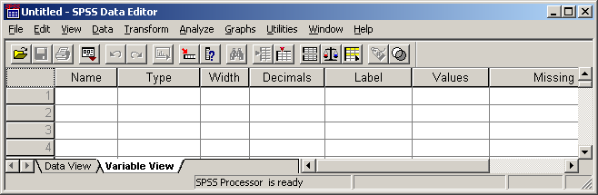

Now click on File … New … Syntax, type in your SPSS commands for a title and the data list using positional variable names:

title 'Page 43b of BSA 1986'.
data list file 'f:bsa86.dat' records 23
/15 v1508 8-9 v1510 10 v1511 11 v1512 12-13.

..and type [CTRL]+R or click on RUN to produce a data table (on which it’s easy to check the accuracy of the specifications as the names and start column should match up).

Page 43b of BSA 1986
Data List will read 23 records from F:\bsa86.dat

Variable Rec Start End Format

V1508 15 8 9 F2.0
V1510 15 10 10 F1.0
V1511 15 11 11 F1.0

V1512 15 12 13 F2.0

The Data File also fills up...
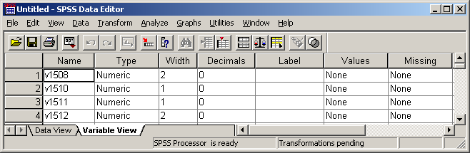

My advice would be always to construct your file definitions in direct syntax. It’s also much easier to keep visual track of what you’re doing, especially for beginners, if you you use tabs to inset continuation lines. Syntax files are much easier to check, amend or correct later. If yours is a large data set, it’s probably better to do it in two or three or even more stages. For this example, type in:

missing values
v1508 v1512 (98,99) v1510 (8,9).

var labels
v1508 'Q105a Household size'
v1510 'Q105b Marital status'
v1511 'Q106a Sex of respondent'
v1512 'Q106b Age of respondent last birthday'.

value labels
v1510 1 'Married' 2 'Living together' 3 'Sep or div'
4 'Widowed' 5 'Not married' 8 'DK' 9 'N/A'
/v1511 1 'Men' 2 'Women'.

..and [CTRL]+R or RUN to get:

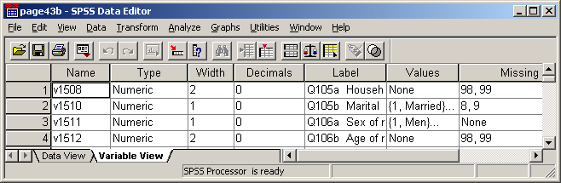

To save page43b.sav to drive f: for future use File… Save as…

or type: save out 'f:page43b.sav'. and then [CTRL]+R or RUN

4.2: Utilities

When working on a file, even a small one containing your own data, it is useful to have available a printed summary of the file contents. When (as in the following example from the Polytechnic of North London Course Evaluation Survey 1986) it’s a large file and possibly not your own data, such summaries are essential.

Although you can get a quick check by sliding to each variable in the file from: Utilities … Variables…

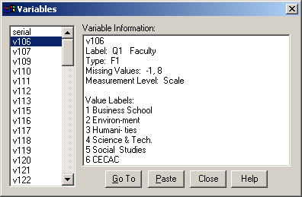

the output from: Utilities..
File info..

List of variables on the working file
Name Position

SERIAL Serial number 1
Measurement Level: Scale
Column Width: 8 Alignment: Right
Print Format: F4
Write Format: F4

V106 Q1 Faculty 2
Measurement Level: Scale
Column Width: 8 Alignment: Right
Print Format: F1
Write Format: F1
Missing Values: *, 8

Value Label

1 Business School
2 Environ-ment
3 Humani- ties
4 Science & Tech.
5 Social Studies
6 CECAC

…gives far more detailed information than you may need. You can get much shorter data summaries, but not from drop-down menus. For these you need to use the display command in syntax direct.
display. …displays the variables currently in the file (to be read in columns downwards).

Currently Defined Variables

SERIAL V117 V127 V137 V147 V157 V166 V177
V106 V118 V128 V138 V148 V158 V167 V178
V107 V119 V129 V139 V149 V159 V168 V179
V109 V120 V130 V140 V150 V160 V169 V180
V110 V121 V131 V141 V151 V161 V171 AGESTART
V111 V122 V132 V142 V152 V162 V172 COURSE
V112 V123 V133 V143 V153 V163 V173 FACULTY
V113 V124 V134 V144 V154 V164 V174 YEAR
V115 V125 V135 V145 V155 V165 V175
V116 V126 V136 V146 V156 V170 V176

display labels. …is useful for checking presence and accuracy of variable labels.

List of variables on the working file

Name Position Label

SERIAL 1 Serial number
V106 2 Q1 Faculty
V107 3 Q2 Course
V109 4 Q3a Full time or part time
V110 5 Q3b Daytime or evening
V111 6 Q3c Sandwich course
V112 7 Q3d Year of course
V113 8 Q4 Age started course
V115 9 Q5 Sex
~~~~ ~~~~~~~~~~~~~~~~~~~~~~~
V118 12 Q7a Lectures
V119 13 Q7b Seminars
V120 14 Q7c Academic tutorials

display variables. …is mostly useful for checking presence and accuracy of missing values.

List of variables on the working file

Name Pos Level Print Fmt Write Fmt Missing Values

SERIAL 1 Scale F4 F4
V106 2 Scale F1 F1 *, 8
V107 3 Scale F2 F2 -1
V109 4 Scale F1 F1 *, 8
V110 5 Scale F1 F1 *, 8
V111 6 Scale F1 F1 *, 8
V112 7 Scale F1 F1 *, 8
V113 8 Scale F2 F2 -1
V115 9 Scale F1 F1 *, 8
~~~~ ~~~~~~~~~~~~~~~~~~~~~~~~~~~~~~~~~~~~~~~~~~~~~~
V118 12 Scale F1 F1 *, 8
V119 13 Scale F1 F1 *, 8
V120 14 Scale F1 F1 *, 8

Printed copies of such summaries can be annotated and used later for amendments and corrections.

All of the above commands (none of which are available in drop-down menus) can be abbreviated.

disp.
disp lab.

disp var.

Another useful facility (also not available in drop-down menus) which can be used as an alternative to Data View in the Data Editor is the LIST command. Be careful: if used on its own it will list all values for all cases in the file!

LIST.

PNL Survey Analysis Workshop

V V V V V V
V V V V V 1 1 1 1 1 1
SERIAL 4 5 6 7 8 0 1 2 4 6 7 V18 V19 V20 SEX V24 AGE METRES FEET INCHES HEIGHT

1 3 5 2 1 4 1 1 2 5 1 2 5 . . 1 3 32 . 5 10 1.78
2 1 4 5 3 2 2 3 3 3 1 2 3 4 . 2 1 44 . 5 7 1.70
~~~~~~~~~~~~~~~~~~~~~~~~~~~~~~~~~~~~~~~~~~~~~~~~~~~~~~~~~~~~~~~~~~~~~~~~~~~~~~
69 5 1 4 2 3 2 3 2 4 1 2 5 . . 2 1 40 1.68 . . 1.68
70 1 2 5 4 3 2 3 3 2 1 2 3 . . 2 4 21 1.58 . . 1.58
~~~~~~~~~~~~~~~~~~~~~~~~~~~~~~~~~~~~~~~~~~~~~~~~~~~~~~~~~~~~~~~~~~~~~~~~~~~~~~
97 1 5 4 2 3 1 2 3 5 1 2 3 4 5 2 4 24 . 5 1 1.55
98 1 4 3 2 5 2 2 3 5 1 2 . . . 2 4 40 . 5 10 1.78
99 4 3 2 1 5 1 3 2 5 2 . . . . 1 4 28 . 6 6 1.98

Number of cases read: 169 Number of cases listed: 169

[NB: Even after 1990, few students knew their height in metres. HEIGHT was calculated later]

You can specify both the variables and the number of cases to be listed.

list serial sex age height
/cases 5.

SERIAL SEX AGE HEIGHT

1 1 32 1.78
2 2 44 1.70
3 1 32 1.73
4 2 39 1.68
5 2 34 1.60

Number of cases read: 5
Number of cases listed: 5

LIST is especially useful for checking values before and after recoding.

4.3: Data Analysis

Detailed comparisons of syntax with drop-down menus are given in section 5 later.

Paste from SPSS Syntax direct

Frequencies
FREQUENCIES freq var agegroup sex.
VARIABLES=agegroup sex
/ORDER= ANALYSIS .

Crosstabs
CROSSTABS cro sex by agegroup.
/TABLES=sex BY agegroup
/FORMAT= AVALUE TABLES
/CELLS= COUNT .

Correlation
CORRELATIONS corr v2018 to v2023
/VARIABLES=v2018 v2019 v2020 /pri nos.
v2021 v2022 v2023
/PRINT=TWOTAIL NOSIG
/MISSING=PAIRWISE .

4.4 Data transformation

RECODE

For the 1986 British Social Attitudes survey, drop-down menus took several minutes to create a new variable agegroup by grouping the values of v1512 (age in years) and produced this:

Paste from SPSS

RECODE
v1512
(18 thru 29=1) (30 thru 44=2) (45 thru 59=3) (60 thru 97=4)
(ELSE=SYSMIS) INTO agegroup .
VARIABLE LABELS agegroup 'Age group of respondent'.
EXECUTE .

….but how do you put the labels in? ….. by typing them into the Data Editor which takes even longer!! It’s far quicker to write the whole thing yourself in a syntax file or even in a Word file and then copy the text into a syntax file.

COMPUTE

Create a variable antiprot from the sum of v2018 to v2023 and subtract 6 from the total to give a true zero point. Won’t even do it! ..or perhaps it will if I enter the variables separately?

COMPUTE antiprot = v2018 + v2019 + v2020 + v2021 + v2022 + v2023 - 6 .
EXECUTE .

This takes up valuable time and it’s much quicker to write it yourself as:

comp antiprot = sum.6 (v2018 to v2023) - 6 .

4.5: First checks on raw data (and on data transformations)

It’s sometimes a good idea to read in raw data in alpha format or even as column-binary, particularly from surveys processed on Hollerith cards. It used to be standard practice in fieldwork agencies to code more than one variable in the same column (eg sex, marital status, household status) and also, where multiple response was allowed, to punch more than one response code in the same column. A frequency count will then tell you what’s actually in the data. Frequencies on serial and record number can be revealing. Sorting by record number and then running correlation on serial numbers can throw up errors caused by duplicate or missing data lines. Listing serial numbers finds duplicate cases: this may seem wasteful, but at least these days there’s no paper involved.

I once used such a check on a data set provided by a research agency to a client who had contracted (and paid) for double sampling of young people. The check revealed around 200 duplicate serial numbers, and a subsequent check revealed that the agency had duplicated the cases rather than conducting additional interviews. The client was less than pleased at being deceived and the MD of the agency was furious at being thus exposed.

4.6: Using functions to generate groups

Household composition types (eg single, couple with or without responsibility for children) or groups taking account of different (for now) State Retirement Pension ages for men and women. For instance, I once did some secondary analysis for a client who wanted to generate a new family status variable with four categories, 1 single – no child responsibility; 2 couple – no child responsibility; 3 single – responsible for child(ren); 4 couple - responsible for child(ren) from the respondent’s marital status and whether he/she had any responsibility for children.

First we needed to check the data by frequenciy counts for each variable:
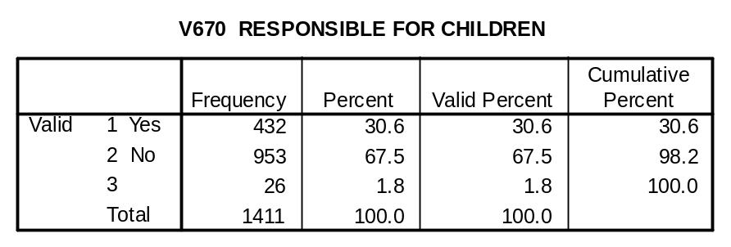
[NB: v670 code 3 has no label and is probably a DK or Inapp response]
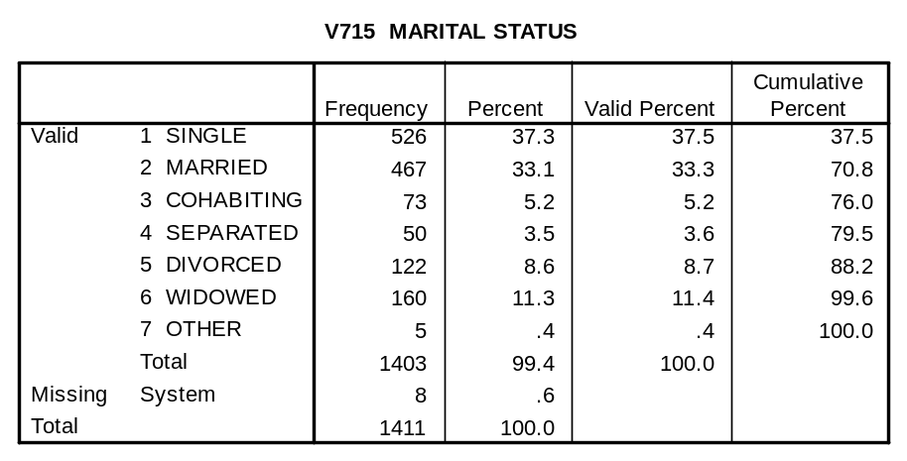

… and also a crosstabulation:
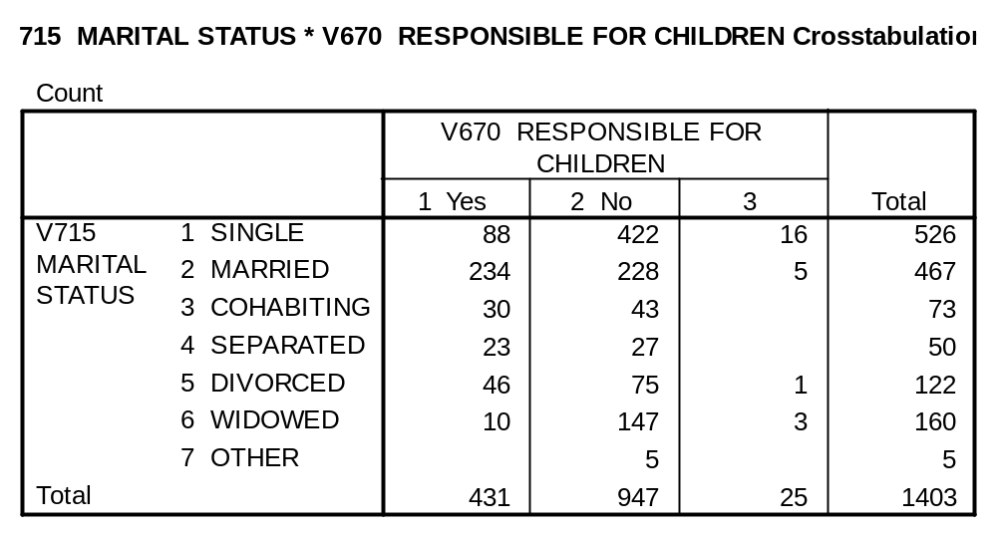

There are several ways of generating the new variable (the longest using a succession of IF commands or DO IF ~~~ ELSE IF), but a quick way is:

compute famstat=v670*10+v715.
recode famstat (21 24 25 26=1)(22 23=2)
(11 14 15 16=3)(12 13=4)(else=sysmis).
value labels famstat
1 'Single: no kids' 2 'Couple: no kids'
3 'Single: + kids' 4 'Couple: + kids'.
freq var famstat.

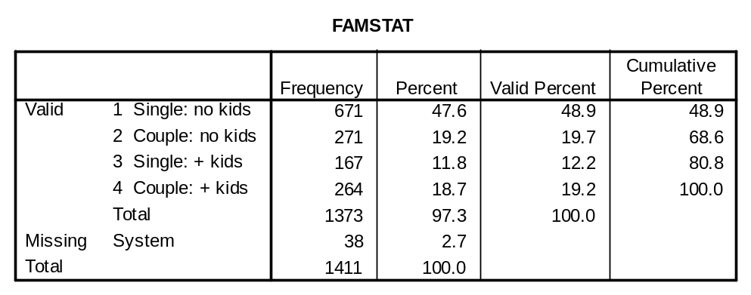

[NB: Row labels limited to 20 characters in those days]

compute can also be used in other ways. For instance a quick way of looking at grouped distributions is to use the truncation function e.g.

compute agegrp10 = trunc (age/10)

. . . which divides age by 10 and knocks off the decimal part to leave an integer. The same principle can be applied to year of birth (e.g. decade of birth for people born 1900-1999: subtract 1900 and divide by 10) or income in ££ (groups dividing by 100,200, 500 etc). This can get complicated, but it can also save time.

4.7: Complex calculations taking account of missing data

Missing data can be full of pitfalls for the unwary. For instance, in the 1982 Undergraduate Income and Expenditure Survey for the National Union of Students , detailed diaries were kept of expenditure under different headings. Values which were declared as missing for one purpose sometimes needed to be recoded to zero for others. Some of the SPSS setup files for such analysis ran to well over 100 lines of IF, COUNT and COMPUTE commands.

NUS Undergraduate Income and Expenditure Survey 1982

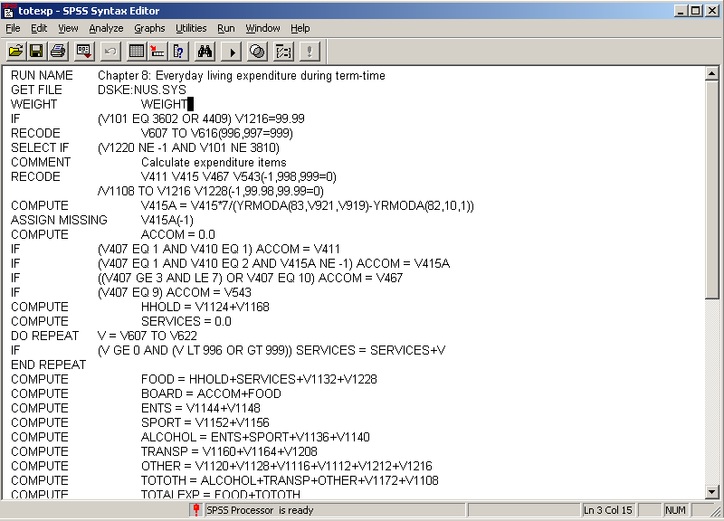

…and this is one of the less complex setups! If you want to have a shot at doing this with drop-down menus, feel free.

5: Exercises from Pallant 2005 (and one from 2001)
(for RECODE, COMPUTE and CORRELATIONS using questionnaire and data set as supplied.)

Facsimile of Optimism-Pessimism scale

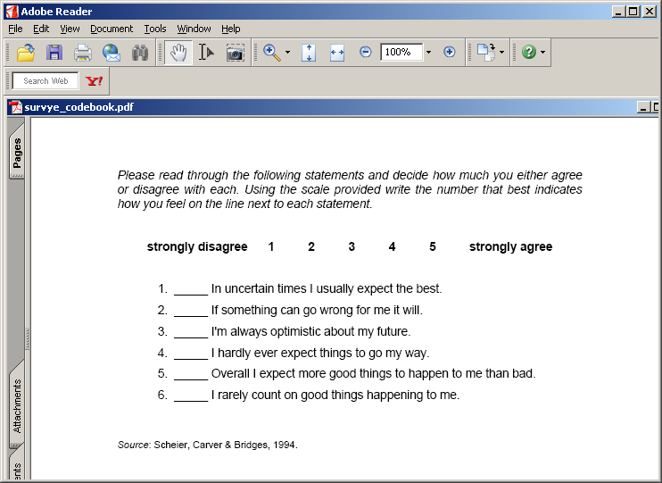

Open the file survey.sav as supplied by double-clicking the icon:

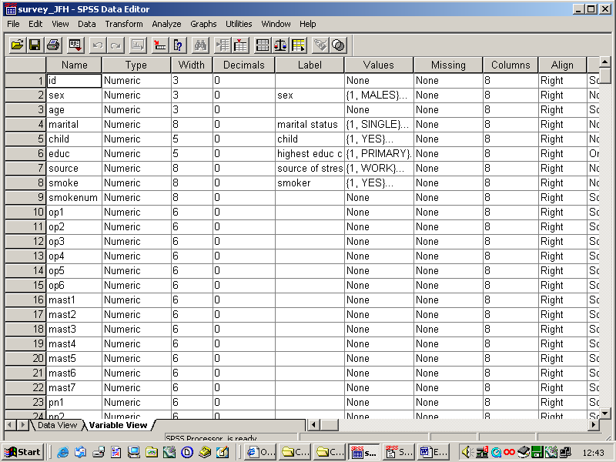

Adjust the window to contain only variables of interest:

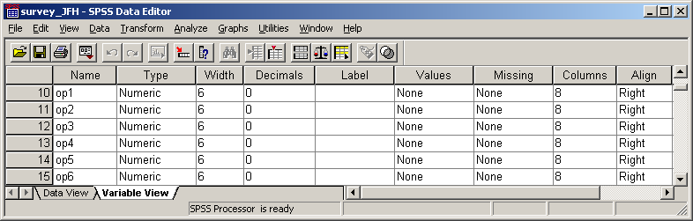

Note the lack of labels: this may be OK for a lone researcher working on her own material for a PhD, but pity anyone else trying to use the data set. I know psychologists dislike single item measures and like to go straight to scale scores derived from items surviving from someone else’s factor analysis (usually with researcher administered pencil and and paper schedules on captive subjects in an office or classroom rather than interviewer administered or self-completed questionnaires to respondents from general populations in their own homes) but my advice is always to check your data first with an initial frequency count. . .
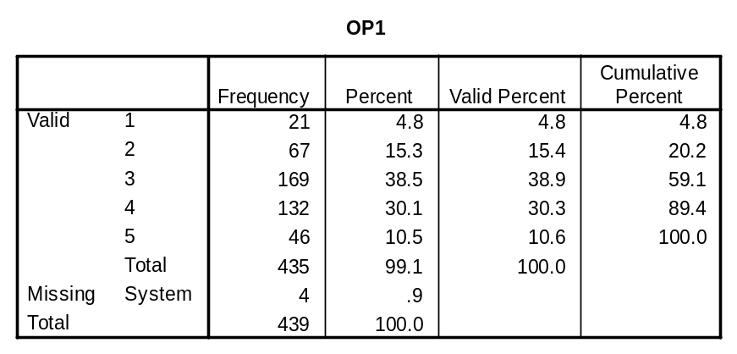
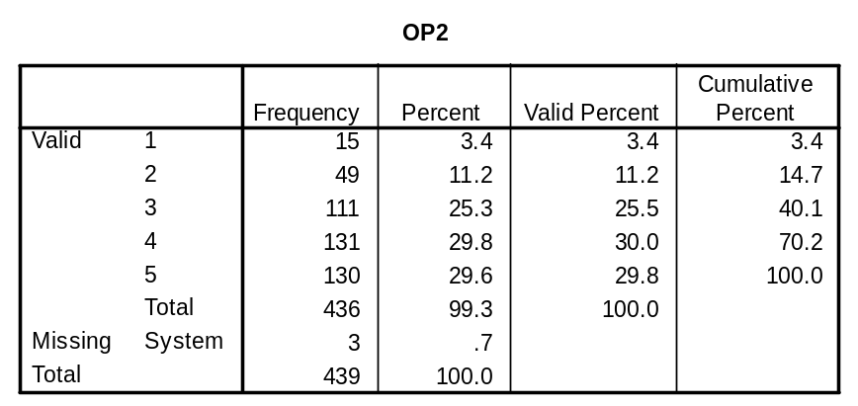

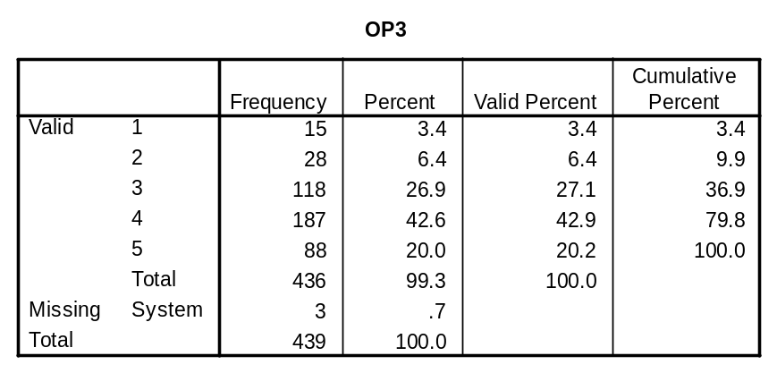

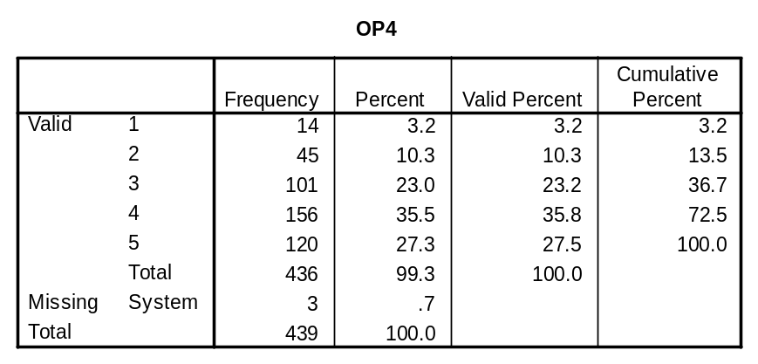
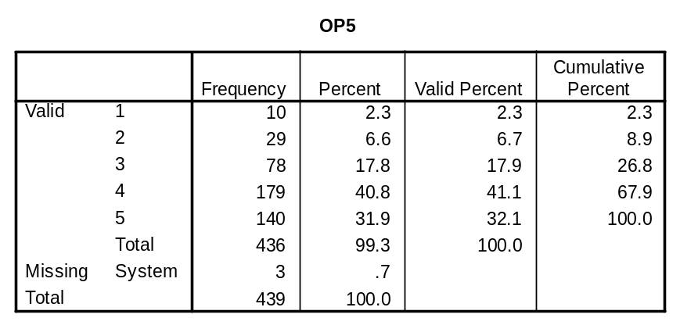
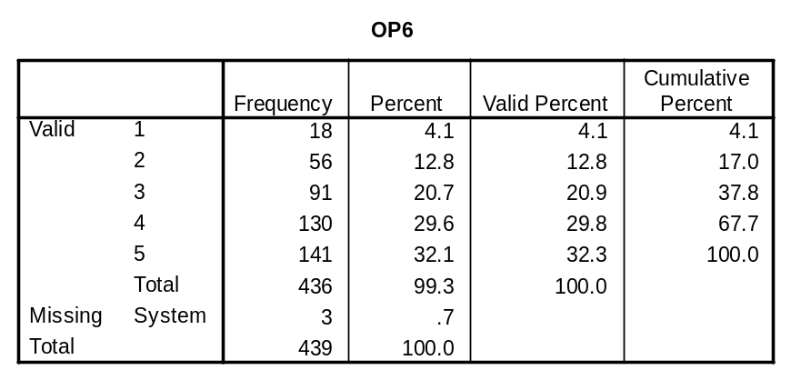
[NB: On 18 Oct 2006 I found another way of doing this via drop-down menus (which I wouldn’t otherwise have found) but I couldn’t find a way of displaying the variable names for each column, so they were inserted manually.]

Analyse…
Custom Tables…
Tables of Frequencies

op1 op2 op3 op4 op5 op6
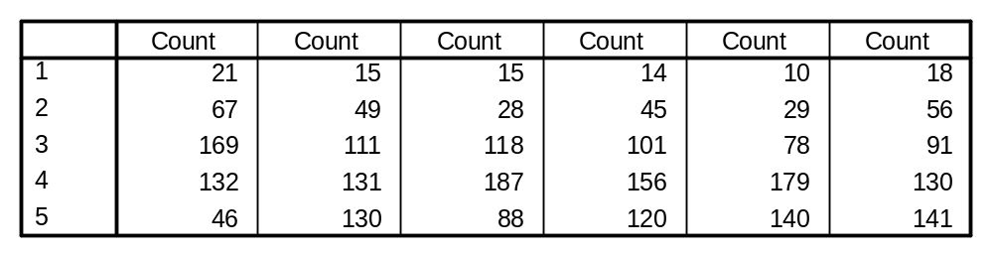

For a visual check you can use a graphic such as a barchart.

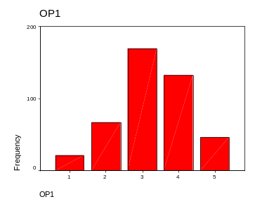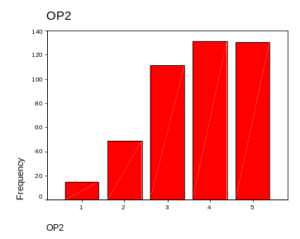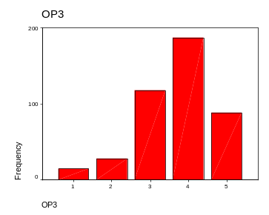

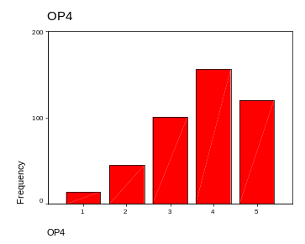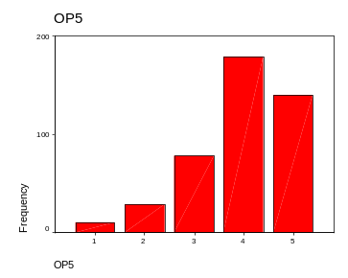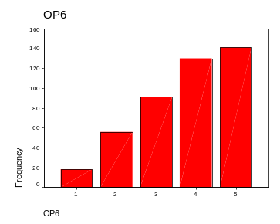

The result of this doesn’t make sense! The frequency distributions for the negative items have the same shape (negatively skewed) as the positive items, when they would be expected to be skewed in opposite directions.

A frequent professional trick with batteries of attitude and similar items is to run off a correlation matrix to check strength and direction of association (and to see if the coding matches the questionnaire).

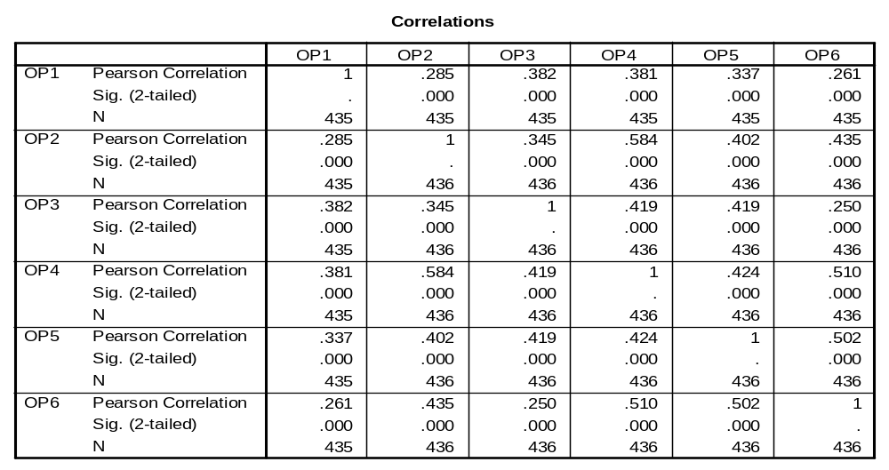

What’s going on? The problem is that Pallant does not give specimen results to use as a check. Clearly the variables have already been recoded in the file as distributed, so I’ve recoded them back again and this time the initial frequencies make intuitive sense.
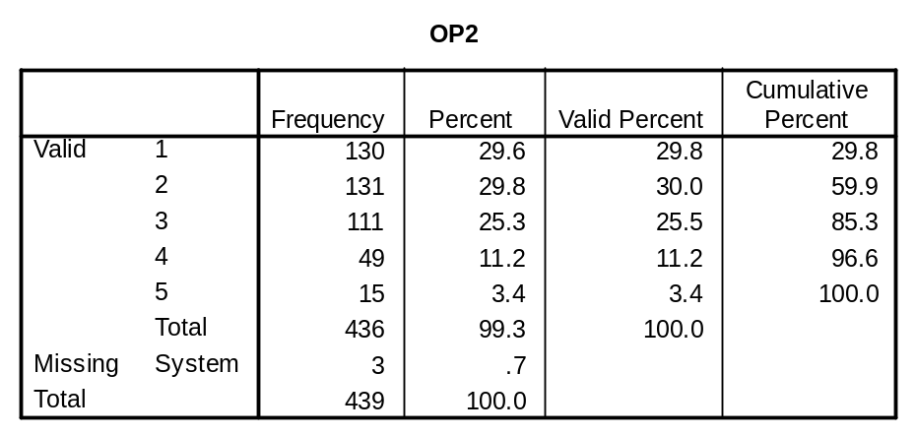
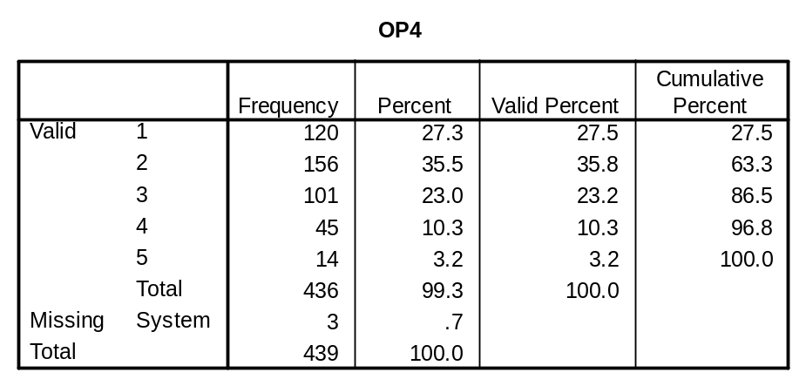
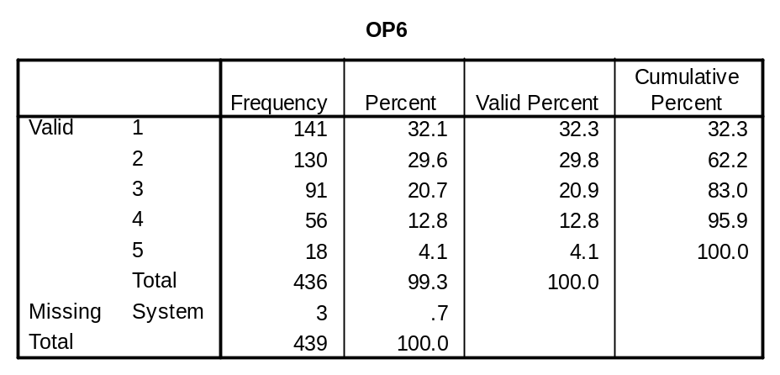

…and in condensed form:

Analyse
Custom Tables
Frequencies

op1 op2 op3 op4 op5 op6
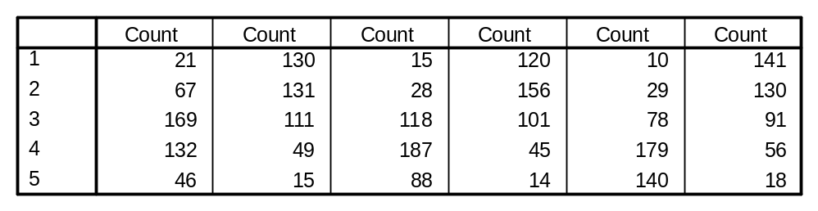

Graphically:
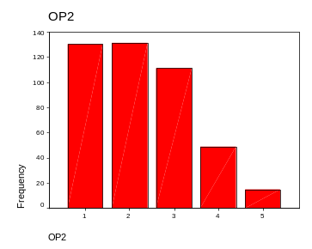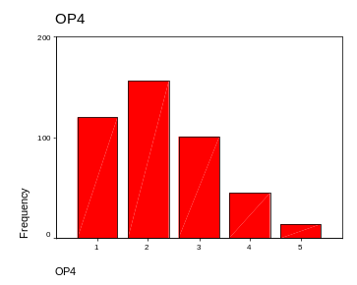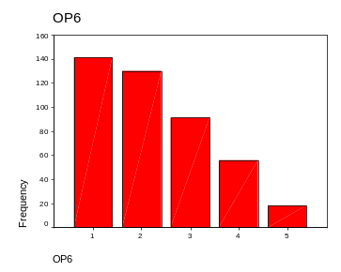
and, as an additional check, the correlation matrix has negatives in the right places, as one might expect.
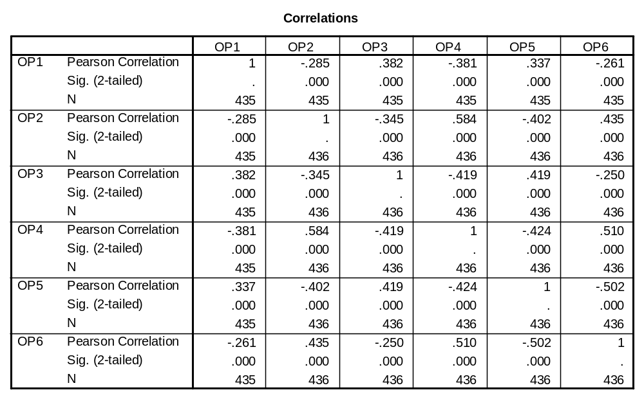

This file is deficient by my standards as it has very few variable or value labels. I’m not sure it wouldn’t also benefit from renaming most of the variables in file order (using the row numbers) to make them easier to find, or else putting the names on the questionnaire as well so that it can be used as documentation.

Failing that, it helps to have something like this (reading downwards in columns):

Currently Defined Variables

ID OP6 PN7 LIFSAT1 PSS10 M4 PC8 TNEGAFF
SEX MAST1 PN8 LIFSAT2 SEST1 M5 PC9 TLIFESAT
AGE MAST2 PN9 LIFSAT3 SEST2 M6 PC10 TPSTRESS
MARITAL MAST3 PN10 LIFSAT4 SEST3 M7 PC11 TSLFEST
CHILD MAST4 PN11 LIFSAT5 SEST4 M8 PC12 TMARLOW
EDUC MAST5 PN12 PSS1 SEST5 M9 PC13 TPCOISS
SOURCE MAST6 PN13 PSS2 SEST6 M10 PC14 EDUC2
SMOKE MAST7 PN14 PSS3 SEST7 PC1 PC15 AGEGP3
SMOKENUM PN1 PN15 PSS4 SEST8 PC2 PC16 AGEGP5
OP1 PN2 PN16 PSS5 SEST9 PC3 PC17 AGEBAND3
OP2 PN3 PN17 PSS6 SEST10 PC4 PC18 EDUCREC
OP3 PN4 PN18 PSS7 M1 PC5 TOPTIM
OP4 PN5 PN19 PSS8 M2 PC6 TMAST
OP5 PN6 PN20 PSS9 M3 PC7 TPOSAFF

So, having restored the original data values to the variables of interest, and with summary documentation to hand, we are now ready to follow Pallant’s steps.
Exercise 1: Reversing scores of items 2, 4 and 6 (2005, pp79-80: 7 steps, one with 4 repeats)

Edit, options, data is redundant as the file is already open in this mode, but I’ve saved a copy with a different name so as to preserve the original. Here we go!

Transform
Recode
Into Same Variables

Let’s assume you haven’t read the previous section and don’t know where the variables are in the file: luckily they’re near the beginning and the first item in the battery, op1, appears at the bottom of the Recode into Same Variables box:

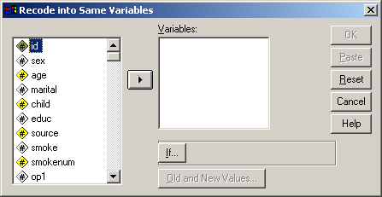

so by scrolling down we can display all six items

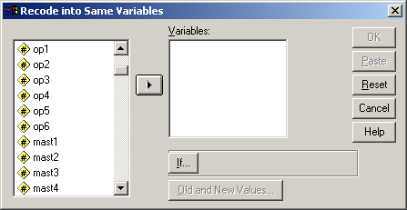

Pallant doesn’t tell us how to select them either, but we need to highlight variables op2 op4 and op6.

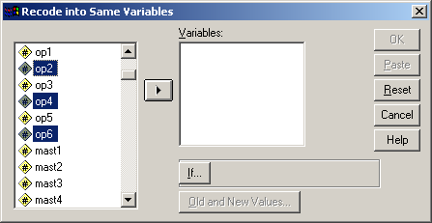

… and either move them one at a time by clicking first the variable and then the right arrow, or all at once by clicking on op2 and using [CTRL]+click to highlight op4 and op6 (making sure we don’t drag id with them as well) then clicking the right arrow to copy them into the Numeric Variables box.

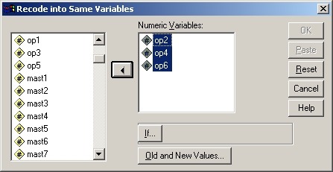

Type [Alt]+O or click on Old and New Values

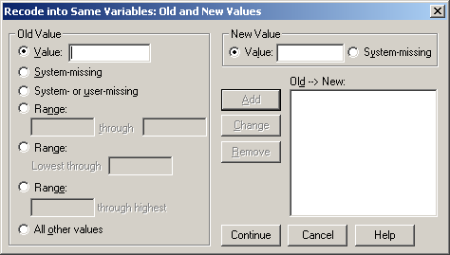

Enter 1 in Old Value and 5 in New Value

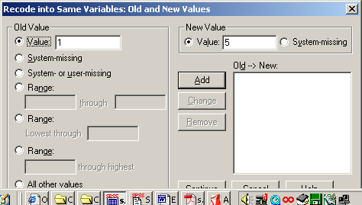

…and click Add for

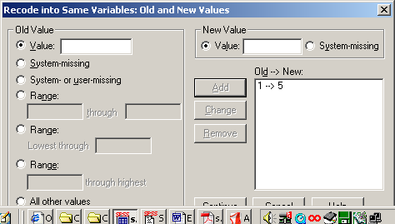

Now do the whole thing another four times (!!!) to change 2 to 4, 3 to 3, 4 to 2, and 5 to1 until:

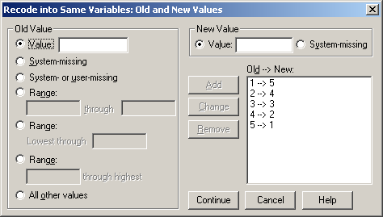

and click on Continue

Oops! I clicked PASTE first and had to start again as I lost the window and couldn’t go back. Couldn’t work out what happened, but discovered later that it pastes direct to the syntax file, so you need to open the latter then run the job with [CTRL]+R. You can also use the dialog recall box, which takes 2 clicks.

Clicking OK immediately effects the changes as permanent. It would have been quicker to write:

RECODE
RECODE
op2 op4 op6 (1=5) (2=4) (3=3) (4=2) (5=1) .
EXECUTE .

…as obtained from PASTE, but there is no need to recode (3=3) and you don’t need to EXECUTE either (this overwrites your original data: it’s safer to do this as a TEMPORARY recode anyway.

Now check the frequency counts for the recoded variables (In the book, Pallant rightly recommends this before and after data transformations, but doesn’t do it for this example)

Analyse
Descriptives
Frequencies

… and scroll down find variables op1 to op6:

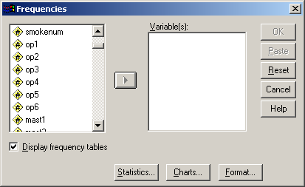

Highlight variables op2 op4 and op6:

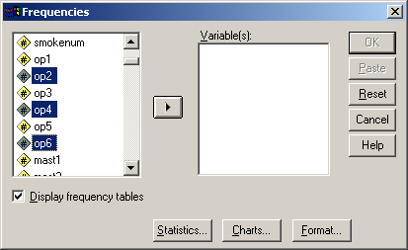

…and click right arrow transfer to Variable(s) box:

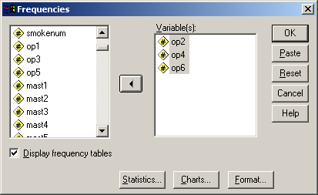

..then click OK to run.
The frequencies for the recoded variables are now the right way round for the next step, but you really need to make this clear, possibly by changing the variable labels to something like OP6 reversed. I would have either generated new variables and left the originals as per questionnaire, or more likely used temp)

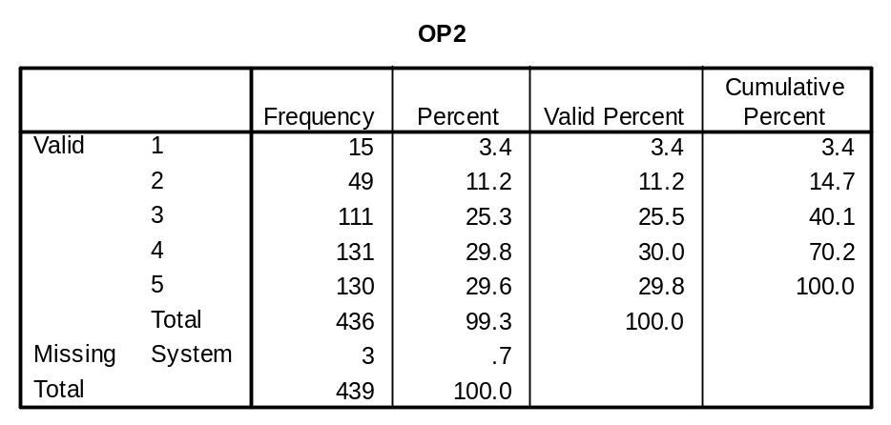
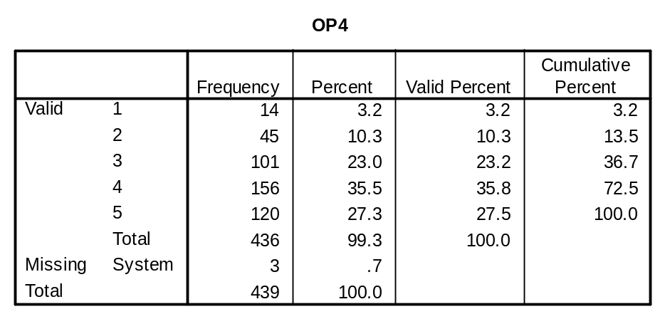
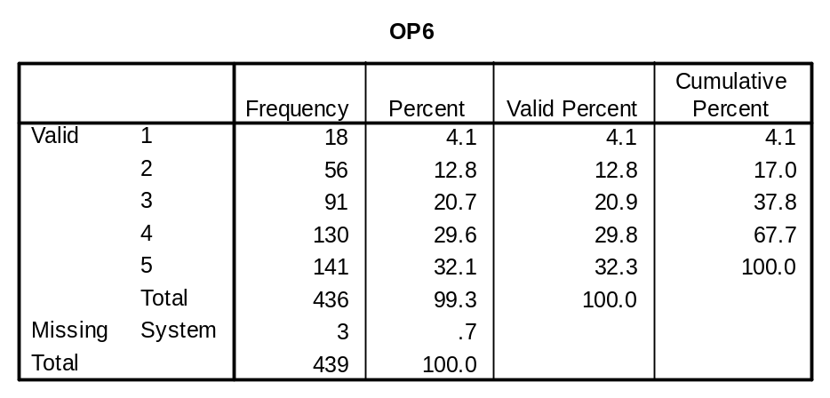

It’s a lot quicker to write:

freq var op1 to op6. | or | freq var op2 op4 op6.

Another way of doing the recode is:

do repeat
X=op2, op4, op6
compute x=6-x.
end repeat.

Exercise 2: Adding up items to yield scale score (2005, pp80-81: 9 steps, one with 4 repeats)

Transform
Compute

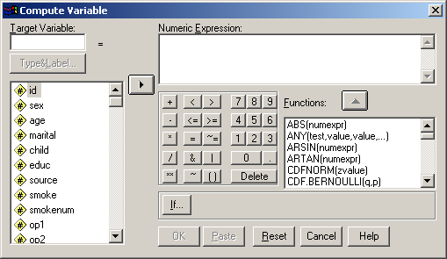

Drop-down menus then require no fewer than 9 steps !!! (one with 4 repeats!!) to produce::

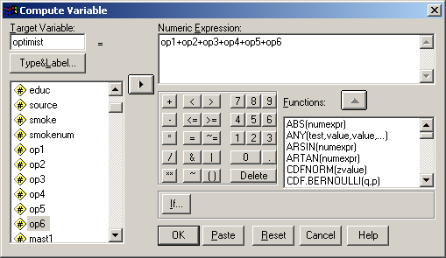

Now check the frequency count for the newly computed variable. Pallant doesn’t do it for this example either, but by now I’ve given up entirely on drop-down menus. It takes for ever and you get a painful bunion on your wrist!.

Again, it would be quicker to write:

COMPUTE
optimist = op1+op2+op3+op4+op5+op6.
FREQUENCIES
VARIABLES=optimist
/ORDER= ANALYSIS .

as obtained from PASTE, but all the above can be done (in seconds) directly in syntax:

recode op2 op4 op6 (1=5)(2=4)(4=2)(5=1).
comp optimist = op1+op2+op3+op4+op5+op6.
freq var optimist.
…which is not much shorter than the original PASTE, but would be if the score was calculated over a longer list: it is however a lot quicker to use syntax than drop-down menus.

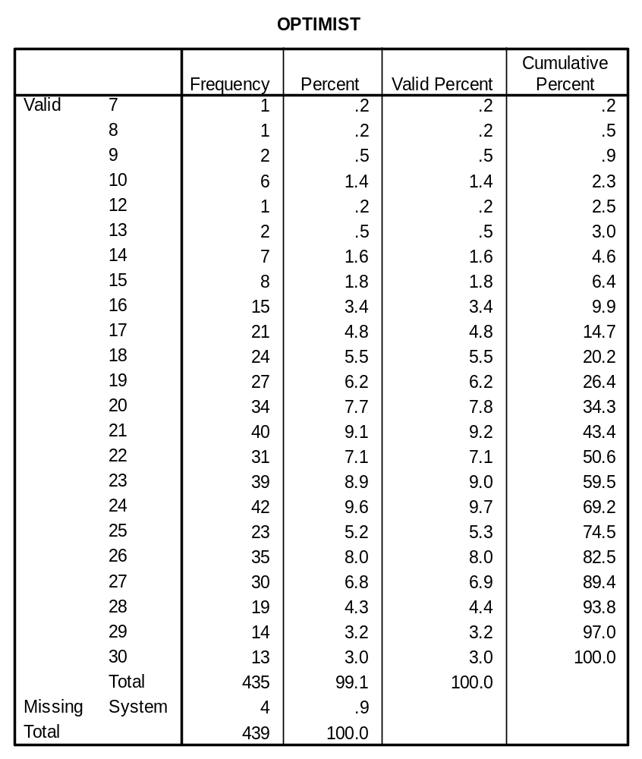
[ie a range from 7 to 30 out of a theoretical range of 6 to 30]

There is another way of calculating the total score using the SUM function:

comp optimist = sum (op1 to op6) .

…but to ensure a score is calculated only if all six items have been answered we need to write:

comp optimist = sum.6 (op1 to op6) .

The resulting score has a range of 6 to 30, but we really ought to subtract 6 from the total to give the score a true zero point, and make it a ratio scale (so that we can say 20 is twice as optimistic as 10?).

comp optimist = sum.6 (op1 to op6) - 6 .

Pallant doesn’t do this: presumably neither do her sources.

Exercise 3: Grouping the values of a continuous variable (Pallant 2005, pp85-87).

Task: Create 3 approximately equal-sized groups for AGE

Step 1: Find the cutting points (Pallant 2001, pp 81-84)

Open Data Editor

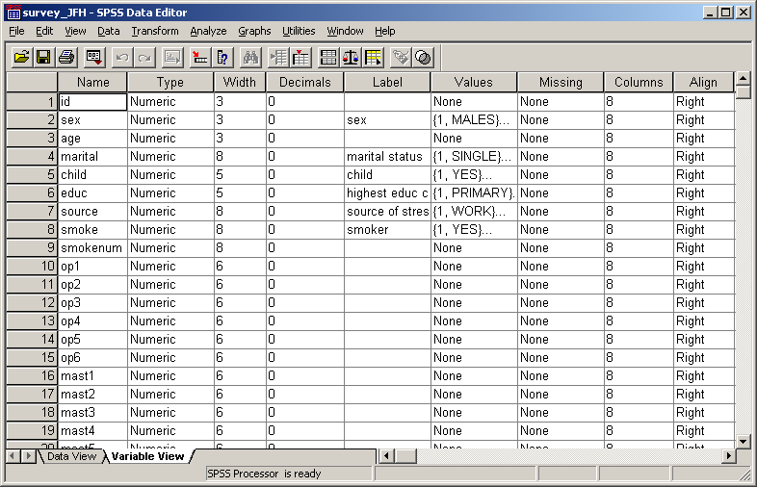

Standard practice would be to check the initial frequency count first, but Pallant goes direct to optional statistics from frequencies to find her cutting points and summary statistics, and produces a frequency count almost by default. Age itself may be a continuous variable, but the variable recorded here is age last birthday. Pallant’s calculated mean is actually inaccurate: for a more accurate mean you should really add 0.5, but the cutting points remain the same, even after this adjustment.

Frequencies…

Statistics…

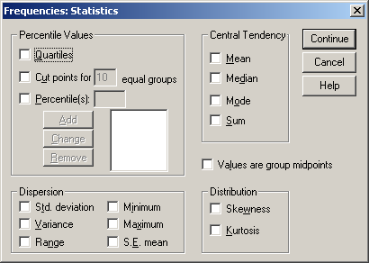

In the Percentile Values panel, click on Cut points for ….

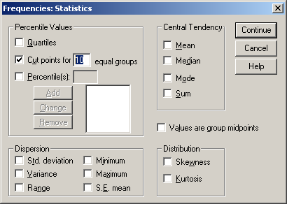

and enter 3 in the box for [ ] equal groups:

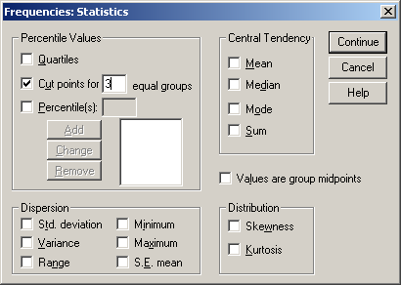

NB Pallant has missed a step out here as she doesn’t show how to get the required statistics: are they automatic? No, but they’re produced in the summary table:

Continue…
OK
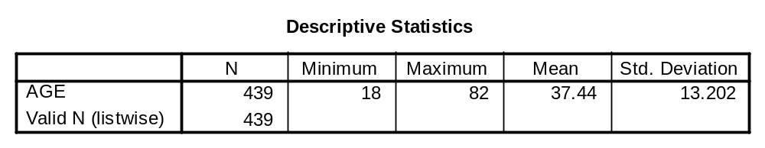
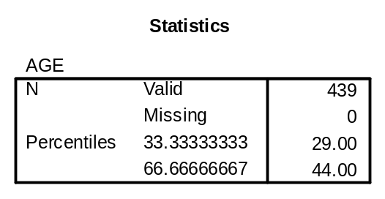
To get Pallant’s version, you have to tick the boxes for Mean in the Central Tendency panel and the boxes for Std. deviation, Min and Max in the Dispersion panel. This could be very confusing for beginners.

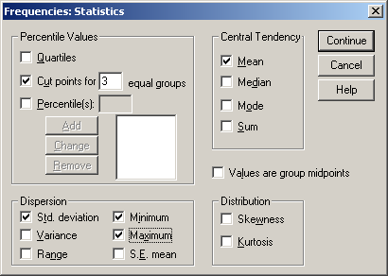

Continue which produces:
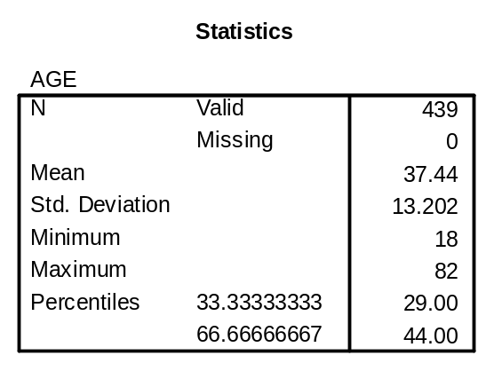

and also, not shown in the book, the frequency table, the Cumulative Percent column of which could just as easily have been used to find these or any other cutting points visually. The table can be suppressed by setting an upper limit to the number of categories under Formats, but Pallant does not demonstrate this. The condensed format subcommand for frequency counts of variables with many values, /format condense, is not implemented in SPSS11 for Windows.
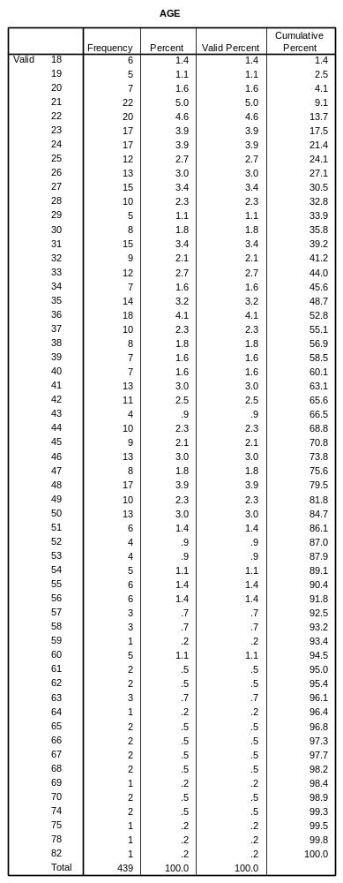

Step 2: Grouping the values

As in the previous exercise the new variable already exists in the file distributed by the Open University. SPSS will not allow it to be overwritten, so yet again I had to overcome this by deleting the variable from the file and recreating it from scratch.

Transform

Recode
Into Different Variables

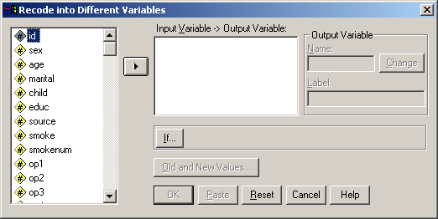

Highlight age and click on right arrow to transfer it to the Input Variable box which now becomes the Numeric Variable → Output Variable box:

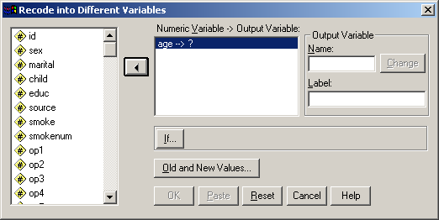

Type agegp3 in Output Variable Name box, and age 3 groups in the label box then change:

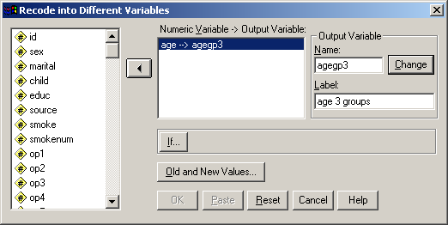
Click Old and New Values

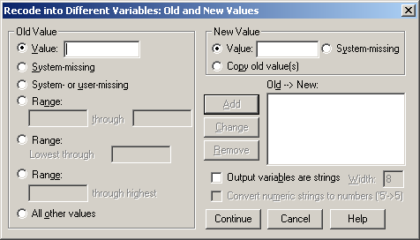

then tick Range Lowest thru and enter 29 in the box and 1 in the Value box of the New Value panel

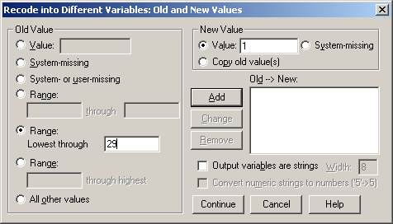

and click Add

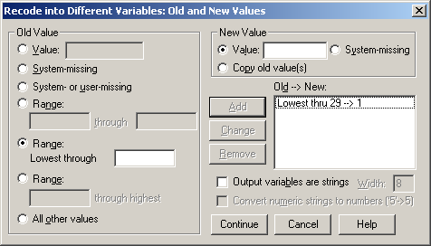

Click on Range and enter values 30 [through] 44: enter 2 in the Value box of the New Value panel

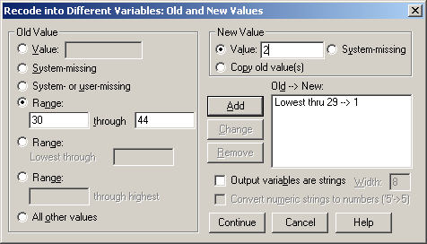

Click on Add

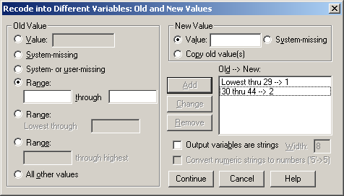

Finally tick Range through highest, enter 45: then enter 3 in the Value box of the New Value panel

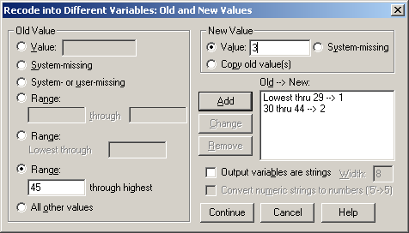

and click on Add

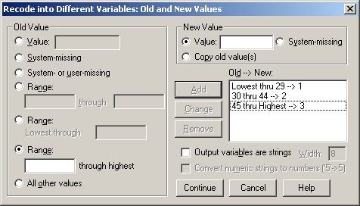

and Continue

Although this is only an exercise, the use of Lowest thru and thru Highest can be dangerous unless you are certain there are no non-missing values outside the valid range. A safer way would have been to use: 18 thru 29 --> 1 30 thru 44 --> 2, 45 thru 82 --> 3 and ELSE -- > SYSMIS.

Step 3: Adding in Value Labels

[CTRL]+End or scroll down to the new variable agegp3 (which will be appended at the end of the file) and click on the Values cell:

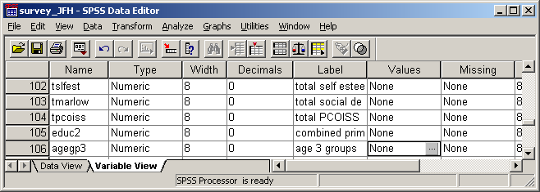

..then on the gray patch to bring up a new window, the Value Labels dialog panel:

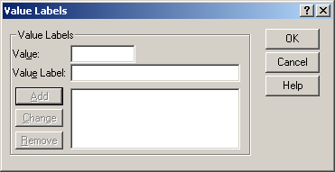

Enter 1 in the Value box and 18-29 in the Value Label box
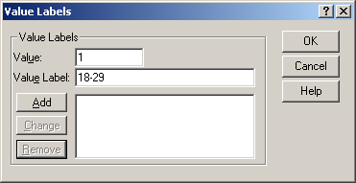

then Add
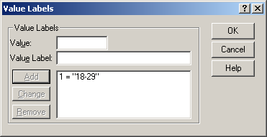

Now do the same for values 2 = “30-44” and 3 = “45+” then Add
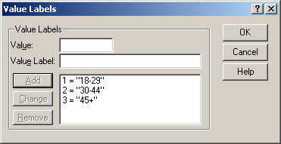

and click OK. The cell in the Values column in the Data Editor will now have changed:

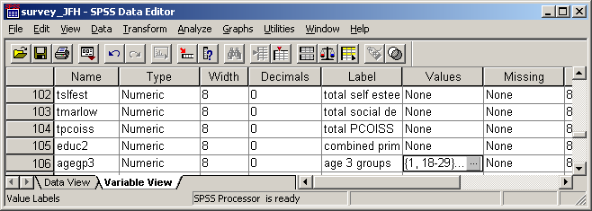

[NB: I have not found a paste facility for this: is there one??]

Again standard procedure would be to check the frequencies for the new variable: Pallant does not do it for this example. In general, it is better to check on initial frequencies for variables to be recoded, as there is always a risk of outliers and missing values being erroneously included in the recodes. Anyway:

Analyse…
Frequencies …
etc., etc…
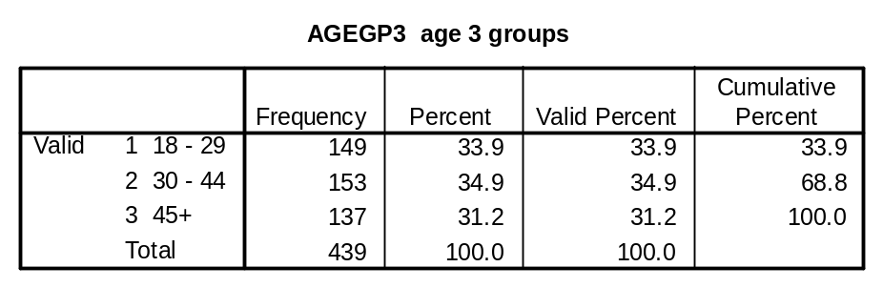

[NB: If you do this with drop-down menus, previous options and statistics are retained (because of the automatic EXECUTE and you will finish up with more output than you wanted! ie:]
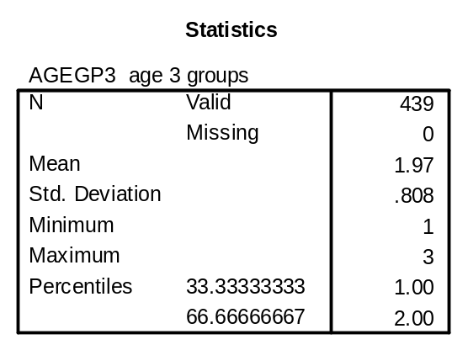
which is clearly nonsense! As before syntax is quicker (from PASTE):

RECODE
age (Lowest thru 29=1) (30 thru 44=2) (45 thru Highest=3) INTO agegp3 .
VARIABLE LABELS agegp3 'age 3 groups'.
EXECUTE .

FREQUENCIES
VARIABLES=age
/NTILES= 3
/STATISTICS=STDDEV MINIMUM MAXIMUM MEAN
/ORDER= ANALYSIS .

but to suppress the frequency count table (from PASTE ):

FREQUENCIES

VARIABLES=age
/FORMAT=LIMIT(10) /NTILES= 3
/STATISTICS=STDDEV MINIMUM MAXIMUM MEAN
/ORDER= ANALYSIS .

[NB: 10 is the default limit for format, but it can be set at any value]

But forget PASTE. I would have done (as a preliminary check on value range, outliers, unexpected values etc.)

freq var age.

…then to get Pallant’s cutting points: (which you can do just as easily from the frequency count)

freq var age /for not/ per 33 67.
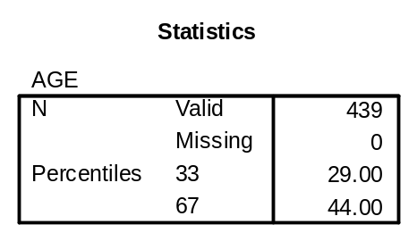

For the recode (since you already have the valid range from the frequency check):

recode age
(18 thru 29 =1)
(30 thru 44 = 2)
(45 thru 82 = 3)
(else=sysmis)
into agegrp3.

…for the labels:

var lab agegrp3 ‘Grouped age (3 groups)’.
val lab agegrp3 1 ’18 - 29’ 2 ’30 - 44’ 3 ‘45+’.

…and for the frequency check on the new group:

freq var agegrp3.

Thus, all the above laborious steps in drop-down menus could have been done (again in seconds) with:

recode age (18 thru 29 =1)(30 thru 44 = 2)
(45 thru 82 = 3)(else=sysmis)
into agegrp3.
var lab agegrp3 ' Grouped age (3 groups)'.
val lab agegrp3 1 '18 - 29' 2 '30 - 44' 3 '45+'.
freq var agegrp3.

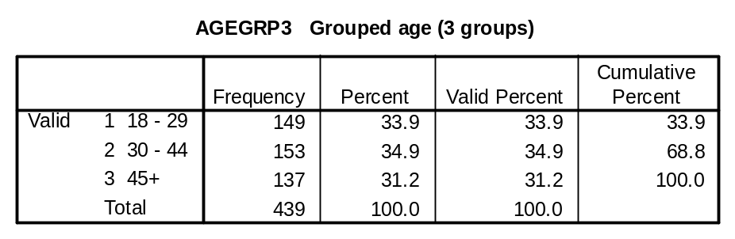

…but to be statistically correct:

comp age = age+0.5.
freq var age /for not /sta mea std /per 33 67.
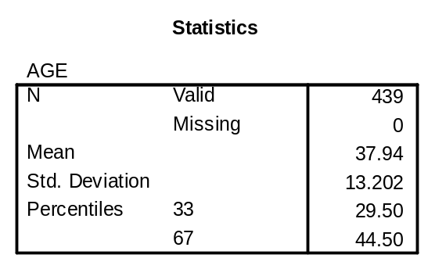

…which is more accurate, but doesn’t change the groupings needed for recode into agegrp3

Exercise 4: Correlation (2005, pp78ff)

I found a major problem repeating this exercise from the book. Although the variable names are given in an initial decision-making table, they are not given in the actual exercises. The sample outputs use variable labels, not variable names, and this is confusing, especially for the second exercise for which, “Click on the first variable” is not particularly helpful. However, having worked out which variables (tpcoiss and tpstress) are supposed to be used:

Step 1: Scatterplot

Graphs
Scatter [Simple will be highlit]
Define

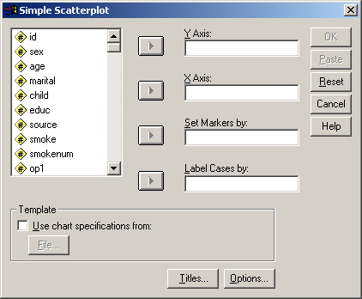

Scroll down to find the variables

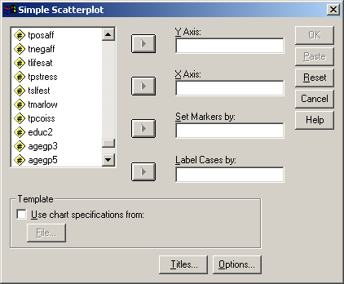

Click and drag tpstress to the Y Axis box and tpcoiss to the X Axis box

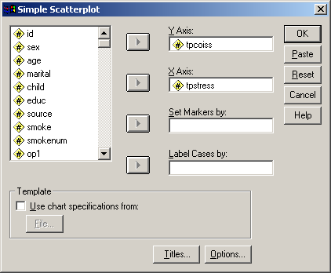

then click OK
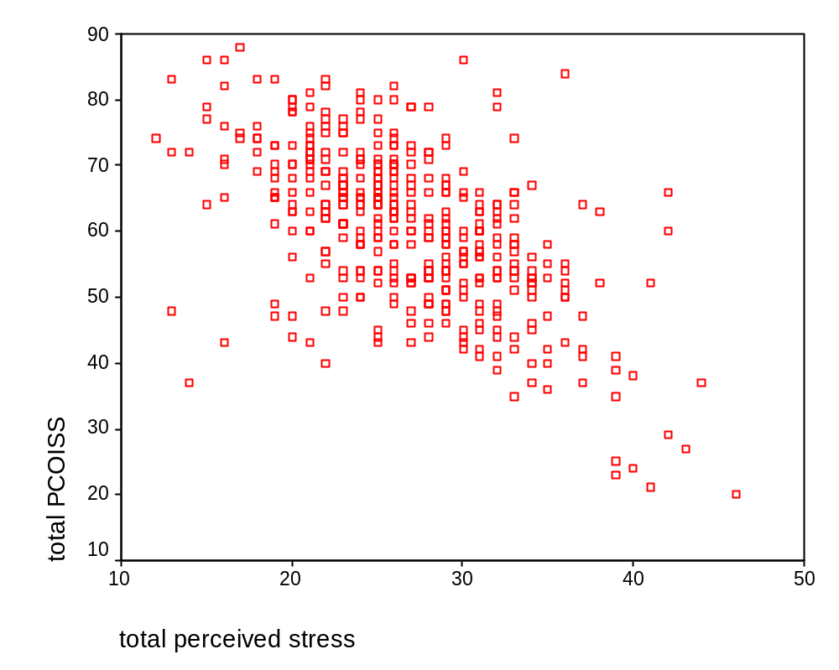
PASTE produces:

GRAPH
/SCATTERPLOT(BIVAR)=tpstress WITH tpcoiss
/MISSING=LISTWISE .

…but it’s quicker to write: GRAPH /SCAT tpstress WITH tpcoiss.
since LISTWISE is the default.

Step 2: Correlation

Analyse
Correlate

Bivariate

Scroll down and highlight variables tpstress and tpcoiss:

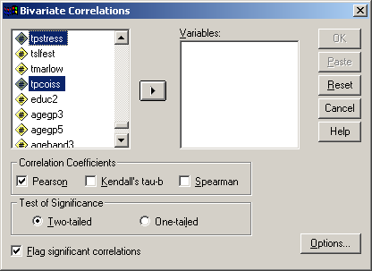

Click on right arrow to place tpstress and tpcoiss in the Variables box:

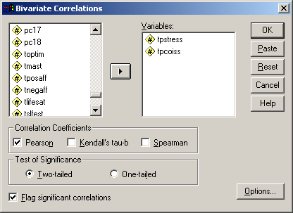

Check that Pearson is ticked in the Correlation Coefficients box and Two-tailed selected in Test of Significance then click on Options

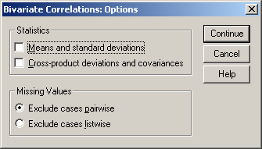

Check in Missing Values box that Exlude cases pairwise is selected then click

Continue

…and OK
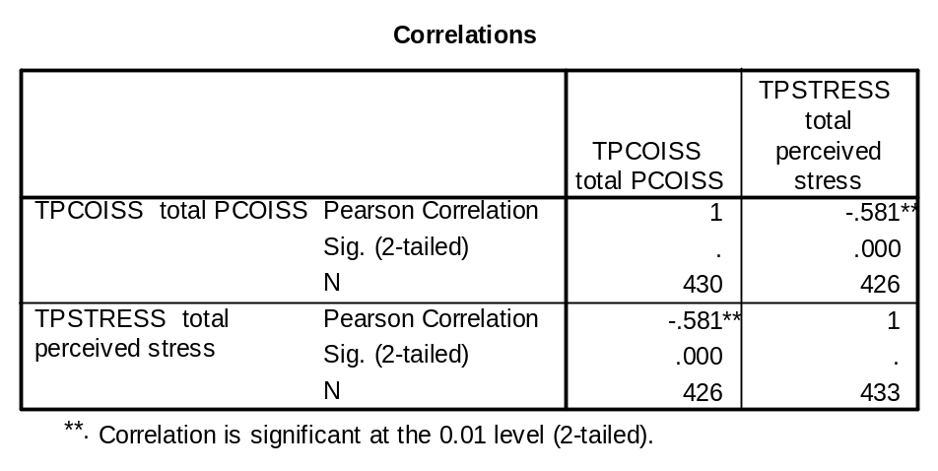

PASTE produces:

CORRELATIONS
/VARIABLES= tpcoiss tpstress
/PRINT=TWOTAIL NOSIG
/MISSING=PAIRWISE .

. . . but it’s quicker to write:

corr tpcoiss tpstress
/pri nos.

. . . since Pearson, two-tail test and pairwise deletion are the default.

The same process can be used to generate a matrix of correlations, but Pallant’s example of a triangular matrix on page 122 has variable names which do not match those in the file (or their labels). However:

Analyse

Correlate

Bivariate

Scroll down, highlight and transfer variables to Variables box:

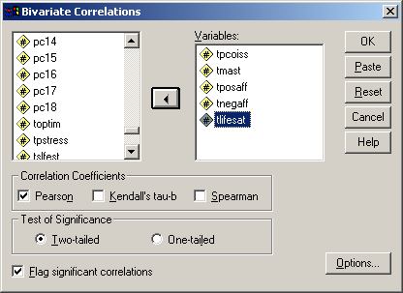

Click on OK
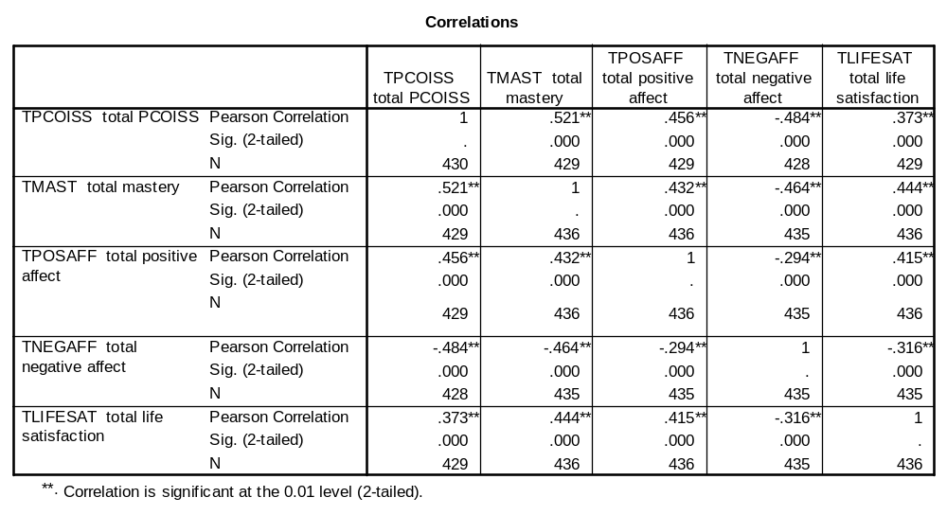
Finally, in only the second example in the entire book, Pallant is forced to use syntax (and indirectly at that) to produce correlations of one set of variables with another set. In the above example, PASTE produces:

CORRELATIONS
/VARIABLES=tpcoiss tmast tposaff tnegaff tlifesat
/PRINT=TWOTAIL NOSIG
/MISSING=PAIRWISE .

…and she has to resort to syntax mode to insert with

CORRELATIONS
/VARIABLES=tpcoiss tmast tposaff with tnegaff tlifesat
/PRINT=TWOTAIL NOSIG
/MISSING=PAIRWISE .

…to produce:
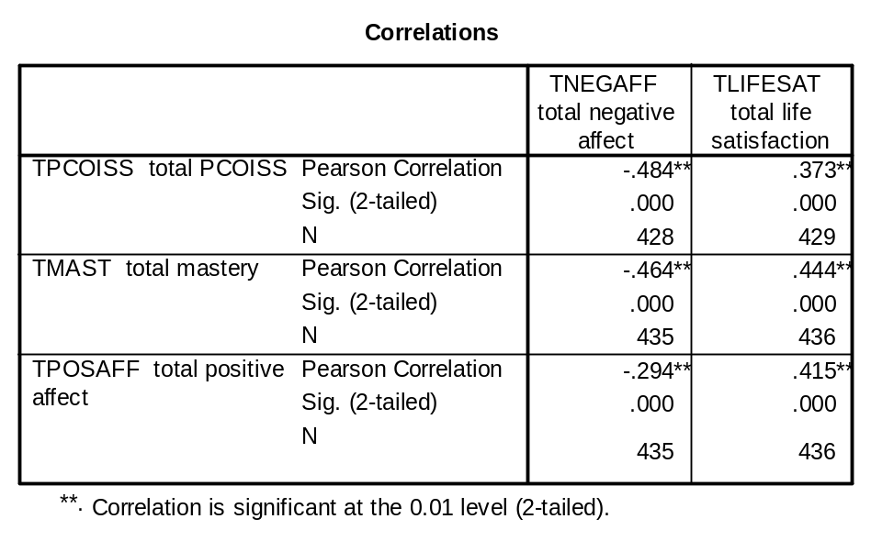
which could just as easily have been produced by:

corr
tpcoiss tmast tposaff with tnegaff tlifesat
/pri nos.

Far better to stick to syntax or at least use PASTE. That way, if you make a mistake you can go (back) to the syntax file, check or amend it and run the job again with [CTRL]+R or RUN. You can’t do this with drop-down menus, except by recalling the dialog box, clicking on whichever set of procedures you were using and then amending the dialog box(es), but it would be nice to have a proper <back button (Undo doesn’t seem to work inside Data Editor).

After all that, I had to buy one of these!


No, it’s not from the Family Planning Clinic: it’s a mouse-pad with a soft wrist-support!
Perhaps I should have used the title Pilgrim’s Progress or Bunyan’s Bunion. I would have used Not Waving, but Drowning! but Sylvia Plath got there first.




Point made?

Trebles all round!

Any questions?

Time for tea…

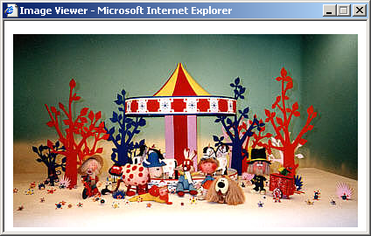

Copyright BBC
…said Zebedee

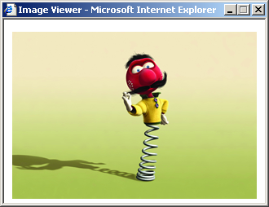

Copyright 2002 Pathé Pictures

…and that’s one thing you can’t do in syntax!

Appendix 1: How SPSS came to UK

1: Tracking down the culprits (by searching the web for their names)

From: John Hall
To: Tony Coxon, David Muxworthy, Andrew Westlake
Cc: 17 others
Date: 25 May 2006

Re: Study Group on Computers in Survey Analysis 1974
Ferreting in the attic the other day I found some scribbled notes on scrap paper for secondary analysis of the Quality of Life in Britain surveys to test the Goldthorpe & Lockwood embourgoisement theory (convergence of consumption, divergence of values). On the back of the scrap paper I found this.
[Pdf file of contents page of Quantitative Sociology Newsletter No. 11 April 1974 announcing the SPSS design conference at LSE and papers by Mark Abrams, Tony Fielding, Colm O’Muircheartaigh and Andrew Westlake]
A few names to conjure with, plus the solution to the original source of the Mark Abrams paper (which later appeared with a different title in Quantitative Sociology Newsletter, and is now posted on the SRA website: see www.the-sra.org.uk/mark_abrams.htm and its link Social Surveys, Social Theory and Social Policy (pdf 31k) to the paper).
For those of you who don't remember me, I'm the guy at the bottom of the page who also organised the SPSS conference at LSE and later set up the UK SPSS Users Group (a precursor of ASSESS). I worked at the SSRC Survey Unit until it closed in 1976 and then at the Polytechnic of North London (PNL) until I took early retirement in 1992. I came to live in France in 1994.
I retain an active interest in social research, being on the panel of judges for the Mark Abrams Prize which I set up in 1986 on the occasion of his 80th birthday and which has been awarded (almost) annually since then by the Social Research Association for the best piece of work linking survey research, social theory and/or social policy: this year is the centenary of Mark's birth.
(see http://www.the-sra.org.uk/documents/pdfs/mark_abrams_prize_flyer_2006.pdf - 401k). I've even agreed to do a turn in November for ASSESS (SPSS Users Group: see http://www.spssusers.co.uk/Events/2006/confprog.html ) to push syntax versus point-and-click, and to demonstrate a few tricks that aren't in the manual.
I have also been busy on the computer and have not only been restoring data (retrieved from the UK Data Archive at Essex University) from many of my past surveys as SPSS portable files, but also converting and updating training materials from my PNL post-graduate hands-on course Survey Analysis Workshop (involving conversions of exercises, handouts and setup files from SPSS 4 for mainframe Vax to version 11 for Windows) for placement in the public domain. Three of these, Introduction to Survey Analysis; Introduction to Tabulation; Naming conventions in SPSS (only the naming one is specific to SPSS) are already posted on:
http://www.marketresearchworld.net/index.php?option=com_content&task=category&sectionid=15&id=74&Itemid=60
but others await a more suitable home as they contain colour text, colour graphics and tabular formats which the site can't yet handle. They include:
SR501 Stage 1; SR501 Stage 2: (step-by-step process from completing a fun questionnaire, entering data and setting up first (data list) and second (variable labels, value labels, missing values) editions of saved files, containing screen dumps of each stage) Derived variables 1a: count (part 1 of a section on the use of count and compute to generate scores: example of attitudes to women from a survey of fifth formers) The Use of Computers in Survey Analysis; Analysing two variables: (general notes not specific to SPSS, but the tables in them are from various releases of SPSS)
SR501 Statistical notes 1-7 & 8-13 were specially written by (mostly) Jim Ring and myself for students on the course, as a supplement to the standard texts referred to in the notes. Jim also wrote the special front end to SPSS-X for students on the course, later extended from Ladbroke House to include other sites which made it much easier to use the Vax, edit and run (and correct) SPSS and to print results (and avoid exceeding disc quotas!) He is still there: j.ring@londonmet.ac.uk
I also have the syllabus for the final version of the course 1991-92 (which includes a mock assessment) and a stack of handouts (eg on multiple response) and exercises which I am still working on to include output from SPSS11 for Windows
Pallant final review; Pallant additional notes are a review I did of Julie Pallant, SPSS Survival Manual for SRA News, the newsletter of the Social Research Association. The review appeared in Nov 2002 ( http://66.102.9.104/search?q=cache:lXQlm9cTcn8J:www.the-sra.org.uk/documents/pdfs/sra_nov_2002.pdf+SRA+%2B+Pallant+%2B+Hall&hl=en&ct=clnk&cd=2 pp 11-12), but the additional notes have yet to be posted on their website. I do not rate it for beginners, or for students in sociology and related subjects, so apologies to the psychometricians and statisticians among you. It's biggest fault is the wretched use of point-and-click throughout, which is useless for those who, like me, are ardent syntax fans.
I also have a complete set of the Quality of Life in Britain surveys conducted by Mark Abrams and myself at the SSRC Survey Unit between 1971 and 1975 (see attached flysheet), together with several other surveys done by me or under my supervision as Director of the Survey Research Unit at PNL, all available as SPSS portable files. The quality of life in France is fine (see attached pic).
If any of you would like copies of any of the above (or information on other items not listed) I would be happy to forward them to you, especially if you can get feedback on ease of understanding and use. However, some of them won't be much use without access as a registered user to a licensed copy of SPSS.
Apologies if any of this duplicates stuff you have already had from me or elsewhere. One of these days I'll get a website together, but I'm fairly new to Windows, SPSS for Windows, MS-Word and mice.

John Hall to Tony Coxon 12 June 2006

Tony

Tracked you down after all these years. I'm doing a turn for the SPSS
users' group ASSESS in York in November and want to stick a bit in at the
beginning about how SPSS got to UK. David Muxworthy says you brought it
over and it was first installed at Edinburgh in 1970.
I've been doing a bit of work here restoring old SPSS files from SSRC Survey
Unit days and teaching materials from PNL. Had to teach myself Windows,
Word and mouse from scratch when I offered to review Julie Pallant's SPSS
Survival Manual for the Social Research Association. Luckily I got SPSS to
let me have an evaluation copy of the Windows version and then they gave me
a free 5-year licence (expires Sep 2007).
I can send you the review and other materials if you're interested.
Also found some old QSN material from 1974 and 1978. Interesting reading!

2: SPSS arrives in Edinburgh, 1970

Tony Coxon to John Hall 12 June 2006-08-31

Excellent to hear from you, even though the route taken by the email was circuitous! In the signature below you will find a selection of addresses, though tony@tighcargaman.com is the preferred one.
I retired from Essex (with relief) in 2002 and moved here to the Isle of Islay (eight whisky distilleries ...)
…………….

Now to the subject matter of the email. As you (and David) rightly say 'twas I that was responsible for bringing SPSS over to the UK ... though I keep quiet about it .

The background is in some ways more interesting than the mere fact. You especially will remember that the late '60s were characterised by governmental protection of home computer industries (EELM/ ICT/ICL of course) and it was virtually impossible for Universities to get their hands on an IBM. Indeed, it was only those with big natural-science clout that did -- Imperial, Newcastle, Edinburgh come to mind. Equally, you will remember that in those days all the interesting new social science software emanated from the US and Michigan in particular and that it a tedious expensive job to adapt for bloody non-IBM machines, so that those Universities with an IBM were in the privileged position to be able to implement/ run such software immediately.

My involvement was that in 1968 I moved from Leeds and took a year as Visiting lecturer at MIT/Harvard Political Science, returning to take up a new post as Lecturer at Edinburgh (now you see the link?). During that time, the first interactive survey package was being developed at MIT (PI: Ithiel de Solla Pool), called ADMINS and also at Harvard, David Armor was developing a general package for the analysis of BOTH survey AND textual data called DATA-TEXT (see my comments at: http://www.qualitative-research.net/fqs-texte/2-05/05-2-40-e.htm ). Armor was pissed off that the Chicago lot had pinched most of his structure and evacuated it of the qualitative component. He was not a happy bunny ... and of course "the Chicago lot" were SPSS!. However, I did take a copy of SPSS back with me from the US to Edinburgh.

The story continues. Edinburgh University had a standing committee for creating a new Edinburgh all-singing, all-dancing Survey Package. Tom Burns sent the new poilitically-naive Tony Coxon as the departmental representative. I couldn't believe it ... Big departments with entrenched positions (Agriculture, Economics ...) were arguing furiously and were unprepared to give an inch. In desperation, I interjected with something like " In the mean time, would it be an idea to use an existing new package until the subtleties of the Edinburgh package are decided? ... it so happens I happen to have a tape with SPSS" ... and that was it. It was agreed, and PLU (with Marjory Barritt -- remember?!-- and David Mux. ) ran with it. Nothing more was heard of the Edinburgh Package!

So there you have it!

Incidentally, I'm still persevering with MDSX -- now in a Windows incarnation. Have a look: www.newmdsx.com

Tell me more about yourself and your developments.

John Hall to Tony Coxon and David Muxworthy, 16 August 2006

I've got quite a long way with a draft presentation for the November ASSESS meeting in York. One paragraph reads as follows:

SPSS was originally written in Fortran for an IBM by three postgraduate students. It came from Chicago to Edinburgh in 1970 via Tony Coxon and was implemented at ERCC (one of the few places with an IBM) by David Muxworthy and Marjorie Barritt (thereby scotching university plans to commission a survey processing facility at great expense from scratch) and when first installed was reputedly called more times than the Fortran compiler. Conversions to ICL followed later, but those with CDC and DEC machines got SPSS sooner.

Is this accurate and complete? Please amend to suit and return to me.

David Muxworthy to John Hall 16 and 19 Aug 2006:

As I understand it SPSS first appeared in 1968. The first UK installation was indeed at Edinburgh RCC in 1970, brought in on Tony Coxon's recommendation. I'm not sure about plans for commissioning something from scratch. I'll poke about in my loft to see if I've anything to jog the memory.
Norman Nie and Dale Bent were political science postgrads at Stanford in the late 1960s and, fed up with the 'put a 1 in column 72' type command language of the programs at the time, they devised a language that a political scientist would want to write to specify an analysis. They scraped together some funds and hired Tex Hull to help with coding the program, which was in Fortran IV for the 360. I
think Tex must have been finishing his first degree at Yale or maybe a Masters at Stanford, but I'm not sure what he did at Stanford. Norman and Tex both moved to Chicago, Norman to the National Opinion Research Center, Tex to the Computing Center. (Norman was originally from St Louis, Tex from Minnesota). Dale went back to Alberta and, apart from having his name on some of the manuals, dropped out of SPSS.
People got to hear about the program, which was superior in user interface to much that was available at the time, and requested copies. This led to Patrick Bova, a librarian at NORC, being hired 25% of his time to act as distribution agent and Karin Steinbrenner being hired as full time programmer. When I visited Chicago in the summer of 1972 this was the total staff. I thought I was going to a large software house. It was surprising to find it not much bigger than a one man and a dog in a bedroom outfit (at that time at least). Tex acted largely as advisor but was busy as associate director of the computing center.
As I remember it, Jean Jenkins was hired as programmer later in 1972 or in 1973. She was certainly around at the SCSS planning meetings in the summer of 1973. The program was so successful that NORC became wary of losing their non-profit status and strongly encouraged Norman to form a company and move out. This happened sometime between 1974 (when I worked with them at NORC) and 1977 (when they had moved to an office block in downtown Chicago).
In Edinburgh the program grew to be so popular there were demands to move it to the ICL system 4 and later the ICL 2980, the IBM having been removed by higher authority. This led to PLU organising
conversions to some other platforms in UK universities, notably the ICL 1900. SPSS themselves arranged conversions to other series, notably the CDC 6600 at Northwestern University, just up the road from Chicago.

(JFH: …..thereby scotching university plans to commission a survey processing facility at great expense from scratch.)
You were quite right. Attached are the relevant minutes of the Edinburgh committee looking into this. These appear to be the only references to SPSS - much of the committee time was spent on building up maths and engineering software. The names won't mean anything to you but will revive memories (good or bad) for Tony.
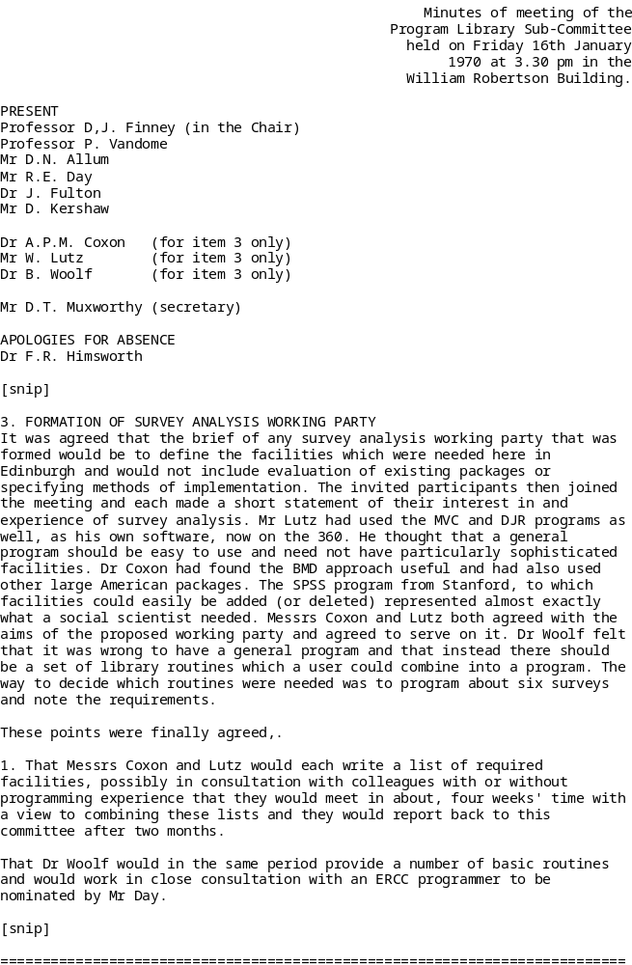====
NOTE: The DJR program was a locally written partial survey program in Atlas Autocode which required the user to complete it, still using Atlas Autocode.
===============================================================================

Minutes of meeting of the
Program Library SubCommittee
held on Friday, 24th April
1970 at 3.30 p,m. in the
William Robertson Building.

PRESENT
Professor D.J. Finney, (in the Chair)
Professor P. Vandome
Mr R. E. Day
Dr J. Fulton
Mr D. Kershaw

Dr A.P.M. Coxon (for item 3 only)
Mr C.L. Jones (for item 3 only)

Mr D.T. Muxworthy (secretary)

APOLOGIES FOR ABSENCE
Dr F.R. Himsworth

[snip]

3. REPORT FROM SURVEY ANALYSIS WORKING PARTY
APOLOGIES FOR ABSENCE: Mr W. Lutz Dr B. Woolf
Dr Coxon reported that he had met Messrs. Jones and Lutz several times since the working party was set up and that Mr Lutz's notes, circulated to Members of the Committee, incorporated some suggestions from, the other two. There had been broad agreement between them and they had differed only on details. Messrs Coxon and Jones had tended to think in terms of SPSS possibly augmented and with a preprocessor for binary-punched data as the best solution.

It was reported that the Centre had bought a copy of the SPSS program and were very pleased with it. The manual however was unsuitable for general use.

The Committee noted Dr Woolf's proposed open meeting of survey analysis users and decided that Dr Woolf should be requested to make documentation available before the meeting. Dr.Woolf's Mark I survey program should be generally available in October.

The Committee thanked the working party: they had contributed to a major advance in survey program facilities at the Centre. It remained for the Centre to prepare a simpler manual and to consider transferability to the System 4 and for all users to obtain working experience of SPSS. Requests for extra facilities should be referred to Mr Muxworthy.

[snip]
===============================================================================
Note: The SPSS manual referred to predated the McGraw-Hill version and was a thick loose leaf set of duplicated typescript sheets.
===============================================================================

Appendix 2: Syllabus for SR501 - Survey Analysis Workshop

The Polytechnic of North London
Faculty of Environmental and Social Studies

Post Qualifying Scheme

Level: Postgraduate (15 points at CNAA Master level)

Module Number: SR501

Module Title: Survey Analysis Workshop

Location: Policy Studies and Social Research

Module Convenor: John Hall (Director, Survey Research Unit)

Study Requirement:

6-9 hours per week of which 3 hours will involve timetabled classes (normally 1 hour instruction followed by 2 hour workshop/discussion). 3-6 hours should be used for private study and/or keyboard experience and follow-up exercises.

Module Objectives:

By the end of the module you will:

a) acquire practical and intellectual skills in data management and statistical analysis of single variables (univariate), two variables (bivariate) and many variables (multivariate)

b) be familiar with the language and logic of data analysis (with an emphasis on explanation as well as description) and the interface between theory and data

c) be able critically to assess published reports which include analysis of survey and similar data

- become sufficiently confident and proficient to tackle your own research projects in college, on placement and in employment, or as a basis for more advanced methods

e) understand how to code data from questionnaire surveys to a standard data layout and how to enter them into a file

f) understand how to define data and associated dictionary information for entry into SPSS-X and save this in a system file for future use

g) understand how to prepare and use supporting documentation

h) acquire a working knowledge of the Vax control language, VMS, and the screen editor, EDT

j) enjoy a distinct advantage in the employment market

- discover that survey analysis is fun and you can do it!

Module Assessment:

The course will be assessed by three components:

Component 1: Data Capture and Documentation (20%)

Component 2: Analysis and Report (60%)

Component 3: Descriptive and Inferential Statistics (20%)

The first assignment will be to select from a British Social Attitudes Survey a topic of interest to yourself, to select questions relevant to your topic, and to use SPSS to read the relevant survey data and construct a "system file" with missing value specifications, labelling, and a frequency count, together with appropriate user-documentation. (20%)

The second will be to conduct an analysis of your chosen topic and to write a short report on your findings. (60%)

The third will consist of a set of exercises involving data management and descriptive and inferential statistics, to be designed, conducted and interpreted within a limited time. (20%)

All work for assessment must be submitted (preferably typed) double spaced and single sided on A4 size paper including SPSS output which must be burst before stapling and clearly marked with your correct assessment number.

For components one and two, you should prepare an outline proposal identifying your research topic and listing the variables (and related questions/items) you propose to use and your initial ideas for the line of enquiry you intend to pursue. This should be submitted on the official proposal form not later than 4pm on Friday 13th March 1992.

Assessment date(s):

Component one must be submitted not later than 4pm on Friday 27th March 1992

Components two and three must be submitted not later than 4pm on Friday 19 June 1992

All three components must have been submitted before any marks can be considered by the Examination Board.

There is no provision for extensions. Work submitted late must be accompanied by a statement of the reason(s) for lateness and, if appropriate, copies of supporting evidence.

Study Programme:

This course is heavily skill-based, but with an emphasis throughout on logic and professional standards. Statistics as such are not taught, although the procedures for producing them will be used and their rationale and results explained (in non-mathematical language!)

Teaching programme

Block I From questionnaire to SPSS-X system file (Norušis 1990 Ch 1-6)

1 Data matrix. CASES, VARIABLES, VALUES. Coding of questionnaire data. Levels of measurement. The use of computers in survey research. Intro to Vax computer. Use of computer terminals and printer. Simple VMS commands. Special keys. Files on the Vax. Demonstration of SPSS-X. Creating and editing files with the screen editor EDT. Entering questionnaire responses into a data file.

2 Intro to SPSS-X. Basic structure of SPSS-X language; commands, sub-commands and specifications. Using SPSS-X to read an external data file. Records, fields, formats. Naming variables. Dictionary, active file. Displaying contents of dictionary and active files.

3 Extending a dictionary. Labelling variables and values. Missing values. Saving an external system file.

Block II One Variable (Norušis 1990 Ch 7-8,10)

4 Describing data. Univariate distributions. Graphical representations. Retrieving an external system file. Selecting variables for analysis. Frequencies for nominal and ordinal variables. General and integer mode; treatment of missing values; absolute, relative, adjusted frequencies. Barcharts. Utilities for printing

- Frequencies for interval variables. Cumulative percentages. Univariate statistics. Measures of central tendency and dispersion. Histograms, percentiles. Condensed format for variables with many values
.
- Data transformations. Changing the coding scheme. Derived variables. Selecting cases for analysis. Conditional frequency distributions.

Block III Two variables (and sometimes three) (Norušis 1990 Ch 9,11,13)

7 Joint frequency distributions for two variables. Contingency tables. Dependent and independent variables. Rules for percentaging. Specifying cell contents. Percentage differences (epsilon).

8 Introducing a third variable. Conditional contingency tables. Controlling for test variables. Elaboration.

9 Handling multiple response questions. Frequencies and contingency tables using multiple response.

10 More transformations. Creating simple scales. Comparing averages across different groups of cases.

Block IV Testing hypotheses (Norušis: 1990 Ch 14-16,18-23)

11 Testing the differences between means from samples. The t-test. One way analysis of variance.

12 Testing for statistical independence of variables in contingency tables; the chi-square test. Observed and expected frequencies; residuals; significance levels.

13 Plotting data on scattergrams. Correlation and regression.

Presentation of findings.

14 The final session is given over to brief presentations by individuals or groups of their experiences and findings, and to course evaluation.

Essential Reading:

Norušis M J The SPSS Guide to Data Analysis for Release 4
(ISBN 0-923967-08-7: SPSS Inc., 1990)

Further Reading:

Norušis M J, SPSS Introductory Statistics Student Guide
(ISBN 0-923967-02-8: SPSS Inc., 1990)

Norušis, M J SPSS Base System User's Guide
(ISBN 0-918469-63-5: SPSS Inc, 1990)

Technical Report on British Social Attitudes Survey
(Social and Community Planning Research, annually).

British Social Attitudes (Gower, annually)

Survey Analysis Workshop: statistical notes
(Survey Research Unit, PNL, 1988)

Learning Materials:

Facsimile questionnaires and other material from the British Social Attitudes survey.

There is some PNL Computer Services documentation on SPSS-X and the Vax and its operating system, but most of the course relies heavily on extensive documentation by John Hall.

As well as your own exercises on the 1989 British Social Attitudes data, Marija Norušis' book includes some on the 1984 General Social Survey (National Opinion Research Center, Chicago). This data set has been installed on the Vax as a SPSS system file ASS:GSS84.SYS and access is open to any Vax user.
Component 1: Data Capture and Documentation (20%)

In the following exercise, think in terms of variables for analysis, especially dependent and independent variables, bearing in mind that the second component will involve using the resultant system files for analysis and writing a report.

Choose a topic from the 1989 British Social Attitudes Survey. Select at least 10, but not more than 20 variables, including attitudes and beliefs, and items which might affect variation in your dependent variables (eg attitudes to private education or NHS facilities could well be affected by experience or usage of such provision). Appropriate demographic variables should be included, as should variables from both interviewer and self-completion sections of the questionnaire. You may interpret "variable" as sometimes comprising more than one data item (eg for attitude scores or for multiple response questions)

1. Using SPSS-X, create a system file containing only those cases necessary to your analysis, plus all your selected variables, together with missing value specifications and appropriate variable and value labels. Include a document.

2. Submit the final version of your SPSS-X command file, together with your user documentation (if any).

3. Display variable labels and document. Produce frequency counts in general mode for all variables in your file.

The data are on file ASS:BSA89.DAT and there are 23 records per case.

The coding for open-ended questions and for the letter-coded income questions is not given on the questionnaire. See Brook, Taylor and Prior, Technical Report, SCPR, 1990, in Library if you need these.

Some questions are capable of more than one answer (multiple response) and special facilities are available for analysing them. If you wish to use such questions, check first, as the coding schemes vary in complexity (eg 63b, 84f (open-ended) 27b, 33a-c, 41b-d, 67, 907b, 914 (precoded)) and you may need help.

There are no multiple response items in the self-completion questionnaire for Version A. Version B has them in qq 4, 7 , 15.

In general, single column fields have 8 (DK) 9 (N/A) as missing, and two column fields 98 and 99. Some variables have values 0 or -1 which need to be treated as missing. Codes 7 and 97 tend to be used for "Other uncodable" and should be treated as missing. Separate documents are supplied giving details of income codes and of data for additional variables entered on record 23.

Printing of SPSS listing files is by default on A4 at Ladbroke House, but to print your SPSS command file on A4:

$ LPRINT __________.SPS

Component 2: Analysis and Report (60%)

Write a report of not less than 2,000 and not more than 3,000 words (excluding figures and tables) to cover the following:

Introduction to the topic chosen and variables selected for your first component, including any preliminary hypotheses or ideas you had about what you expected to find or prove (or disprove) and referring to any relevant literature.

What analyses you performed on the data and why.

What your main findings were.

Methodological comments and insights.

Use the SPSS system file you generated for your first component, but amend any errors or omissions you may have made. Feel free to use any additional variables you think you need (e.g. for multiple response questions). Try to keep your final analysis simple by restricting yourself to a few key variables, if necessary by constructing scales or summary types.

There is no need to copy tables by hand into your report: just hand in your final selection as SPSS output, making sure that the tables or figures are clearly numbered and titled. You must also clearly indicate in the text which table or figure you are referring to (e.g. See Table 4 or Table 10 here) Tables do not count towards the 1,500-2,000 words needed in the report. Do not include more than ten tables.

Component three: Descriptive and Inferential Statistics (20%)

For this component you will have to design, execute and interpret statistical analyses using SPSS-X. The format will be that of an examination paper which you will be required to complete within a limited time. The paper will be distributed on 21 May 1992.

SPECIMEN ONLY 1992 format, but using 1986 data instead of 1989

Component three: Descriptive and inferential statistics (20%)

You may use abbreviated forms of SPSS-X commands and subcommands. All answers to be on A4 paper, including SPSS-X output, burst, with banner pages attached. No answer to be longer than two A4 sides.

File ASS:NOPROT.SYS contains the following variables from the 1986 British Social Attitudes Survey:

SEX REGION PARTY EDQUAL V2018 V2019 V2020 V2021 V2023 AGE

File ASS:XMAS.SYS contains details of numbers of injury causing accidents in 41 police authorities in Dec 1986 INJ86 and in Dec 1987 INJ87

Answer ALL questions

- - - - - - - - - - - - - - - - - - - - - - - - - - - - - - - - -

Section A (Technical)

Question A1

Using file ASS:NOPROT.SYS write a command file in SPSS to perform the following analysis. Construct a score NOPROT with a range of 0-20 from items v2018 to v2023 and recode it with four groups (0-3)(4-6)(7-9)(10-20) into NOPROTGP. Recode AGE into AGEGROUP (18-29, 30-44, 45-59, 60+) and EDQUAL into EDGROUP (GCE O-level and above, CSE2-5 and none) and leaving out foreign qualifications. Write appropriate variable and value labels and take account of missing values.

Produce the following output:

frequency counts (in general mode)

NOPROT with a histogram overlaid by a normal distribution; the mean, standard deviation and standard error; the lower and upper quartiles and the median.

NOPROTGP EDGROUP AGEGROUP

crosstabs (with row percent and chi-square)

Dependent variable: NOPROTGP (column variable)
Independent variable: SEX (row variable)
First order test variable: AGEGROUP
Second order test variable: EDGROUP

means (in crossbreak format)

Dependent variable: NOPROT
Independent variable: SEX
First order test variable: AGEGROUP
Second order test variable: EDGROUP

t-test

Dependent variable: NOPROT
Independent variable: PARTY (Labour vs SDP/Lib)

oneway (with descriptive statistics and tukey range check)

Dependent variable: NOPROT
Independent variable: REGION

Question A2

Using file ASS:XMAS.SYS write a command file in SPSS to find the mean number of injury causing accidents each year and plot the 1987 figures against the 1986 figures in regression format.

- - - - - - - - - - - - - - - - - - - - - - - - - - - - - - - - -

Section B (Interpretation)

Question B1

Write a short account of the effects of sex, age and educational level on anti-protest attitudes using either the crosstabs output or the means/crossbreak output.

Construct an appropriate summary table using either percent "Definitely not allow" or mean anti-protest score.

Question B2

Choose TWO of the following inferential statistics topics and, from the SPSS output for section A, explain what the test is, what the technical and statistical terms are and why the test was used for these data.

What do the results tell you?

chi-square (but not Likelihood ratio or Mantel-Haenszel)

t-test

oneway analysis of variance

linear regression

(Draw an approximate regression line on the plot and comment generally on your results. What would be your best estimate of the number of injury causing accidents in 1987 for an authority which had 300 in 1986?)
Guidelines for preparation of assessed coursework

Component 1: Data capture and documentation (20%)

This component should consist of two SPSS command files; the first will be your initial file to include:

data list
missing values
variable labels
value labels
save

The second SPSS command file to include all the commands and specifications (document, recode, compute, select if, if, save) used for documentation, data transformation or construction of derived variables. These can be produced using:

$ LPRINT _________.sps

Finally, you should submit one SPSS listing file with:

set length 72 width 80 print off.
title ........(to include your student number)
get file ......
display labels.
display document.
frequencies ...(in general mode for all variables except those with more than 20 values, e.g. age)

Remember, one criterion for this component is to enable someone else to understand what you are doing and to carry on where you leave off, or work on your material when you are not there. You may submit notes in addition to your SPSS output if you wish, but these should not cover more than 2 sides of A4.

Component 2: Analysis and Report (60%)

This should be submitted double-spaced, single-sided (preferably typed) on A4 paper. SPSS output containing tables and figures for your report can be appended to your text. Use:

set length 72 width 80 print off.
title ...........(to include your student number)
subtitle ...........(Table/Figure number)

Component 3: Descriptive and Inferential Statistics (20%)

To be run as one SPSS job with:

set len 72 wid 80
title (to include your candidate number)
subtitle (as appropriate)
The Polytechnic of North London
Faculty of Environmental and Social Studies
School of Policy Studies and Social Research
Survey Research Unit

SR501: Survey Analysis Workshop Assessment 1991/92

- - - - - - - - - - - - - - - - - - - - - - - - - - - - - - - - - - - - - - - - - - - - - - - - - - - - - - - - - - - - - - -
Name: Student ID Number:
- - - - - - - - - - - - - - - - - - - - - - - - - - - - - - - - - - - - - - - - - - - - - - - - - - - - - - - - - - - - - - -
Vax Username: Password:
- - - - - - - - - - - - - - - - - - - - - - - - - - - - - - - - - - - - - - - - - - - - - - - - - - - - - - - - - - - - - - -
Data Set:
- - - - - - - - - - - - - - - - - - - - - - - - - - - - - - - - - - - - - - - - - - - - - - - - - - - - - - - - - - - - - - -
Analysis Topic:
- - - - - - - - - - - - - - - - - - - - - - - - - - - - - - - - - - - - - - - - - - - - - - - - - - - - - - - - - - - - - - -
Working Title:

- - - - - - - - - - - - - - - - - - - - - - - - - - - - - - - - - - - - - - - - - - - - - - - - - - - - - - - - - - - - - - -
Variables: (Give question(s) and data position(s))

Dependent

- - - - - - - - - - - - - - - - - - - - - - - - - - - - - - - - - - - - - - - - - - - - - - - - - - - - - - - - - - - - - - -
Independent

- - - - - - - - - - - - - - - - - - - - - - - - - - - - - - - - - - - - - - - - - - - - - - - - - - - - - - - - - - - - - - -
Summary proposal

- - - - - - - - - - - - - - - - - - - - - - - - - - - - - - - - - - - - - - - - - - - - - - - - - - - - - - - - - - - - - - -
Signed: Date:

To be submitted by 4pm on Friday 13 March 1992

Appendix 3: Forensic notes

(unedited, in order of surveys tackled, direct from logs kept during processing and restoration of files retrieved from UK Data Archive and attempts at restoration using SPSS for Windows)

1: Fifth form survey 1981 (processed Oct 2002 and Oct 2004)

2 Oct 2002 Converted fifth.dat from Essex WP6.1 to MSWord *.txt format as fifthdat.txt

Converted fifth.sps from very old SPSS syntax to SPSS11 for Windows syntax (mainly input format changes to read as alpha and convert to numeric and changes in value labels to get rid of brackets and replace with single primes) Ran a few test jobs on sexism and other scales (not saved) and left as initial *.sav file with no derived variables. Currently saved as fifthx.sps and fifthx.sav on c:\jfh\fifth and backed up on floppy.

Some multiple response specifications written. Scaled variables were initially in short jobs for teaching purposes for use one at a time. Have to watch problem of permanent recoding of items used in batteries to generate attitude measures: might be better to save derived variables separately using save out …/keep…. and merge files at a later stage.

References:

Paul Ahmed, Harriet Cain and Alan Cook Playground to Politics: a study of values and attitudes among fifth formers in a North London comprehensive school Report on 2nd year project for BA Applied Social Studies (Social Research) Polytechnic of North London 1982

John Hall and Alison Walker, User manual for Playground to Politics: a study of values and attitudes among fifth formers in a North London comprehensive school Survey Research Unit, Polytechnic of North London 1982 (mimeo 40 pp – codebook, questionnaire, coding notes)

Note: Latest version is SPSS portable file fifthx.por (Feb 2004, 107kb) now saved in sub-folder fifth in folder PNL_SRU in desktop

Need to generate a flysheet for this study as per QoL, Trinians etc

Also need variable and value labels for spread data on card 4.

JFH 16 Oct 2004

2: Quality of Life in Britain: 1st pilot survey March 1971 (processed Jan – Feb 2004)

Resuscitation attempt 15-16 Jan 2004

Data received from Essex as a concatenation of SPSS setup files and data files, although the survey was originally deposited as ready to use SPSS saved files.

In order to recreate these files it was necessary to be the person who created the original data (me!) and to know why and how an original set of multipunched Hollerith cards (2 per case) was exploded into 6 lines of data per case (multiple response questions and also more than one variable per column!!) and use of upper and lower zones on the cards as well as digits 0-9.

This was an absolute nightmare as SPSS syntax has completely changed and the data had to be rewritten using data list and different conventions for reading alpha data then converting it to numeric. It has taken the best part of two days.

Most of the data seems to have been captured with most of the labelling and missing value info, but there is a lot of checking and tidying up to do. In 1973 SPSS was very primitive and everything is in upper case (including value labels) with most variable names in the VARxxx to VARyyy convention.

Much of the data was first read in as single column alpha to circumvent the use of upper and lower zones (‘+’ and ‘-‘) and of multipunching in the same column, then converted to numeric and then (if necessary) reassembled as multicolumn numeric. Sounds horrifyingly cumbersome but is actually quicker if you know what you’re doing. Later the alpha variables will be dumped and the remaining variables reordered to follow the original questionnaire order, apart from the multipunching. These can be left as spread out data on records 3 to 6 and a file of multiple response specifications can be created from which sections can be copied into analysis runs.

17 Jan. 04

Couldn’t get SPSS to read the data from d247 yesterday, so copied contents of data file into spss job and ran with:

begin data
…..data set on 6 cards….
end data.

This worked.

Unearthed original documentation, including interviewer instructions, data layout info and Users’ Manuals (SSRC reprographics request 1973), together with PNL printout of labels (18 Nov 77). Manuals include raw frequency counts for all variables in the original file.

Time taken in trying to use original SPSS jobs probably might have been better spent starting from scratch using more recent facilities such as lower case letters and sequential variable naming with other than VARxxx TO VARyyy.

Positional variable naming retained.

Gradual piecemeal restoration of file, but frustrating. SPSS frequency counts don’t appear to allow codes and labels on same table. Must investigate this. Awkward work, but frequencies so far seem to tally with original. Main problem is checking which code values have been or need to be declared as missing

Value labels

Lower case letters introduced in value labels as these are neater. Also some original labels were written up as two blocks of 8 characters to keep output reasonably clear and tidy with SPSS then limits of 20 characters (only 16 printed as column headers). These restrictions no longer apply, except when using mult response.

Variable labels

Later file construction conventions at SSRC and PNL mean that some of these do not comply for easy relating to questionnaire )eg Q8 Anomy scale. These should be changed to include question number at beginning plus some indication of content of question.

Thus: VAR124 ANOMY MEASURE Q8A might usefully be changed to

VAR124 Q8a Most people will go out of their way or longer as SPSS no longer limited to 40 characters, eg VAR124 Q8a (Anomy scale) Most people will go out of their way

Perhaps a better example would be VAR144 STATE OF HEALTH changed to
VAR144 ‘Q.12 Your general state of health’.

Variable names

For the moment I’m leaving them in VARddd format, but it would save typing for analysis if they were in vddd format. That’s 2 key depressions saved for every variable typed, and they can be done in lower case as well.

Gone through checking and deleting alpha columns whose multipunched codes were spread out on cards 3-6.

Next check that frequencies for converted variables from alpha Vxxx to numeric VARxxx are a) all present and b) the same as per original user manual. If so the alpha Vxxx variables can also be deleted. Then got to find a way of saving the file with all the variables back in the original order. Some converted variables need to be kept in order to generate derived variables such as duration of interview (in minutes). Some VARxxx variables can be renamed in the case of common demographic variables such as SEX AGE etc. These will be kept together in a block at the end of the file to make analysis easier.

Some codes grouped on original (because of very small numbers) have been left ungrouped here eg VAR144 where only 2 respondents gave their health as “poor”. Also SPSS does not print totals for empty categories (or at least I haven’t found a way to force this). Thus the frequency count for complete dissatisfaction with health (Code 0) has no respondents, but should have been included in the table. Same problem with satisfaction with friendships and police and courts (VAR162 and VAR169): table is truncated as there are no R’s on scale point 1.

Manual has 54 R’s on 0 code for job satisfaction (VAR149) but this file only has 2. Check that this tallies with numbers with jobs (either self or partner).

Can’t get SPSS to reorder variables in the file using save out filename /keep varlist

Just managed to do this by copying file to drive a: then using a get file command to retrieve it with /keep etc and save the resultant file to QL1 area on c:

One or two missing values added, but the whole of the spread out multipunches needs to be looked at again in the light of practice developments at PNL and later versions of SPSS. The best thing would be a complete set of mult response specifications kept on file for downloading into particular SPSS jobs, bearing in mind that there are limits on the number of implied variables than can be used at any one time. It is also better for analysis to use separate codes for each response and use these for labelling the first variable in a mult response job. (SPSS only looks at the first variable in the list for value labels) In binary mode the variable labels need to be clear as to the nature of the variable. Unless duplicate sets of mult response variables are kept on file (wasteful) either convention will require recodes to spread binary 1’s out to 2,3,4 etc or to recode 2,3,4 etc to 1 for binary analysis. This will not be a problem, but will be time consuming. Anyway that’s a job for later!

I’ve been at this all day today, but at least I’ve cracked it for now.

Also had to generate intermediate variables to get alpha coded to numeric as (convert) doesn’t work if recode is into original vars.

24 Jan 2004

Ran off a set of overall satisfaction items to send to Roger Jowell at NatCen to compare with their new European stuff.

2 February 2004

Checking over versions for deposit at Essex. Most further work will involve changing case of letters in labels. Missing values added for qq9-23.

Errors found: (amend manual accordingly)

page variable amendment

5 Var144 there are 2 cases with code 1 (Poor) and 21 with code 2 (Fair) total = 23 Var149 there are only 2 cases with code 0, but 52 blank (not asked) in data
9 var230 summary only: age is coded as actual years
16 var306-318 Labels not clear: change
20 var365 180 should be 179 (1 code blank in data)
var374 174 should be 173
var368 90 should be 89
21 var420 to 427 should be corrected to var421-428 in manual.
28 566,576 NA (No) declared as missing, but could be recoded and used as “No”

No var232 or 233. Multipunched? Where now? Spread out on 250ff I think.

Checked means and correlations for Abrams & Hall paper. They’re not the same, so tried using a weighting procedure, but they’re still not the same. God knows where we got these from. Could have been LSE or also RSL. Doesn’t make much difference to the rank order of values, but it’s a bit worrying all the same.

3: Quality of Life in Britain: 2nd pilot survey Oct-Nov 1971 (processed Jan – Feb 2004)

Latest system file: qlukpilot2.sav

Same procedure as for QL1, with same problems for alpha recodes. Much quicker this time, but tedious having to make manual alterations to variable lists to resolve it.

File saved in original format with all capital letters and VARddd except where edited manually, but SPSS case insensitive for varnames..

There’s a weight statement at the end which gives whole sample 2 but London 3. Not sure whether to put this in or not. Have put it in as weight

11 Feb. 04

Added spread out multipunches from card 3. Put all variables in card order. Computed sdscore and anomy. Computed weight = 2 for every case except 3 for London. Run off unweighted frequency counts for all variables. Can’t get Adobe to print manual on single pages, so son Richard has printed off pp 15-92 and will post. Need to check frequency count against manual. Then this one can be put to bed as portable file. Done

There do not appear to be any derived variables other than sdscore and anomy in the original setup files, so it may be worth creating some standard variables such as sex, age, class etc plus a set of overall satisfaction ratings to tally with the same variables eg life, health, job etc in the other surveys. The latter are all on 1-7 scales for comparison with ISR studies by Campbell et al. Codes on the items in the sd scale have been reversed so that 7 = high/good for scaling purposes.

Saved to dsk:e as ql2ukpilot.por

All frequencies to be checked against manual pp 19 ff Done, but nearly went blind comparing spo with pdf files

All rating scales have codes 8 and 9 as missing, but in the manual these seem to have been condensed to 9. The combined missing totals tally OK.

Some NA and DK codes don’t tally, though the totals missing do tally. This may be because of later logical checks. Usually this amounts to only a single case. It may also be due to the way DK was coded. Check that this was consistently 9 or was sometimes 8. Not worth it: leave

Dollar signs in value labels need changing to £ signs. Done

Card 1 frequencies OK apart from comments above. Missing values won’t affect any analysis as they’re all declared anyway.

Var272 week of interview: code 5 = ??? Too many to be missing, so could be Nov 7-13. Have entered this as ??Nov 7-13??

Var273 in output is grouped as var/10 for conurbations, but manual has full list on p.23 (also in sampling appendix) Have generated var273 as var273*10+var274 and put labels in to match manual.

Reversed items from semantic differential scales have no missing values (because they were outside the original command having been converted. A new missing values statement should sort it, but the data have code 8 whilst manual has 9 for DK. Done

No value labels on var252 ff (be careful as codes are reversed on alternate items to retain scaling properties) . Done

What happened to var259 (newspaper readership)? . Done

Sdscore and anomy are simple sums of items in their respective scales, but strictly speaking they need reducing by the number of items in the scale to yield a true zero point. However, I’ve left them in their crude state for now.

For Essex, strip out derived variables, expand var273 to full borough codes (? Add labels?) so that data set matches manual as published. Done

First edition of file for Essex is qlukpilot2.por with all variables from case to var399 plus four additional variables, sdscore, anomy, conurb and weight. Partial setup file ql2newvars.sps for additional variables and labelling, including additional value labels for variables using response cards A, B and C. No further work envisaged on this file for some time, but this will involve changing all labelling to lower case, and generation of standard sets of derived variables. Also an unweighted frequency count for all variables ql2freq.spo Done

Lot of piddling fiddly work on some incomplete labels and the odd missing value, but I think it’s all there now for the first release. Erratum on data layout sheet: var264 and var265 (sex and age group) transposed. Age and class ditributions very even, probably because of quota restrictions. Should the data be reweighted to take account of this, even though it’s a quota sample?

4: Attitudes and Opinions of Senior Girls – Feb 1973 (processed Jan – March 2004)

There was no information on the questionnaire which could be used for data layout and data-preparation (it would have made for cluttered presentation and in any case there was no room!). The questionnaires were manually coded in-house by Eleanor Clutton-Brock and the data transferred to (?pre-printed?) coding sheets (can’t remember unless there’s an example extant), then punched on to 80-column Hollerith cards (3 per questionnaire).

This makes it difficult to work direct from the questionnaire when performing data management and analysis, so if there is no data guide sheet, then one needs to be produced. Otherwise variable labels need to be checked to ensure the question number is included.

Most of the questions were single response pre-coded on the questionnaire and these were single-punched on cards 1 and 2. Codes for some multiple response questions were multipunched, but facilities for handling multi-punching of columns were not available in SPSS at the time, and so codes for multiple response questions on readership of newspapers and magazines were spread out and single-punched on card 3 for input to a very early version of SPSS. Some data seems not to be present ( Questions 6, 7 and 8: ‘O’ and ‘A’ level subjects taking/taken, and pupil’s interest therein. This seems odd, but unless any other documentation comes to light, we must assume the data lost or the questions not coded in the first place.)

Restoration of files

Although the final version of the SPSS saved file was submitted to Essex on a mag tape, this has not been preserved. A later version kept at the Polytechnic of North London seems to have suffered the same fate, as the tape archive available only goes back to 1986. This a great pity, as export and import would have saved a great deal of time and tears. The author is not yet completely au fait with the Windows version, but has managed to recreate a new saved file from the original setup files supplied by Essex.

** Mark Abrams and John Hall Attitudes and Opinions of Girls in Senior Forms
SSRC Survey Unit, March 1973 (mimeo 20pp)

[NB Author hasn’t worked out to do footnotes yet, or superscript characters]

Since 1973 there have been many subsequent releases of SSPS, not just for mainframe, but also for PC and most recently for Windows. The Windows release 11 has now got most, but not all, of the facilities of mainframe release 4. SPSS syntax has completely changed, and so many setup jobs simply will not work. Thus (with apologies to Ronald Searle) the file supplied defined data thus:

RUN NAME TRINIANS CREATION
PAGESIZE NOEJECT
FILE NAME TRINIANS
VARIABLE LIST FORM NUMBER MONEY YEARBORN MONTH VAR111 TO VAR119 JOB1 TO JOB5
JOBAT25 SUCCESS1 SUCCESS2 LIKELY FATHER MOTHER PARENTS WEEKENDS
SISTERS BROTHERS ELDEST VAR142 TO VAR176 VAR205 TO VAR234 VAR237
TO VAR266 VAR270 TO VAR276 VAR305 TO VAR312 VAR314 VAR317 TO
VAR339 VAR341 TO VAR349 VAR353 TO VAR364
INPUT MEDIUM INDATA
INPUT FORMAT FIXED(F1.0,F2.0,1X,F3.1,F1.0,F2.0,9F1.0,6A2,2A1,43F1.0/
4X,30F1.0,2X,30F1.0,3X,7F1.0/
4X,8F1.0,1X,F1.0,2X,23F1.0,1X,9F1.0,3X,12F1.0)
N OF CASES 216

But this had to be changed to:

data LIST records 3
/1 FORM 1 NUMBER 2-3 MONEY 5-7 (1) YEARBORN 8 MONTH 9-10 VAR111 TO VAR119 11-19
xOB1 TO xOB5 xOBAT25 20-31 (a)
xUCCESS1 xUCCESS2 32-33 (a)
LIKELY FATHER MOTHER PARENTS WEEKENDS
SISTERS BROTHERS ELDEST VAR142 TO VAR176 34-76
/2 VAR205 TO VAR234 5-34 VAR237 TO VAR266 37-66 VAR270 TO VAR276 70-76
/3 VAR305 TO VAR312 5-12 VAR314 14 VAR317 TO VAR339 17-39
VAR341 TO VAR349 41-49 VAR353 TO VAR364 53-64.

A second problem was trying to read the data from an external file. On my machine, SPSS could not find the data file specified, or did not like the way it was defined. Eventually it was quicker to copy the raw data file into the setup job and run it with begin data and end data. The eventual saved file was generated over several runs.

In the original version of SPSS it was possible to read in variables in alpha format and then recode them with a (convert) keeping the same variable names. This is no longer permitted as string variables (as they are now called) can only be converted into a new set of variables. Therefore the first letter of the initial variables to be read as strings was changed to x (eg JOB1 was read in as xOB1) to create intermediate variables and a later recode (convert)ed them into the original names as specified in 1973; the intermediate variables were then deleted from the file.

This entailed modifications to the data transformation commands which were tedious rather than complicated. The variable labels and value labels needed modification to get rid of single primes and full stops, which took several runs as they were quite difficult to spot, but with the sheer speed of SPSS it was quicker to run jobs and look at the error reports, then delete the output file without saving it.

SPSS still generates far too much output and could do with a facility for automatically keeping only two editions of output files, or at least having a prompt “Do you want to keep the output?” instead of clicking on the x and then answering a question.

Also in 1971 there were no facilities for lower case letters or for automatic variable generation other than by VARxxx TO VARyyy. Later releases allowed names with any letter of the alphabet, but still only in capital letters (eg Q1 to Q10): nowadays lower case letters are allowed for names in setup jobs, but will be printed as capitals in output. There is still no facility for generating names by e.g. Q1a to Q1g.

The author has a distinct preference for operating via syntax files rather than ‘point and click’ on a menu, which horrifies him and is confusing and exasperating to use because not all the information needed is displayed in the view. Because at SSRC and later at PNL he and his colleagues were handling large numbers of surveys and even larger numbers of SPSS runs he developed a system for naming of files in which file names indicated what kind of run it was and file extensions what kind of file. Thus:

TRINIANS.DAT contains raw data for the Trinians survey
TRINIANS.SPS would be a SPSS setup file generating output file TRINIANS.LST
TRINIANS.SYS would be the saved system file
TRINIANS.DOC would be a documentation file for the Trinians survey.

and so on for RECODE1.SPS RECODE2.SPS VARLABS.SPS VALLABS.SPS
For a full explanation and of SSRC/SU and PNL/SRU conventions for variable naming, see file NAMES.DOC

FREQ1.SPS and TAB1.SPS generate FREQ1.LST and TAB1.LST (frequencies and tabulations)
Even the extension names have been changed over the years, so even though .sps is the same, .lst became .lis and then .spo, whereas .dat now seems to indicate a WordPerfect file and .doc a file for MS-Word! Self-evidently jobs like FACTOR.SPS and ANOVA.SPS are easy to find in a directory and indicate the contents better than SYNTAXddd etc. At least two and sometimes three copies of all files were backed up on mag tape, and in cases where significant and substantial changes had been, there would be two or three previous editions of each file backed up as well.

SPSS for Windows doesn’t like this convention for names and extensions, but it doesn’t take long to learn to leave the extensions off and use the default SPSS (implied) extensions.

So far this restoration has taken 15 hours on 17 Jan and 5 hours on 18 Jan. and even more on subsequent days. The file has all the original variable and value labels in block capitals, except where some editing has been done. A first frequency count has thrown up some variables which have unexpected values or values with no labels, plus a few values still to be declared as missing. Also, the variable labels need to be checked to make sure the question numbers are included, as otherwise analysis would be a nightmare as the only documentation so far available is an unannotated questionnaire.

At least this now exists, but caused problems when printing from .pdf as the printer kept having a memory overflow and two of the pages wouldn’t fit properly, so even this is now a scissors and paste job!

[NB Should the relevant bits of the transformations and labels be included here (if I can find them all!) or as an appendix? Originals are on d951.sps, amendments (perhaps not all) on syntax2.sps]

JFH Sunday 18 January 2004 12:50 hrs

Tidied up missing values which, though declared seemed not to work and sorted value labels for some variables where full stop abbreviations made SPSS stop working. Like I said, tedious, but at least it’s done. Current labelling very ugly and might have been quicker to retype the lot with decent lower case printing for output. File needs rearranging to get variables in a logical order, or at least questionnaire needs annotating by hand to indicate variable names.

Phase 1 complete at last!

JFH Sunday 18 January 2004 1500 hrs

Printed up some preliminary documentation last night from SPSS setup files and output from data list and display. There seem to be some variables missing, so need to check original data. Variables were not declared in questionnaire order for some (probably perfectly good) reason. Marked up copy of questionnaire with varnames and data locations. Some of these will need to be changed to conform to PNL-SRU conventions, and it would be useful to have at least rudimentary user manual with full question text, coding instructions, data locations and transformations, plus a frequency count (raw n only, but how to do this with SPSS frequencies which gives everything but the kitchen sink!)

JFH Monday 19 Jan

Tue 20 Jan. 04

Renamed variables from VARxxx and mnemonics to vddd (except derived vars) and reordered variables into order as entered. This is not the same as the questionnaire. Deleted superfluous and intermediate variables and added a couple of labels. Must find out how coding was done for Q2 Weeklies and others: also data for Q3 enjoyment of Folio.

Wed 21 Jan

Checked original data files to see what was coded where for multipunching. There is some, but apparently nothing for qq6-8. Printout of data file does not retain fixed width columns, so very difficult to read. Easier to to use SPSS to write out a new data file. Our full conventions would have left a space after the serial number and a blank column somewhere in the middle of each card so that a printout will reveal codes that have slipped forwards or backwards (easily done when punching long lists of digits). This would be done separately for each card so that the blanks show up as a blank vertical column. Can’t remember who did the spreading out, or where, but probably Jim Ring, who had by then joined SSRC/SU from LSE.

Thu 22 Jan. 04

Amendments to log of work done (confidentiality). Must really edit setup files to use lower case letters for labelling. If I could work out how to do it, the info on the data editor is enough to create a codebook key, but frequencies produces too much, if all we need is the raw codes and counts.

Fri 23 Jan. 04

Had a shot at multiple response tables, but SPSS won’t do recodes into same vars, so had to create new vars for newspaper readership etc. Also Sundays and monthlies have been given labels in common, so needed to split these.

Being lazy, I’ve been trying to find quick ways of doing things, which is frustrating, but I’m learning my way round the editing facilities of SPSS and Word, and using whichever is quicker for me. So I find it’s quicker to copy chunks of text out of SPSS setup files into Word, use that to change cases (usually whole file from upper to lower) and make mass substitutions to put some capitals back, then save as a .txt file. Latter can then be copied into a .sps file and run. Main problem is keeping track of all the changes and filenames, but am using old conventions of varlab… and vallab…. for these plus mult…. for multiple response setups. There’s a lot of complex programming and trial and error in some of these, but there’s no real need to include them in the main documentation except for SPSS buffs to show a few tricks of the trade.

The basic data set has multiple responses spread out as binary data in 1’s and 0’s, but for some applications the 1’s need to be recoded to an ordinary coding sequence of 1 to n. In the former case tabulations can be done in binary format and the tables make sense, but only if the var label includes the code reference: in the latter, it is only necessary to put value labels on the first variable in the group = list even though this may seem bizarre to the novice user as all codes except the first one will not exist for the first variable. Question is whether to save the converted variables and labelling on the main file (eg by using Mddd instead of Vddd to indicate part of a set of variables for use in mult response

Hopefully have now managed to get file into presentable and usable format. One or two more mult response lists to sort out, but some base vars need checking first to see what’s in there. Also the var sequence doesn’t match the questionnaire sequence for precoded responses, but this may be due to in-house coding. Not sure who did this: could have been Sara herself or a trainee researcher, Eleanor Clutton-Brock.

To produce a multiple response frequency table in binary mode..

mult response /group = Dailies 'Daily newspapers read'
(v305 to v314 (1))
/freq dailies.

Group DAILIES Daily newspapers read
(Value tabulated = 1)

Pct of Pct of
Dichotomy label Name Count Responses Cases

Q2 Daily papers - Express V305 29 10.2 13.4
Q2 Daily papers - Mail V306 23 8.1 10.6
Q2 Daily papers - Mirror V307 5 1.8 2.3
Q2 Daily papers - Morning Star V308 1 .4 .5
Q2 Daily papers - Sun V309 1 .4 .5
Q2 Daily papers - Telegraph V310 55 19.4 25.5
Q2 Daily papers - Times V311 86 30.3 39.8
Q2 Daily papers - Guardian V312 46 16.2 21.3
Q2 Daily papers - None read V314 38 13.4 17.6
------- ----- -----
Total responses 284 100.0 131.5

0 missing cases; 216 valid cases

...but an attempt to produce the alternate format with…

recode v305 (1=1)/v306(1=2)/v307(1=3)/v308(1=4)/v309(1=5)/v310(1=6)/v311(1=7)/v312(1=8)/v314(1=0).
value labels v305 1 'Daily Express'
2 'Daily Mail'
3 'Daily Mirror'
4 'Morning Star'
5 'Sun'
6 'Daily Telegraph'
7 'Times'
8 'Guardian'
0 'None'.
mult response /group = Dailies 'Daily newspapers read'
(v305 to v314 (0,8))
/freq dailies.

produces exactly the same table and so the following is needed….

do repeat
x1=v305 to v314
/x2=m305 to m312 m314.
compute x2 = x1.
end repeat.
recode m305 (1=1) /m306(1=2) /m307(1=3) /m308(1=4) /m309(1=5) /m310(1=6)
/m311(1=7) /m312(1=8) /m314(1=0).
missing values m305 to m314 (0).
if v314=1 m314=9.
value labels m305 1 'Daily Express'
2 'Daily Mail'
3 'Daily Mirror'
4 'Morning Star'
5 'Sun'
6 'Daily Telegraph'
7 'Times'
8 'Guardian'
9 'None'.
mult response /group = Dailies 'Daily newspapers read'
(m305 to m314 (0,9)).

Group DAILIES Daily newspapers read

Pct of Pct of
Category label Code Count Responses Cases

Daily Express 1 29 10.2 13.4
Daily Mail 2 23 8.1 10.6
Daily Mirror 3 5 1.8 2.3
Morning Star 4 1 .4 .5
Sun 5 1 .4 .5
Daily Telegraph 6 55 19.4 25.5
Times 7 86 30.3 39.8
Guardian 8 46 16.2 21.3
None 9 38 13.4 17.6
------- ----- -----
Total responses 284 100.0 131.5

0 missing cases; 216 valid cases

The scales at the end need to be adjusted to give a true zero point, by subtracting the number of items in the scale from the score.

5: Quality of Life Survey (Urban Britain) 1973 (processed Jan – Feb 2004)

Real problems reading data. Alpha data included ‘/’ characters, but not reported in error or processing messages. After several attempts and getting blank saved file, realised what was happening and converted all ‘/’ to ‘£’ in raw data. This worked.

File restored in 3 stages so far (easier to keep control)

- Read in alpha data from cards 1-5
- Convert alpha to numeric
- Further changes with compute and recode

Major problem with repeated shut-down of SPSS. After a couple of hours, tracked this down to a recode list with two variable names separated from their labels by a hyphen, not a space or comma. SPSS should surely have picked this up? Replacing hyphens with spaces solved the problem.

Next stage is to add data from cards 6-9.

Lot of fannying about, but got it done eventually. SPSS makes a new file when using data list, so can’t use it to amend existing file. Is there an ADD DATA LIST command? All saved on QL3UK

24 Jan

Construct single setup file from several piecemeal sequential setup files.

Found quite a lot of ‘.’ characters in labels, especially ‘Q. etc….’ which have now been eliminated. Some data corrections to var456 (all coded 33 but needed changing) have been entered manually into the data editor as seqnum no longer available as a keyword. Fortunately the SPSS line numbers are the same as the serial numbers.

Labels needed for VAR743 to VAR753

Load of vars called RECddd etc., but they are not in the user manual. May be stuff used for Norman Perry*, but there are no recodes with them, so ??? Finished up with double the number of cases, so start over!! All alphas recoded to numeric, alphas deleted and vars put in questionnaire order as per manual.

Think it’s all sorted now. Also put derived vars on file, but these aren’t in the manual, so must decide what to do with them. This has taken all day on Sat.

15 Feb. 04 File has all the original derived variables in at the end. REC864 is not a duplicate of var864, it’s a recode to take account of no local paper on var862.

File had sexkid1 to agekid8, but have renamed them as per manual as var916 etc. Can’t think why these were spread out with spaces between or started in col 16. Added labels for health symptoms var743 to var753

All variables in file now labelled.

Current file has JFH’s working derived variables, but perhaps for general release these should be in a separate file or at least signposted for users. They’re much more convenient to use, especially when using the varxxx to varyyy convention.

E3 needs to be recoded and labelled for leisure wants etc. Done

Get from var406 ff

P50 E1 code 3 should be 291 not 191

Latest file is e:qluk73jfh.por or ….\ql3\qluk1973-2.sav

Must sort out E3 as it’s too complicated for students. Var347 ff Done

P 20 var369 to var369 should be var347 to var369

Tried this: totals tally for codes 2 –5, but not for 1. Why? Ditto for “want to do more often”. Codes 1 and 2 tally, but nothing else. Looks like complex conditional transformations needed. Something wrong here anyway as Yes totals are sometimes lower than the follow-up totals. Think the layout on p20 is misleading: the Yes goes with E3c not E3b so Yes to E3b is the sum of Yes, No DK, so the IF clauses need to be done before the recodes to condense the time spent codes. Got it down to a few cases, and the totals tally if 98* is included. Need to split this off now. So far, so good. Got it! It was original ‘/’ in data, but needed changing to ‘£’ then pick up ‘£’ in recodes. This involved reading in raw data for cols 347 to 369 in alpha format then running three separate recode commands to generate three sets of variables for qq E3a-c. This is probably too big to put in basic public version so had better be a supplementary file (or setup file) Setup file is E3sort.sps, data file is E3sort.sav and frequency check output is E3freq.spo. This file has been merged with the main file, and the intermediate alpha variables ar347 to ar369 stripped out.

Labels missing on anomy and sdscale items; these are now added. SD scale items not reversed on raw data, but have in the .sav file. The manual is confusing (p39) as the frequencies are correct, but the labels need switching or vice versa. Would it be better to have 2 files, one as per manual and the other as a supplement? Some missing values are 10 and 55; odd, but left them as they match manual. Same argument for var476 where 0,10,55,1 need recoding to 1,2,3,4 as they’re not even in order!!. Done this.

Two variables workstat and occstat should be the same, but they aren’t. The labels on output for workstat don’t match the ones in the data file either!! Kept both for now.

Check coding at g6b: should 98 be 1? Coding for H5 doesn’t match manual. Ditto J7. System file is all binary. Decide what to do, but it will mean changing all the labels or having a special label for binary and using recode. Ditto newspapers at Q.L

Quality of Life in Britain 1975 (processed Feb 2004)

Got most of this done, but problems with labels (v363) so check against manual. Sorted

Hopefully sorted out. File stored as QL4UK6. Need to find codes for VAR363.

Whole stack of value labels misplaced: must start again. Stuff on consumer goods seems to have got on to all the 0-10 scales. Got rid of them, but now have to find correct value labels. This caused serious problems, but got round it by specifying labels for all of these as (‘ ‘) which SPSS reported as an error, but it worked!

Some missing values not declared.

Some odd values in some vars.

var244

Value labels needed for:
var150 var244

Whole string of variables disappeared VAR308ff. Recreated them with a data list and saved the whole thing as ql4uk7.sav.

Why won’t SPSS let me start over from the original data list? It looks as if it’s working, but doesn’t actually read the data in when it’s doing begin data Think this is because I should have done

File…
New…
Data..

No derived variables in this data set, but there were some in the PNL version, and I’m sure the instructions for these are in the user manual. Can’t find my QL4 user manual for now (unless it’s in the pdf files) , but have found questionnaire, show cards, interviewing and coding instructions.

Found it now

There’s some really fantastic stuff in here, especially given the history of the last 30 years. Pity little of it ever got reported, but we were in the middle of being closed down and made redundant. It would be wonderful to repeat some of the questions today.

Some labels in here are misleading and should be changed.
(eg on var722 pets in house) see petcheck runs:

Need to do something with var150 2-digit codes for single change most wanted to house: can be grouped by first digit into smaller generic codes. Value labels for var244 var450.
Ditto for var634 to var640 (too long: leave alone)

Latest file ql4uk8.sav

Derived variables pp 56 ff Better to use compute than count because of missing values? This has been done on this file, or missing values have been accounted for in conjunction with count.

Recoded 10=11 and 0=10 for var707 to var720 to yield more logical sequence for tabulation.

Got catastrophic error in SPSS whilst exporting file to dsk:e Can’t reproduce it, but I think it was to do with overlapping names in either value labels or missing values lists.

_ASSERT(qvalid) failed in svqfil

>Error # 91
>An SPSS program error has occurred: Programmer's assertion failed. Please
>note the circumstances under which this error occurred, attempting to
>replicate it if possible, and then notify SPSS Technical Support.
>This is an error from which SPSS cannot recover.
>The SPSS run will terminate now.

export out 'e:qluk1975.por'
/keep serial to var964 symptoms limit anxiety to trust
affgen constr noise nuisance .

Error in data file on var513: need to swap 1 and 0 over. May mean TRUST not right either. Done, also trust recalculated and new sav file saved.
Quality of Life: Sunderland 1973 (processed April 2004)

17 April 2004-04-17

basic data file created. Check ql3gb files and run some, but some odd recodes (eg var114 var115 1=4 makes spouse = child!)

18 April

Results all wrong when using national setup file. Checked data supplied and found only 8 cards per case, so data for sex and age of children may be lost. Preliminary checks on frequencies seem OK. Got most of this up, but still some missing values and var and value labels to add.

Latest file is sund1check.sav

Quality of Life: Stoke-on-Trent 1973 (processed June 2004)

14 June 2004

First shot at creating stoke file using copies of Sunderland setup. Something odd about var372 as recoded once GT30 = var372-20, but another setup has GT9 ditto. There are cases with value 79 which must originally have been 99, therefore missing. Think I’m right, but will now have to go back to raw data to unscramble the 99’s from the 0’s! Created file var372.sav to merge.

Done. Current saved file is stoke1.sav

Still got to split leisure items as per QL3GB. Check QL3GB log for this: may need to change ‘/’ to ‘£’ in raw data. There’s at least one full stop in there as well!

Thankfully retired: previously Lecturer, University of Birmingham, 1968-70, Senior Research Fellow, SSRC Survey Unit, 1970-76; Principal Lecturer in Sociology and Director, Survey Research Unit, Polytechnic of North London, 1976-92.
www.the-sra.org.uk/mark_abrams.htm
(1st edition, Open University Press, 2001: there is now a 2nd edition, 2005, with new material on log-linear regression)
Enormous sparse matrix in SPSS saved file which should have been supplied by the fieldwork agency as a hierarchical file. No mainframe, just SPSS for Windows on powerful PC and a very bright young researcher, Siobhán O’Regan. No facility for recreating original data file in hierarchical format, so resorted to complex job involving repeated multiple response (me syntax, she mouse). Nearly drove us mad, but sorted after 2 days and report duly published. See Huws U and O’Regan S EWork in Europe: The EMERGENCE 18-Country Employer Survey Report No 380 Inst for Employment Studies 2001
Page no longer available, but recommended similar tutorials are: http://www.indiana.edu/~statmath/support/bydoc/ (getting started) and http://www.utexas.edu/cc/stat/tutorials/ (statistics analysis and more advanced help topics). A useful hub for links to other SPSS users, tutorials and topics is http://www.spsstools.net/
www.the-sra.org.uk/documents/pdfs/sra_nov_2002.pdf (SRA News: see pages 10-11)
yet to be posted: copies are available from the author on johnfhall@orange.fr
http://www.marketresearchworld.net/index.php?option=com_content&task=category&sectionid=15&id=74&Itemid=60
www.aronique.com (click button to enter, then on web design, then JH at bottom right)
by John Whittaker and John Hall 1965-68, initially one table at a time. Conforming to the 3 E’s (Economy, Efficiency, Elegance) writing in Algol was, to the author, just like writing in Latin prose: wonderful.
See: Hall J F A General Data-processing Package BSA Maths and Computing Applications Group, University of East Anglia, April 1968
Legend has it that the KDF9 was developed as project KD9 (Kidsgrove Development 9) and that the 'F' in its designation was contributed by the then Chairman. After a long and tedious discussion on what to name the machine at launch, he declared, "I don't care if you call it the F.......".
Lecturer in Social Studies, Dept of Transportation and Environment Planning, University of Birmingham, 1968-70.
See: Mark Abrams and John Hall Attitudes and Opinions of Girls in Senior Forms, SSRC Survey Unit, March 1973 (mimeo 20pp) ; Sarah Abrams, The Survey, short article (5pp) in Folio, St. Paul’s School magazine 1973
Norman Nie, Dale Bent and Tex Hull: See Appendix 1 for full details
See Appendix 1 for correspondence with Tony Coxon and David Muxworthy plus relevant committee minutes.
Nie, Hull and Jenkins (the blue one). Listed procedures in alphabetical order, so was a bit awkward to use.
See Appendix 1 for full details
The group was never officially recognised by the BSA and never received any funds, hence the eventual name change.
See: Hall J F, Computer Software for Survey Analysis. Special Supplement to SSRC Newsletter 20, October 1973
See: Utting J E G and Hall J F, The Use of Computers in University Social Science Departments, Occasional Paper 3, SSRC Survey Unit, 1973
Suggested by the late Cathie Marsh, whom I had appointed as a trainee researcher, her first post, direct from our 1974 Summer School and halfway through her SSRC funded PhD studentship at Cambridge
See: Cathie Marsh and John Utting, article in ULCC Newsletter (1975)
Colin Brown (Consumer Association), Cathie Marsh (SPS, Cambridge), Norman Perry (West Midlands Regional Planning), Jim Ring (Personal Social Services Council), Alan Marsh (Government Social Survey) John Hall (Polytechnic of North London), John Utting (National Children’s Bureau)
See Appendix 2 for syllabus and sample assessment
See: www.aronique.co.uk click button icon, then Web Design, scroll to and click on JH in bottom right (very experimental)
The review appeared (shortened to 1206 words) in SRA News, Nov 2002 ( http://66.102.9.104/search?q=cache:lXQlm9cTcn8J:www.the-sra.org.uk/documents/pdfs/sra_nov_2002.pdf+SRA+%2B+Pallant+%2B+Hall&hl=en&ct=clnk&cd=2 pp 11-12), but the additional notes have yet to be posted on their website. They are available from the author on hallj@wanadoo.fr
Forthcoming in SRA News, 2007.
For the uninitiated, the A4 class was a Gresley designed 4-6-2 Pacific used by LNER to haul the King’s Cross-Edinburgh express, known to trainspotters as a “streak”. This is Mallard, which holds the world speed record record (for a steam-hauled train) of 126mph (1938 between Thirsk and York). You can see the other side in York at the National Railway Museum. Photo obtained from http://www.schwer.net/Britain2001/York/index.htm covering a visit to York in 2001.
UK Data Archive study 247. The survey was conducted March – May 1971, but SPSS files were not created until 1973.
See: Aughterson K and Foley K Opportunity Lost: a survey of the intentions and attitudes of young people as affected by the proposed system of student loans (National Union of Students, 1989). The example above was written by one of the NUS researchers, who had attended my Survey Analysis Workshop the previous year. Checking and coding of completed questionnaires was done as a vacation job by three of my students, Gill Bendelow, Kim Clarke and Malcolm Williams. All three got Firsts: Malcolm now holds the first UK Chair in Social Research Methodology at Plymouth.
John Curtice is now Professor of Politics at Strathclyde: his original convention for variable names in the 1983 British Social Attitudes was carried over into subsequent waves and was also adopted for the 2002 European Social Survey. Whilst this may be of use to those researchers interested in a few of the same variables over time, they are very awkward to use for everyone else. The juggernaut rolls on! However the ESS team has at least always used lower case labels and for subsequent waves now puts the question number at the beginning of the variable label.
[NB ‘Q appeared in odd places wherever there was a q other than at the beginning of a label. Some variables, eg from classification sections, needed to be edited manually to restore capital letters.]
Prompted if necessary: About “politics and current affairs”: about issues to do with governance and public policy, and with the people connected with these affairs.
Extracted from downloadable SPSS saved file on http://ess.nsd.uib.no/index.jsp?module=main&country=
For the 2005 wave, the question number now appears at the beginning of the variable labels.
The 2005 wave of ESS has the mnemonic names actually displayed on the (electronic) questionnaire, so that may help a bit, but it’s very confusing to look at.
(Cumulative data set from fun questionnaire completed by students at the start of my course)
See the worked example from the European Social Survey on pp 33-34
for Islington Welfare Rights Unit on the Bloomsbury and Islington Health and Lifestyle Survey See: Griffiths S, Unfair Shares: an investigation of the effects the Social Security Act in Islington Welfare Rights Unit, Islington 1989
When the DES (aka Thatcher government) refused to fund this regular survey, the NUS (who had a modest budget set aside) turned to the PNL Survey Research Unit for help. A quick telephone call to Nick Moon of NOP produced a fieldwork quote, and a couple of pints with NUS reps over lunch in a pub in Islington produced a literal back of a serviette costing of £12,000 for the whole exercise: hands were shaken. The survey was completed well within both time and budget, and at a fraction of what the DES would have expected to pay. See: Richard Goring, Jim Ring and John Hall, Undergraduate Income and Expenditure, PNL Survey Research Unit, 1983: J. Saxby, Undergraduate Income and Expenditure, National Union of Students, 1984: National Union of Students, Undergraduate Income and Spending, NUS booklet, 1984.
Supplied as survye_codebook (sic!!) and is only partial, so I can’t evaluate the items. Not sure the questionnaire format couldn’t do with improvement either.
In syntax: freq var op1 to op6 /for not /hbar.
Output from DISPLAY. Can’t be done using SPSS drop-down menus
Pallant 2005 uses a new facility Visual Bander to find the cutting points for this, so I’ve used the 2001 book, p82 instead.
precursor of the Association for Survey Computing

