Analysing multiple response with SPSS ® - an introduction

© Copyright 2010 John F Hall

(Original document 4 May 1990: last edited 30 Jan 2010)

Most surveys have at least one question which allows the respondent to give two or more responses. These may be open ended questions such as, "What are the things you most dislike about living in this house?" or questions with checklists such as subjects being studied at school or leisure activities pursued at least once a week.

In the old days coded data from such lists were transferred manually to punched cards. Originally these were fed into a counter-sorter for (very time-consuming, especially if you made a mistake) mechanical analysis. Later, with the development of computers and appropriate software, they would be transferred via a card-reader on to magnetic tape or disk ready for input into data management and analytical computer programs.

In the academic and public sectors most data was “single-punched” (i.e. only one numeric or alphabetic punch per card-column), but in the commercial sector it was standard practice to use “multi-punching” (i.e. more than one numeric or zone punch in the same column), not just for more than one answer to the same question, but also for single answers to more than one question. Typically sex (1,2), agegroup (3,4,5,6) and marital status (7,8,9,0) would be punched together on the same column. This would save expense on cards, but both types of multi-punching required special software for analysis.

For many users, data supplied in this way from field agencies would be spread out on additional cards: any analysis involved production of separate tables which then had to added together by hand. Early versions of SPSS could not produce multiple response tables from single-punched data or read multipunching in the same column, but in later versions the MULT RESPONSE procedure can handle multiple response if the responses are spread out on additional cards or (preferably) punched separately in their own columns to start with.

There are two basic data layout schemes for handling multiple response questions. The first involves allocating a single field (usually, but not always, a single column) to each possible response. Unless there are strong technical reasons, this can be wasteful if there are 10 possible responses, but the maximum endorsed by any one respondent is only three. The other is to allocate a smaller number of fields and code the responses in any order in any column. In the above example there would be 3 columns, but 10 possible codes, thus saving a lot of key-depressions. Such technicalities need to be taken into consideration at the design stage.

For example, a survey of fifth formers in a North London comprehensive school asked pupils to indicate which four additional subjects they were taking (in addition to three compulsory subjects, English, Maths and Social Studies). Four columns were therefore allocated and the codes for the subjects were then punched in these columns. It does not matter which code is punched where, as long as each code has a column to itself.

SPSS has a procedure, MULT RESPONSE, which effectively makes up four separate tables ( one for each column) and then adds them all up into a single table. To do this it creates a temporary group variable which cannot be saved, but has to be re-created each time you want to use it in an SPSS run. It can only work in "integer mode", and so any variables to be included in the groups have to be in numeric format. If they have been read in as alphanumeric they first have to be recoded to numeric using RECODE….INTO…...

[ Author’s note: For technical and space reasons the original responses to Question 1 in the fifth form survey were coded using letters of the alphabet in columns 6 – 9 of card 1, but these were later recoded to numeric before analysis (following the positional naming convention, yielding variables V106, V107, V108 and V109). These numeric codes are used in this article.]

The general format of the multiple response "group" specification is:

MULT RESPONSE GROUPS =
<group variable> [ ' <label> ' ]
( <variable list> ( <min> , <max> ))
<group variable> ....

in which items in <chevrons> are user supplied, items in [square brackets] are optional and items in bold are compulsory.

Thus to specify a group variable from the fifth form survey for additional subjects taken:

MULT RESPONSE GROUPS =
Q1 'SUBJECTS TAKEN'
( V106 TO V109 (1,21) )

followed by a declaration of ordinary variables, if any, to be used for tables, using the same format as for variable declaration in integer mode for FREQUENCIES and CROSSTABS

e.g. sex of pupil was coded on card 3 column 48 and is accordingly named V348:

/VARIABLES = V348 (1,2)

and finally by the actual statistical analysis to be done. The analyses available are frequency counts and contingency tables, but they are specified in a slightly different way, as sub-commands in the specification field. For frequency tables the format is:

/FREQUENCIES = <group variable> or <varlist>
and for contingency tables:

/TABLES = <group variable> or <varlist>
BY <group variable> or <varlist>

If you want percentages in the contingency tables they have to be requested using a /CELLS sub-command just as in CROSSTABS. (Default base for percent is the number of valid cases.)

Note: The original variables for most multiple response sets will rarely be used as such, and therefore do not normally need variable labels. In MULT RESPONSE the group labels are entered (optionally) in the same way as variable labels, i.e. as labels in single primes. Value labels need be declared only for the first variable in the set.

A full example might be:

GET FILE = 'A:FIFTH.SAV'.
MULT RESPONSE GROUPS =
Q1 'SUBJECTS TAKEN'
(V106 TO V109(1,21))
/VARIABLES = V348(1,2)
/FREQUENCIES = Q1
/TABLES = Q1 BY V348
/CELLS COUNT COLUMN.

The output will look like this:

Group Q1 SUBJECTS TAKEN

Pct of Pct of
Category label Code Count Responses Cases

Human Biology 1 6 1.1 4.3
General Science 2 33 6.2 23.9
European Studies 3 21 3.9 15.2
Relig Studies 4 6 1.1 4.3
Design 5 20 3.7 14.5
Drama 6 13 2.4 9.4
Home Econ 7 11 2.1 8.0
Music 8 5 .9 3.6
Office Skills 10 42 7.9 30.4
Geograph 13 83 15.5 60.1
History 14 81 15.1 58.7
Physics 15 46 8.6 33.3
Biology 16 28 5.2 20.3
Chemist 17 22 4.1 15.9
French 18 43 8.0 31.2
German 19 13 2.4 9.4
Art 20 25 4.7 18.1
Tech Drawing 21 37 6.9 26.8
------- ----- -----
Total responses 535 100.0 387.7

4 missing cases; 138 valid cases

Two sets of percentages are given, one based on the number of cases (the 138 valid cases) in which the sum of percentages is greater than 100% because each respondent can give up to four answers, and the other based on responses (the 535 responses given in total) which always sums to 100%.

[Author’s note: The above layouts for SPSS syntax are used for clarity. The parts in bold indicate SPSS commands and the specifications and sub-commands are inset. In practice, provided commands start in the first column, the rest need only be inset by a single space. The forward slashes separating sub-commands and specifications are obligatory. Additional group variables can be specified in sequence at the beginning, but don’t need to be separated by slashes. The number of group variables which can be defined in a list (they don’t need to be separated by slashes) is limited by the total number of values implied across the list: check the relevant manual.]

The output for the contingency table: [edited on to two columns to display on same page] looks like this:

* * * C R O S S T A B U L A T I O N * * *

Q1 (group) SUBJECTS TAKEN by V348 Q.39 Sex

V348

Count ⬄Boys Girls
Col pct ⬄ Row
⬄ Total
⬄ 1 ⬄ 2 ⬄
Q1 
1 ⬄ 2 ⬄ 3 ⬄ 5
Human Biology ⬄ 3.6 ⬄ 5.3 ⬄ 4.5

2 ⬄ 11 ⬄ 14 ⬄ 25
General Science ⬄ 20.0 ⬄ 24.6 ⬄ 22.3

3 ⬄ 7 ⬄ 8 ⬄ 15
European Studies ⬄ 12.7 ⬄ 14.0 ⬄ 13.4

4 ⬄ 1 ⬄ 3 ⬄ 4
Relig Studies ⬄ 1.8 ⬄ 5.3 ⬄ 3.6

5 ⬄ 11 ⬄ 0 ⬄ 11
Design ⬄ 20.0 ⬄ .0 ⬄ 9.8

6 ⬄ 5 ⬄ 6 ⬄ 11
Drama ⬄ 9.1 ⬄ 10.5 ⬄ 9.8

7 ⬄ 0 ⬄ 11 ⬄ 11
Home Econ ⬄ .0 ⬄ 19.3 ⬄ 9.8

8 ⬄ 1 ⬄ 4 ⬄ 5
Music ⬄ 1.8 ⬄ 7.0 ⬄ 4.5                        
10 ⬄ 1 ⬄ 37 ⬄ 38
Office Skills ⬄ 1.8 ⬄ 64.9 ⬄ 33.9


Count ⬄Boys Girls
Col pct ⬄ Row
⬄ Total
⬄ 1 ⬄ 2 ⬄
Q1 
13 ⬄ 32 ⬄ 34 ⬄ 66
Geograph ⬄ 58.2 ⬄ 59.6 ⬄ 58.9

14 ⬄ 31 ⬄ 36 ⬄ 67
History ⬄ 56.4 ⬄ 63.2 ⬄ 59.8

15 ⬄ 32 ⬄ 10 ⬄ 42
Physics ⬄ 58.2 ⬄ 17.5 ⬄ 37.5

16 ⬄ 15 ⬄ 9 ⬄ 24
Biology ⬄ 27.3 ⬄ 15.8 ⬄ 21.4

17 ⬄ 13 ⬄ 7 ⬄ 20
Chemist ⬄ 23.6 ⬄ 12.3 ⬄ 17.9

18 ⬄ 9 ⬄ 26 ⬄ 35
French ⬄ 16.4 ⬄ 45.6 ⬄ 31.3

19 ⬄ 8 ⬄ 5 ⬄ 13
German ⬄ 14.5 ⬄ 8.8 ⬄ 11.6

20 ⬄ 10 ⬄ 12 ⬄ 22
Art ⬄ 18.2 ⬄ 21.1 ⬄ 19.6

21 ⬄ 24 ⬄ 2 ⬄ 26
Tech Drawing ⬄ 43.6 ⬄ 3.5 ⬄ 23.2

Column 55 57 112
Total 49.1 50.9 100.0

Percents and totals based on respondents

112 valid cases; 30 missing cases

[Author’s note: There were originally 142 questionnaires, but there are only 112 cases in the above table. The question “Are you a girl..or a boy?” appeared towards the end of the questionnaire, but owing to major disruption in one class, some questionnaires were incomplete. However with judicious analysis of subjects taken and magazines read, it is possible to replace missing sex with 100% accuracy, but that’s another story. It’s also an important lesson in survey research practice!]
Another useful application of MULT RESPONSE is to use it in a special way to pick out a single value across a set of variables (known as multiple dichotomies). For instance, one of the questions consisted of a set of agree-disagree items to measure attitudes to women. We can produce a summary table of the number of "Strongly Agree" responses to these items. We do this by specifying the group variable, not with a range of values, but with a single value in the nested brackets, e.g.

MULT RESPONSE GROUPS =
AGST33 'Agree Strongly at Q33'
( V248 TO V261 (4) )
/FREQUENCIES = AGST33.

The output has variable labels instead of value labels e.g.

Group AGST33 Agree Strongly at Q33
(Value tabulated = 4)

Pct of Pct of
Dichotomy label Name Count Responses Cases

Q.33a Womens fulfilment is kids V248 12 3.7 11.7
Q.33b Women should pay on dates V249 25 7.6 24.3
Q.33c Half jobs reserved for women V250 15 4.6 14.6
Q.33d Women in mens jobs V251 23 7.0 22.3
Q.33e Women too emotional V252 15 4.6 14.6
Q.33f Women are not ambitious V253 6 1.8 5.8
Q.33g Women are not as intelligent V254 47 14.3 45.6
Q.33h Women need to be beautiful V255 31 9.5 30.1
Q.33j Husbands have final say V256 15 4.6 14.6
Q.33k Equivalent brain power V257 33 10.1 32.0
Q.33l Equal pay so women go Dutch V258 26 7.9 25.2
Q.33m Equal pay for same work V259 59 18.0 57.3
Q.33n Beauty contests degrading V260 8 2.4 7.8
Q.33o Romantic love is dead V261 13 4.0 12.6
------- ----- -----
Total responses 328 100.0 318.4

39 missing cases; 103 valid cases

There don’t seem to be many pupils strongly agreeing with most items, so it might be better to group the agree and strongly agree responses together using RECODE. However, this needs to be temporary, otherwise the data will be permanently recoded if you save your working file!
To do this we can write:

temp.
recode v248 to v261 (3 = 4).
MULT RESPONSE GROUPS =
AGREE33 'AGREE or AGREE STRONGLY at Q33'
(V248 TO V261(4))
/FREQUENCIES = AGREE33.

To yield the following [NB value 4 now includes value 3]

Group AGREE33 AGREE or AGREE STRONGLY at Q33
(Value tabulated = 4)

Pct of Pct of
Dichotomy label Name Count Responses Cases

Q.33a Womens fulfilment is kids V248 39 3.9 28.9
Q.33b Women should pay on dates V249 81 8.1 60.0
Q.33c Half jobs reserved for women V250 63 6.3 46.7
Q.33d Women in mens jobs V251 94 9.4 69.6
Q.33e Women too emotional V252 63 6.3 46.7
Q.33f Women are not ambitious V253 29 2.9 21.5
Q.33g Women are not as intelligent V254 115 11.5 85.2
Q.33h Women need to be beautiful V255 105 10.5 77.8
Q.33j Husbands have final say V256 48 4.8 35.6
Q.33k Equivalent brain power V257 104 10.4 77.0
Q.33l Equal pay so women go Dutch V258 78 7.8 57.8
Q.33m Equal pay for same work V259 126 12.6 93.3
Q.33n Beauty contests degrading V260 28 2.8 20.7
Q.33o Romantic love is dead V261 25 2.5 18.5
------- ----- -----
Total responses 998 100.0 739.3

7 missing cases; 135 valid cases

To tabulate the above table by sex we would need to write:

temp.
recode v248 to v261 (3 = 4).
MULT RESPONSE GROUPS =
AGREE33 'Agree or Agree Strongly at Q33'
( V248 TO V261 (4) )
/VARIABLES = V348 (1,2)
/TABLES = AGREE33 BY V348
/CELLS COUNT COLUMN.

….but in the output table note the loss of text in the row variable labels (20 character limit)

* * * C R O S S T A B U L A T I O N * * *

AGREE33 (tabulating 4) Agree or Agree Strongly at Q33
by V348 Q.39 Sex

V348

Count ⬄Boys Girls
Col pct ⬄ Row
⬄ Total
⬄ 1 ⬄ 2 ⬄
AGST33 
V248 ⬄ 26 ⬄ 7 ⬄ 33
Q.33a Womens fulfilm ⬄ 47.3 ⬄ 12.1 ⬄ 29.2

V249 ⬄ 36 ⬄ 34 ⬄ 70
Q.33b Women should p ⬄ 65.5 ⬄ 58.6 ⬄ 61.9

V250 ⬄ 12 ⬄ 38 ⬄ 50
Q.33c Half jobs rese ⬄ 21.8 ⬄ 65.5 ⬄ 44.2

V251 ⬄ 35 ⬄ 43 ⬄ 78
Q.33d Women in mens ⬄ 63.6 ⬄ 74.1 ⬄ 69.0

V252 ⬄ 38 ⬄ 16 ⬄ 54
Q.33e Women too emot ⬄ 69.1 ⬄ 27.6 ⬄ 47.8

V253 ⬄ 21 ⬄ 4 ⬄ 25
Q.33f Women are not ⬄ 38.2 ⬄ 6.9 ⬄ 22.1

V254 ⬄ 40 ⬄ 55 ⬄ 95
Q.33g Women are not ⬄ 72.7 ⬄ 94.8 ⬄ 84.1

V255 ⬄ 37 ⬄ 53 ⬄ 90
Q.33h Women need to ⬄ 67.3 ⬄ 91.4 ⬄ 79.6

V256 ⬄ 25 ⬄ 11 ⬄ 36
Q.33j Husbands have ⬄ 45.5 ⬄ 19.0 ⬄ 31.9

V257 ⬄ 41 ⬄ 47 ⬄ 88
Q.33k Equivalent bra ⬄ 74.5 ⬄ 81.0 ⬄ 77.9

V258 ⬄ 39 ⬄ 29 ⬄ 68
Q.33l Equal pay so w ⬄ 70.9 ⬄ 50.0 ⬄ 60.2

V259 ⬄ 52 ⬄ 55 ⬄ 107
Q.33m Equal pay for ⬄ 94.5 ⬄ 94.8 ⬄ 94.7

V260 ⬄ 6 ⬄ 18 ⬄ 24
Q.33n Beauty contest ⬄ 10.9 ⬄ 31.0 ⬄ 21.2

V261 ⬄ 13 ⬄ 7 ⬄ 20
Q.33o Romantic love ⬄ 23.6 ⬄ 12.1 ⬄ 17.7

Column 55 58 113
Total 48.7 51.3 100.0

Percents and totals based on respondents

113 valid cases; 29 missing cases

Appendix 1

Fifth form survey:

This survey was carried out under my supervision by three sophomore students on the BA Applied Social Studies (Social Research and Planning) on a single day in December 1981. They used a self-completion questionnaire administered during Social Studies classes to all fifth form pupils at a North London comprehensive school (11-18 mixed) who were present on the survey day.

Limitations of available technology (no MS-Word or SPSS for Windows in those days!) meant that the 5th Form questionnaire was produced on an IBM electric typewriter (brand new technology then) with a golf-ball head. Square brackets and boxes were not available, so the Δ character was used instead for pre-coded questions requiring respondents to check answers with a tick √

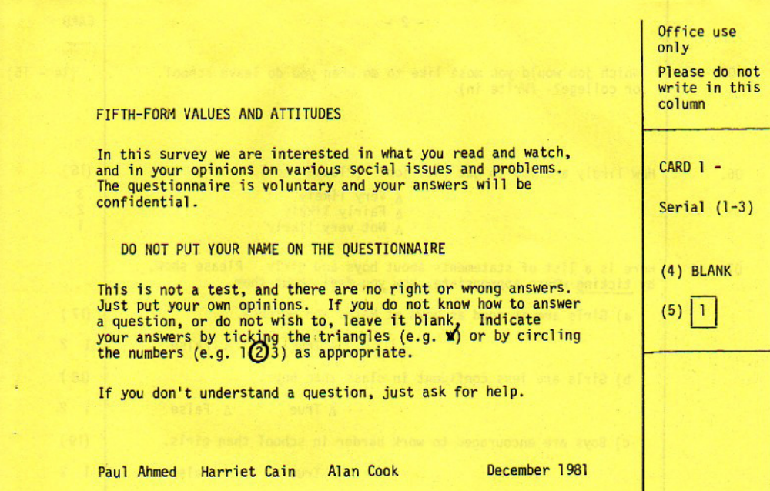

Facsimile of Question 1:

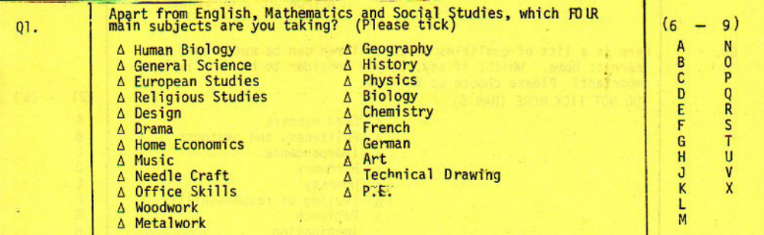

In addition to three compulsory subjects (English, Maths and Social Studies) there were 22 subjects to code. Using a two-digit numeric code 01 – 22 would have meant using 8 key-depressions to type them in and 8 columns of an 80-column card. To economise on cards and key-depressions we used letters of the alphabet in this and other questions with more than 9 possible responses. For this question it meant using only 4 key-depressions and 4 columns. The data were punched in columns 6-9 of card 1, read into SPSS in alphanumeric format as v106 to v109 and then recoded to numeric. In fact, given the possibility of punching errors, plus the use of upper and lower zones, the entire data set was fed in as alpha. Looks incredibly inefficient and cumbersome, but it's actually quicker and cheaper. The syntax in 1981 was as below:

FILE NAME FIFTH1.SYS
VARIABLE LIST SERIAL V106 TO V180 V206 TO V280 V306 TO V380
INPUT FORMAT FIXED
(I3,2X,75A1/5X,75A1/5X,75A1)
INPUT MEDIUM FIFTH.DAT
N OF CASES 142
RECODE V106 TO V380
('A'=1)('B'=2)('C'=3)('D'=4)('E'=5)('F'=6)('G'=7)
('H'=8)('J'=9)('K'=10)('L'=11)('M'=12)('N'=13)
('O'=14)('P'=15)('Q'=16)('R'=17)('S'=18)('T'=19)
('U'=20)('V'=21)('W'=22)('X'=23)('Y'=24)('Z'=25)
(' ',' '=-1)('*'=30) (CONVERT)
DELETE VARS V175 TO V180 V279 V280 V376 TO V380
SAVE FILE FIFTH1.SYS
FINISH

..but this no longer works in the Windows version. The RECODE ….CONVERT procedure is no longer available so RECODE … INTO has to be used instead. For subjects studied the variables now need to read in as alpha a106 to a109 and then recoded into v106 to v109:

data list file 'e:fifth.dat' records 3
/1 a106 to a109 6-9 (a).
recode a106 to a109 ('a'=1)(('b'=2)…. (' ',' '=-1)('*'=30) into v106 to v109.

But even then you need to specify a pathway and directory (oops! folder) for the source and destination files). I find it easier to have raw data on drive e:, specify 'e:fifth.dat' and then use the menus file …save as… to put the saved file where I want it.

Appendix 2

Fifth form survey: Facsimile of Question 33: Attitudes to women

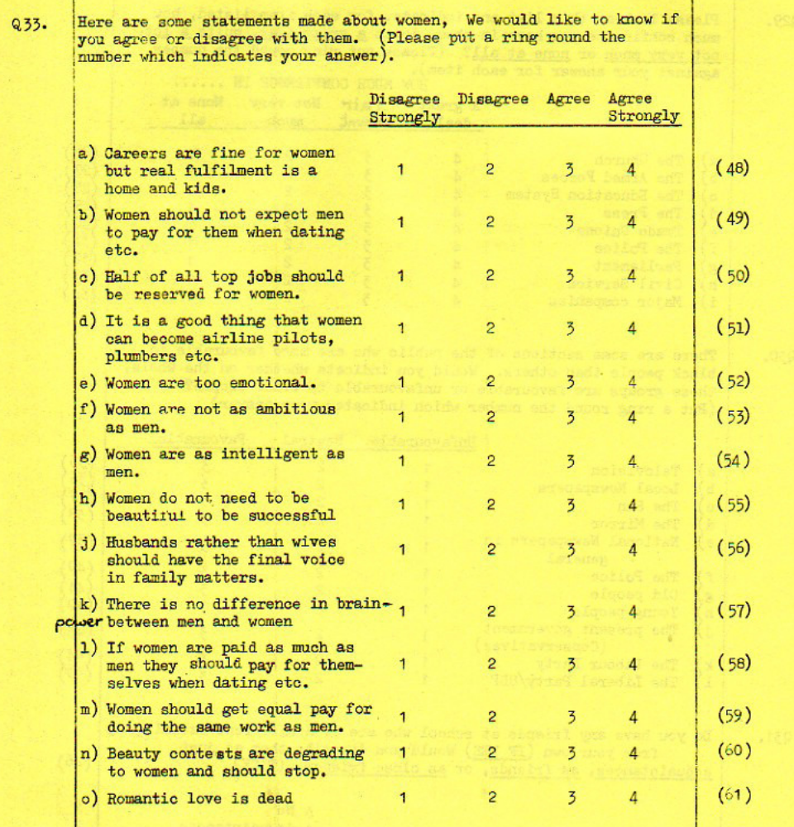

These were usually 80-column Hollerith cards with 12 hole-sites (digits 0-9 plus an upper and lower zone: combinations of these were used for alphabetic and special characters).
This was true when this paper was first written, but SPSS can now handle column binary input.
For a 1981 undergraduate research project by three students from the Polytechnic of North London
See Appendix 1 for facsimile question on additional subjects being taken.
No longer used in later versions of SPSS: all numeric values except missing are now automatically included.
See Appendix 2 for a facsimile of the question and its constituent items.

