The COMPUTE command 2 – Sexism

Last updated: 1 October 2009 Copyright © 2009 John F Hall

Exemplar: Fifth Form Survey
Variable to be derived: Negative attitudes to women (Sexism)
Source variables: V248 v252 v253 v256 V261 (negative: a,e,f,j,o)
V251 V255 V259 V260 (positive: d,h,m,n)
Previous tutorials: Data checks 2 – Sexism
The COUNT command 2 – Sexism

In the Fifth Form survey, we have already used COUNT to create SEXISM (as a crude measure of negative attitudes to women) but a much more accurate and useful score can be obtained by combining all the responses for each item, so that disagreement can be taken into account as well as agreement, and also the level of agreement or disagreement.

We can generate this much superior measure using the SPSS command COMPUTE.

The general format for COMPUTE is:

COMPUTE <computed variable> = <arithmetic expression>.

…in which blue indicates SPSS keywords etc., and <plum> things you have to type in yourself.

Question Q.33 is more complex than Q.34. It consists of 14 statements measuring opinions about women, some negative, some positive, with which pupils can agree or disagree on a 4-point scale. (Codes 1-4 on columns 48 to 61 of card 2, read into SPSS using the positional naming convention as V248 to V261) Only nine of these items will be used for this new measure of sexism.

Using COMPUTE to generate a measure of "Sexism" presents an additional problem. Four of the nine items are actually coded the opposite way round to the other five. If we add them all together they will simply cancel each other out. We want a high score to indicate high sexism, so we need to reverse (at least temporarily) the scores on the four positive items V251 V255 V259 V261 (d,h,m and n) before adding the items together. The resultant variable will have values in the range 9 to 36 where 36 indicates high sexism,

The values of the source variables can be changed using a RECODE statement:

RECODE V251 V255 V259 V260 (4=1) (3=2) (2=3) (1=4).

Be very careful with recodes! The changes will be made permanent if you save the Data Editor. To avoid such problems, it's much safer to use TEMPORARY

TEMPORARY.
RECODE V251 V255 V259 V260 (4=1) (3=2) (2=3) (1=4).

… and even safer to create a new set of intermediate variables with RECODE….INTO.

RECODE V251 V255 V259 V260 (4=1) (3=2) (2=3) (1=4)(ELSE = SYSMIS)
INTO
R251 R255 R259 R260.

…where Rddd indicates a recoded variable, but the positional info is retained. You can then use these for calculating the sexism score. They can be discarded later, unless you want to keep them them for another analysis.

Here's the facsimile of Q.33 again

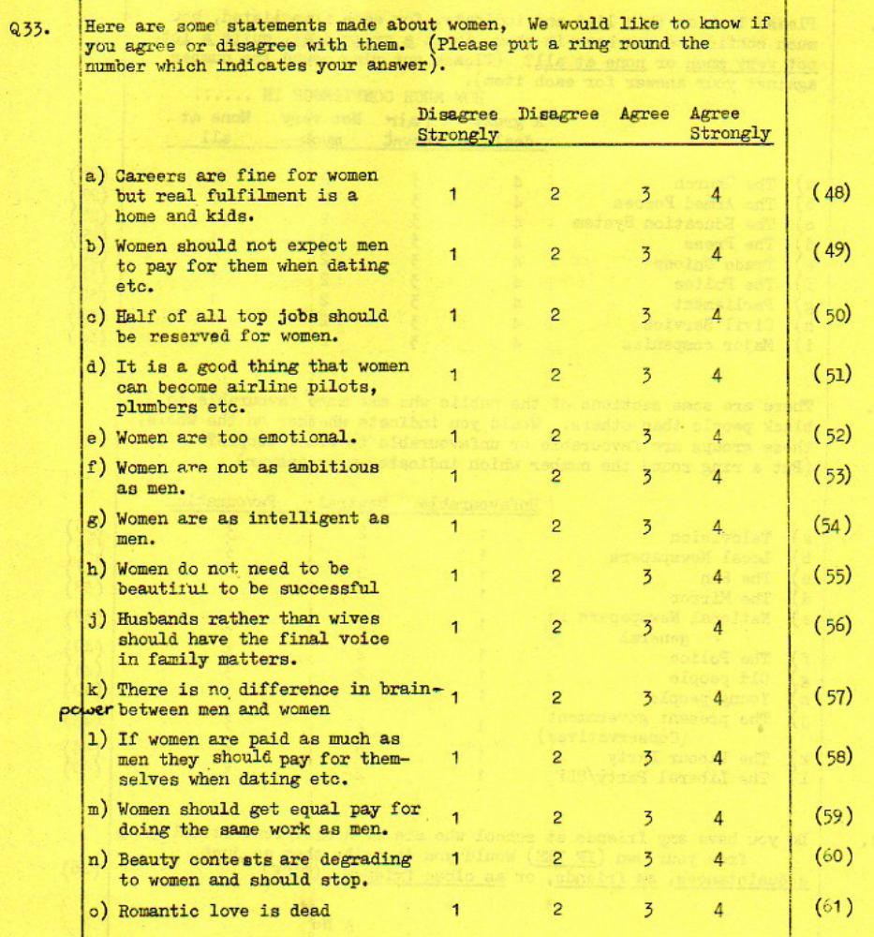

First we need a name for the new variable. We've already got SEXISM so let's call this one SEXISM2.

Going back to the general format for COMPUTE :

COMPUTE <computed variable> = <arithmetic expression>.

…in which blue indicates SPSS keywords etc., and plum indicates things you have to write in.

A small table helps

SPSS command | New variable | Source variables  Negative Positive
COMPUTE | SEXISM2 | V248 V252 V253 V256 V261 | V251 V255 V259 V260  recoded into  R251 R255 R259 R260

Our SPSS command will therefore be:

COMPUTE SEXISM2 =
V248 + V252 + V253 + V256 + V261 + R251 + R255 + R259 + R261 .

…or if you want to keep the variables in questionnaire order:

COMPUTE SEXISM2 =
V248 + R251 + V252 + V253 + R255 + V256 + R259 + R260 + V261 .

If you use the SUM facility, you have to use SUM.n where n is the number of variables to be summed and you must use commas to separate the variable names (unless they are adjacent in the file, in which case you can use Vddd TO Vddd

COMPUTE SEXISM2 =
SUM.9 (V248, V252, V253, V256, V261, R251, R255, R259, R260) .

Do NOT use

COMPUTE SEXISM2 =
SUM (V248, V252, V253, V256, V261, R251, R255, R259, R260) .

It gives a misleading answer because it calculates a score even if one or more items are missing!

Whenever items are being used in constructing new variables it's essential to check the distributions against those in the user manual. We did this in a previous tutorial Data checks 2 – Sexism so there's no need to do it again here. In this version of Fifth Form Survey the values of all nine variables tally exactly with those in the the user manual and we can confidently proceed to create a new variable using the COMPUTE command.

Go back to the Data Editor, scroll to the end: you should have STATQUO, SEXISM and statquo2 if you did the previous tutorials. Adjust the column separators and adjust the pane to see only these variables.

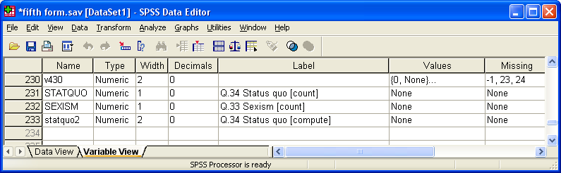

File
…New
…Syntax

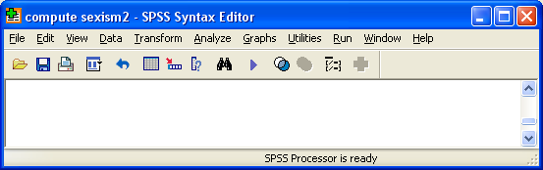

Write in the RECODE command :

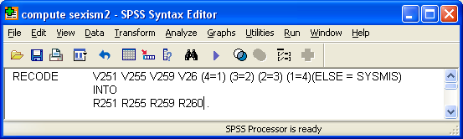

…followed by the COMPUTE command for SEXISM2.

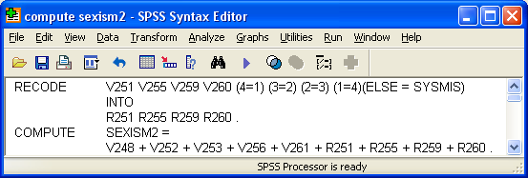

[NB: If you do this with long batteries of attitude scales containing missing values, you will rapidly reduce your effective sample size, so for some statistical purposes it may be better to RECODE the missing values to a central value such as mean, median or mode before calculating any scores.]

Run both commands. As before (with STATQUO2) nothing appears to happen, but if you go back to the Data Editor and scroll to the last row, you will see that R251 R255 R259 R260 and SEXISM2 have been appended at the end of the file.

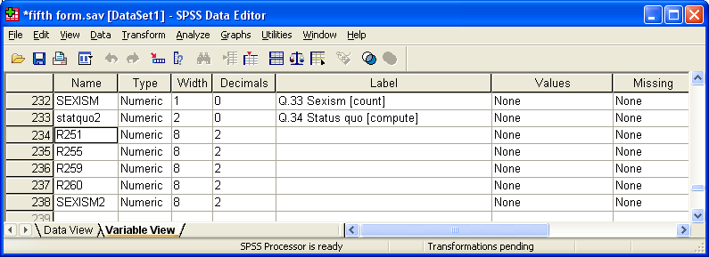
Switch to Data View and skip to the last column

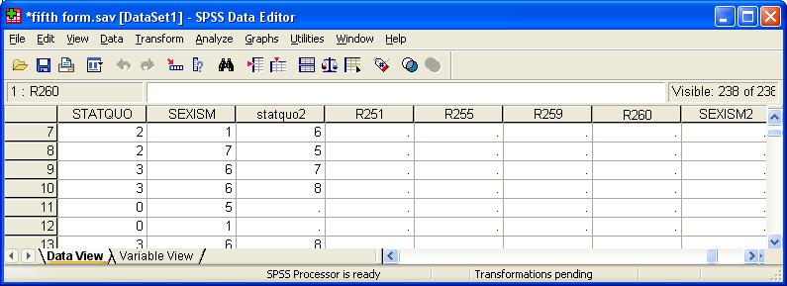

No scores have yet been calculated. SPSS is waiting for an EXECUTE command or a request for statistical analysis. We need a frequency count anyway to check the distribution of scores, so add a FREQUENCIES command:

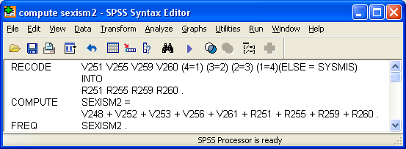

..and run the job to get:
SEXISM2

 |  | Frequency | Percent | Valid Percent | Cumulative Percent
Valid | 10.00 | 4 | 2.8 | 3.5 | 3.5
Valid | 12.00 | 3 | 2.1 | 2.6 | 6.1
Valid | 13.00 | 3 | 2.1 | 2.6 | 8.8
Valid | 14.00 | 3 | 2.1 | 2.6 | 11.4
Valid | 15.00 | 8 | 5.6 | 7.0 | 18.4
Valid | 16.00 | 9 | 6.3 | 7.9 | 26.3
Valid | 17.00 | 5 | 3.5 | 4.4 | 30.7
Valid | 18.00 | 9 | 6.3 | 7.9 | 38.6
Valid | 19.00 | 17 | 12.0 | 14.9 | 53.5
Valid | 20.00 | 12 | 8.5 | 10.5 | 64.0
Valid | 21.00 | 11 | 7.7 | 9.6 | 73.7
Valid | 22.00 | 3 | 2.1 | 2.6 | 76.3
Valid | 23.00 | 5 | 3.5 | 4.4 | 80.7
Valid | 24.00 | 9 | 6.3 | 7.9 | 88.6
Valid | 25.00 | 2 | 1.4 | 1.8 | 90.4
Valid | 26.00 | 2 | 1.4 | 1.8 | 92.1
Valid | 27.00 | 6 | 4.2 | 5.3 | 97.4
Valid | 28.00 | 2 | 1.4 | 1.8 | 99.1
Valid | 29.00 | 1 | .7 | .9 | 100.0
Valid | Total | 114 | 80.3 | 100.0
Missing | System | 28 | 19.7
Total |  | 142 | 100.0
Go back to the Data Editor

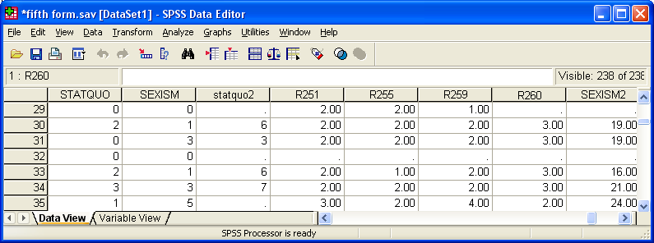

Scroll down and you will see that this time, although SEXISM2 scores have now been generated, some cells are still empty. This is because 28 pupils were missing on one or more of the nine items and SPSS has automatically set their score to system missing.

Go back to Variable View

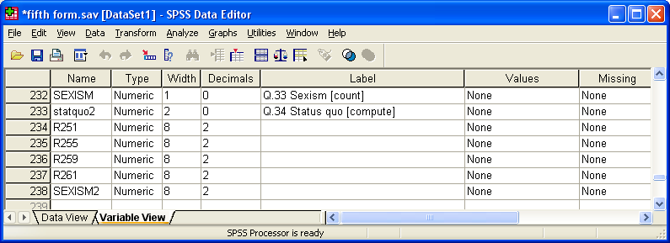

We still need to give SEXISM2 a label and get rid of the decimal places. Both can be done directly in the Data Editor, the label by writing your own text in the Label column:

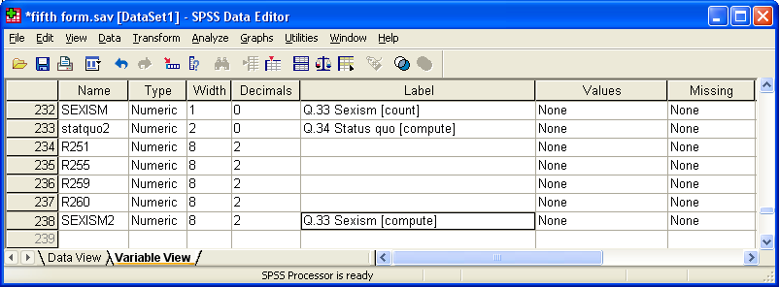

…and the format by changing 2 to 0 in the Decimals column:

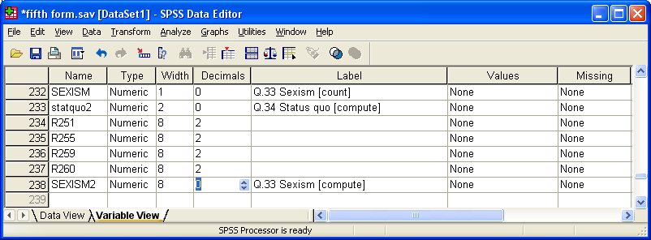

Alternatively you can add variable labels and format commands to the syntax file and run the frequency count again to force SPSS to execute the changes.

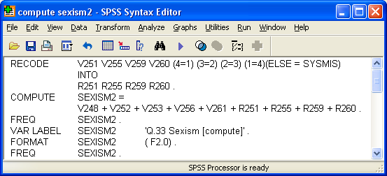

Q.33 Sexism [compute]

 |  | Frequency | Percent | Valid Percent | Cumulative Percent
Valid | 10 | 4 | 2.8 | 3.5 | 3.5
Valid | 12 | 3 | 2.1 | 2.6 | 6.1
Valid | 13 | 3 | 2.1 | 2.6 | 8.8
Valid | 14 | 3 | 2.1 | 2.6 | 11.4
Valid | 15 | 8 | 5.6 | 7.0 | 18.4
Valid | 16 | 9 | 6.3 | 7.9 | 26.3
Valid | 17 | 5 | 3.5 | 4.4 | 30.7
Valid | 18 | 9 | 6.3 | 7.9 | 38.6
Valid | 19 | 17 | 12.0 | 14.9 | 53.5
Valid | 20 | 12 | 8.5 | 10.5 | 64.0
Valid | 21 | 11 | 7.7 | 9.6 | 73.7
Valid | 22 | 3 | 2.1 | 2.6 | 76.3
Valid | 23 | 5 | 3.5 | 4.4 | 80.7
Valid | 24 | 9 | 6.3 | 7.9 | 88.6
Valid | 25 | 2 | 1.4 | 1.8 | 90.4
Valid | 26 | 2 | 1.4 | 1.8 | 92.1
Valid | 27 | 6 | 4.2 | 5.3 | 97.4
Valid | 28 | 2 | 1.4 | 1.8 | 99.1
Valid | 29 | 1 | .7 | .9 | 100.0
Valid | Total | 114 | 80.3 | 100.0
Missing | System | 28 | 19.7
Total |  | 142 | 100.0

This table shows a range of 10 to 29 (out of a theoretical 36). We can improve it by adjusting the score so that it becomes a ratio scale with a true 0 point and a theoretical range of 0 – 27 instead of 9 – 36. To do this we subtract the number of items in the scale (9) using another SPSS command compute sexism2 = sexism2 – 9. This is the equivalent of the original items having been coded 0 to 3 instead of 1 to 4, and avoids the error (common in many reports, especially when comparing group means) of discussing means as though they come from a ratio scale.

We're going to need another frequency count as well.

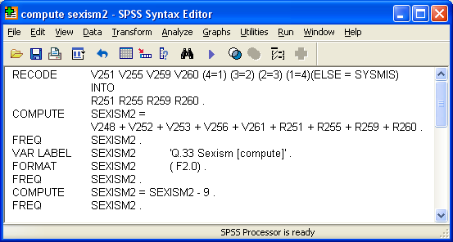

…to get:

Q.33 Sexism [compute]

 |  | Frequency | Percent | Valid Percent | Cumulative Percent
Valid | 1 | 4 | 2.8 | 3.5 | 3.5
Valid | 3 | 3 | 2.1 | 2.6 | 6.1
Valid | 4 | 3 | 2.1 | 2.6 | 8.8
Valid | 5 | 3 | 2.1 | 2.6 | 11.4
Valid | 6 | 8 | 5.6 | 7.0 | 18.4
Valid | 7 | 9 | 6.3 | 7.9 | 26.3
Valid | 8 | 5 | 3.5 | 4.4 | 30.7
Valid | 9 | 9 | 6.3 | 7.9 | 38.6
Valid | 10 | 17 | 12.0 | 14.9 | 53.5
Valid | 11 | 12 | 8.5 | 10.5 | 64.0
Valid | 12 | 11 | 7.7 | 9.6 | 73.7
Valid | 13 | 3 | 2.1 | 2.6 | 76.3
Valid | 14 | 5 | 3.5 | 4.4 | 80.7
Valid | 15 | 9 | 6.3 | 7.9 | 88.6
Valid | 16 | 2 | 1.4 | 1.8 | 90.4
Valid | 17 | 2 | 1.4 | 1.8 | 92.1
Valid | 18 | 6 | 4.2 | 5.3 | 97.4
Valid | 19 | 2 | 1.4 | 1.8 | 99.1
Valid | 20 | 1 | .7 | .9 | 100.0
Valid | Total | 114 | 80.3 | 100.0
Missing | System | 28 | 19.7
Total |  | 142 | 100.0

Because SEXISM2 is a genuine interval scale (also now a ratio scale) it is legitimate to ask for a mean and standard deviation (e.g../statistics mean stdev) plus a histogram overlaid with a normal curve (e.g.…/histogram normal)
You can also suppress the frequency table (e.g. …/format notable) and just get the statistics and the chart.:

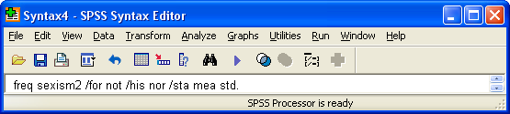

…which produces:

Statistics

Q.33 Sexism [compute]

N | Valid | 116
N | Missing | 26
Mean |  | 12.80
Std. Deviation |  | 3.485
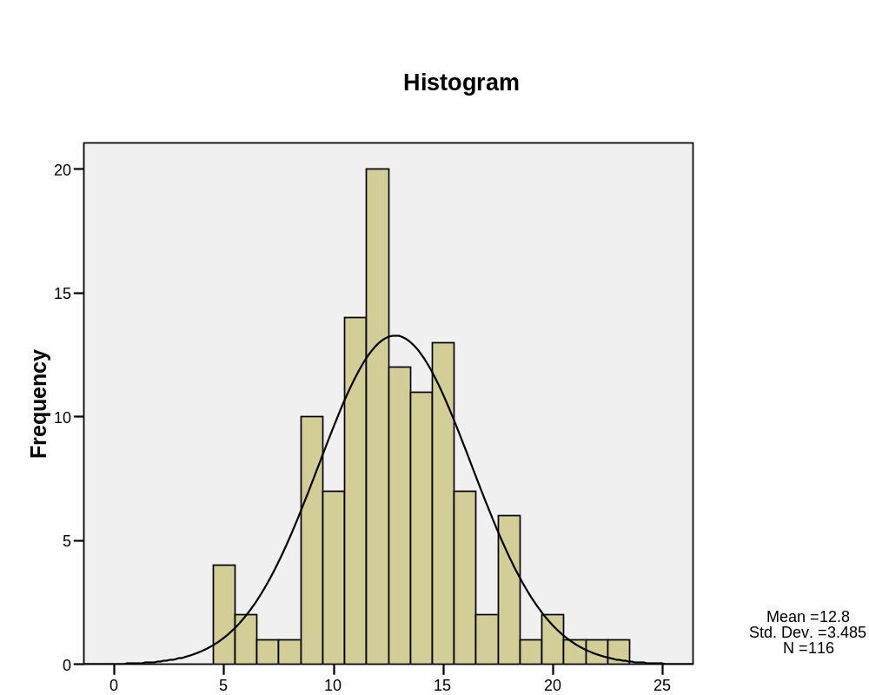

[NB: The histogram has a label on the output, but it's not transferred when copied. You'll have to write your own underneath the chart.]

The point-and click way

If you prefer, you can produce all the above tables, statistics and histogram using the drop-down menus, but it will take you a very long time. I'm not even going to bother. You have been warned!

Feedback on ease of understanding and use of tutorial, please, to: johnfhall@orange.fr

