Data checks 2 – Sexism Copyright © 2009 John F Hall

Exemplar: Fifth Form Survey
Variable to be derived: Negative attitudes to women (Sexism)
Source variables: v275 to v278 (Q34 o, p, q ,r )
Previous tutorials: COUNT and COMPUTE – Preliminary notes;
Data checks 1 – Status quo;
The COUNT command 1 – Status Quo

Question Q.33 is slightly more complex. It consists of 14 statements measuring opinions about women, some negative, some positive, with which pupils can agree or disagree on a 4-point scale. (Codes 1 to 4 on columns 48 to 61 of record 2, read into SPSS using positional variable naming convention as v248 to v261: SPSS automatically generates intermediate variable names)

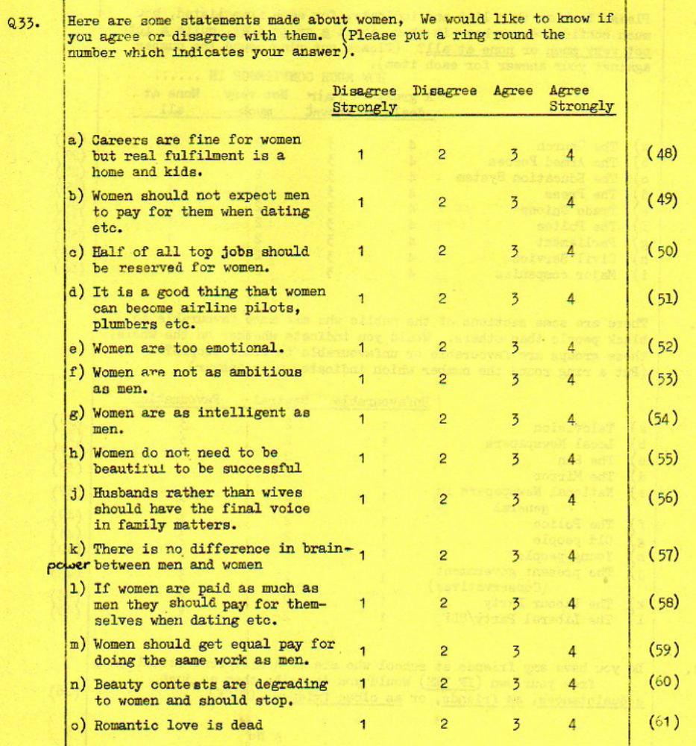

Nine of these items, five of which are negative (a,e,f,j,o) and four positive (d,h,m,n ) will be used to construct an index of "Sexism" (negative attitudes to women).
Here is an extract from the user manual showing the original frequency counts for the responses to these questions.

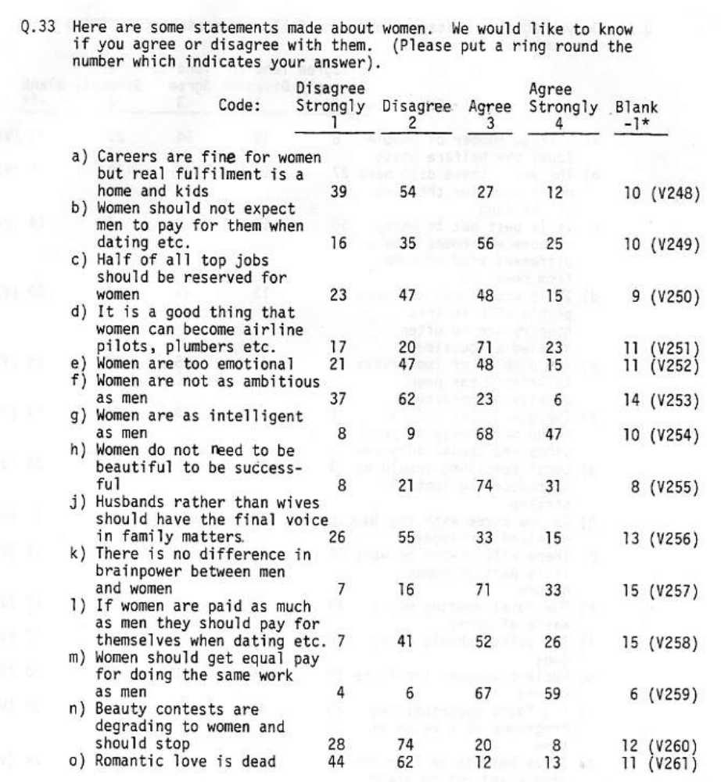

In the following exercise we are going to use the SPSS procedure COUNT to create a new, derived variable containing, for each pupil, a count of the agree or agree strongly responses (codes 3 or 4) to the negative items (a,e,f,j,o) together with the disagree or disagree strongly responses (codes 1 or 2) to the positive items (d,h,m,n ). This will yield a score in the range 0 to 9 where 9 indicates high sexism.

First, however, it is essential to check the original data, and a lot safer, especially in situations like this when working with batteries in which some items may need values to be reversed or recoded before generating scores.

[NB: You won't actually be able to do this next bit without immediate direct access to SPSS: don't worry just follow the tutorial anyway.]

Start by downloading the SPSS saved file Fifth Form Survey

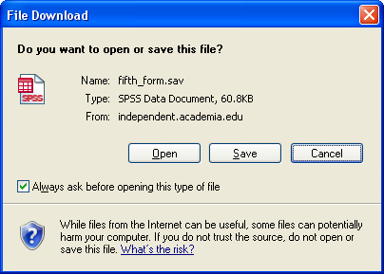

Click on Open to get:

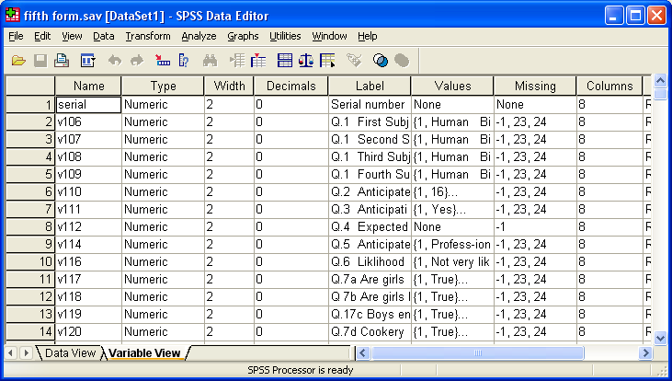
Use the mouse to drag the column separators around to make the display easier to read, then reduce the pane horizontally to include only essential information.

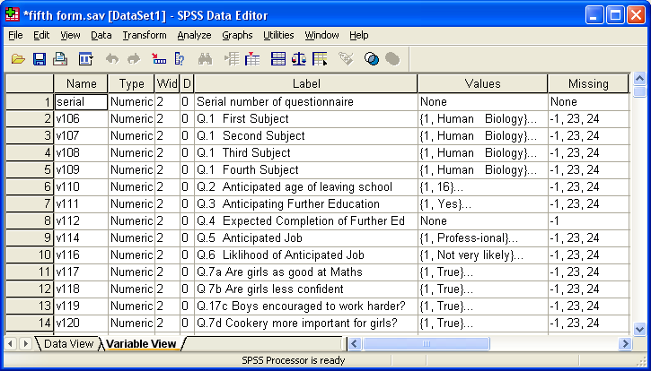

Scroll down to find variables v248 to v261 containing the data for Q.33 (a) to (o) and reduce the pane vertically to show only these:

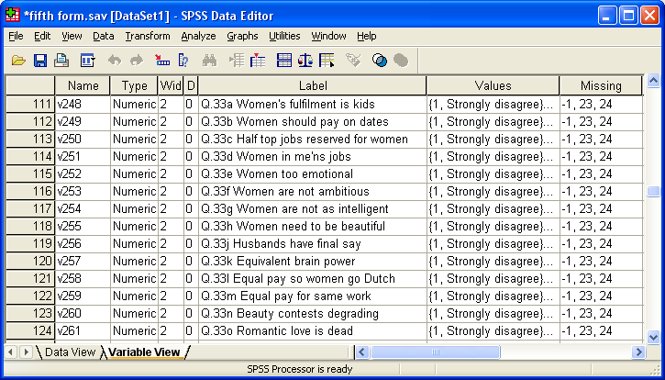

Now you know why positional variable names and informative variable labels are so important! They are so much easier to find in the Data Editor than mnemonics and you (and, more important, others) can work straight from the original questionnaire to the data set and vice versa. If you insist on mnemonics, at least think about using question numbers as variable names, but don't leave the full stops in.

Nine of these items, five of which are negative (a,e,f,j,o) V248 v252 v253 v256 v261 and four positive (d,h,m,n ) v251 v255 v259 v260 will be used to construct a crude index of "Sexism". Before that, however, we need to check these data against the original user manual, so we need to look at the distribution of values for these nine variables.

The syntax way

It's actually quicker to tabulate the whole set with freq v248 to v261 and pick out the variables we want, but for now we'll do it using only the nine variables needed to construct the index. Also, to keep the output manageable (and fit on an A4 page) we'll tabulate the negative and positive items separately, starting with the negative items.

For a small job like this, open a new SPSS syntax file with:

File
…New
…Syntax

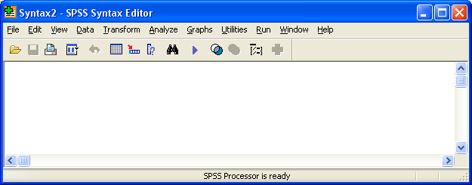

…and write freq V248 v252 v253 v256 v261. in the box. Don't forget the full stop!

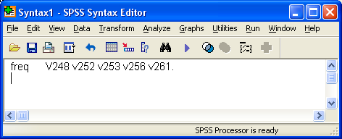

Leave the cursor in or on the line and press [CTRL]+R to run the job.

SPSS will produce the following tables:

Statistics

 |  | Q.33a Women's fulfilment is kids | Q.33e Women too emotional | Q.33f Women are not ambitious | Q.33j Husbands have final say | Q.33o Romantic love is dead
N | Valid | 132 | 131 | 128 | 129 | 131
N | Missing | 10 | 11 | 14 | 13 | 11

This is a summary table for all five (negative) variables showing the number of valid and missing cases for each variable. It is followed by separate frequency tables, one for each variable:

Q.33a Women's fulfilment is kids

 |  | Frequency | Percent | Valid Percent | Cumulative Percent
Valid | Strongly disagree | 39 | 27.5 | 29.5 | 29.5
Valid | Disagree | 54 | 38.0 | 40.9 | 70.5
Valid | Agree | 27 | 19.0 | 20.5 | 90.9
Valid | Agree strongly | 12 | 8.5 | 9.1 | 100.0
Valid | Total | 132 | 93.0 | 100.0
Missing | -1 | 10 | 7.0
Total |  | 142 | 100.0

Q.33e Women too emotional

 |  | Frequency | Percent | Valid Percent | Cumulative Percent
Valid | Strongly disagree | 21 | 14.8 | 16.0 | 16.0
Valid | Disagree | 47 | 33.1 | 35.9 | 51.9
Valid | Agree | 48 | 33.8 | 36.6 | 88.5
Valid | Agree strongly | 15 | 10.6 | 11.5 | 100.0
Valid | Total | 131 | 92.3 | 100.0
Missing | -1 | 11 | 7.7
Total |  | 142 | 100.0

Q.33f Women are not ambitious

 |  | Frequency | Percent | Valid Percent | Cumulative Percent
Valid | Strongly disagree | 37 | 26.1 | 28.9 | 28.9
Valid | Disagree | 62 | 43.7 | 48.4 | 77.3
Valid | Agree | 23 | 16.2 | 18.0 | 95.3
Valid | Agree strongly | 6 | 4.2 | 4.7 | 100.0
Valid | Total | 128 | 90.1 | 100.0
Missing | -1 | 14 | 9.9
Total |  | 142 | 100.0

Q.33o Romantic love is dead

 |  | Frequency | Percent | Valid Percent | Cumulative Percent
Valid | Strongly disagree | 44 | 31.0 | 33.6 | 33.6
Valid | Disagree | 62 | 43.7 | 47.3 | 80.9
Valid | Agree | 12 | 8.5 | 9.2 | 90.1
Valid | Agree strongly | 13 | 9.2 | 9.9 | 100.0
Valid | Total | 131 | 92.3 | 100.0
Missing | -1 | 11 | 7.7
Total |  | 142 | 100.0

From these tables we can see that there are 142 cases in the file, that '-1' has been declared as a missing value for all five variables and that there are no values outside the range of 1 to 4.

You can produce the same tables using the drop-down menus, but this takes a lot longer and is cumbersome, confusing and frustrating. You can also produce a summary table using SPSS syntax, but it looks very complicated for beginners (and also for me) so it's easier for now to do it with the menus. Here's the syntax generated by SPSS.

TABLES
/FORMAT BLANK MISSING('.') /TABLES
(LABELS) BY
( v248 + v252 + v253 + v256 + v261 )
/STATISTICS COUNT ((F5.0) 'Count' ) .

…which produces:

 | Q.33a Women's fulfilment is kids | Q.33e Women too emotional | Q.33f Women are not ambitious | Q.33j Husbands have final say | Q.33o Romantic love is dead
 | Count | Count | Count | Count | Count
Strongly disagree | 39 | 21 | 37 | 26 | 44
Disagree | 54 | 47 | 62 | 55 | 62
Agree | 27 | 48 | 23 | 33 | 12
Agree strongly | 12 | 15 | 6 | 15 | 13

It's easier with the menus, but could be very fiddly if the variables were spread all over the file. For analytical purposes, to compare distributions, we'd be better off with % rather than n in the cells, but this time we're checking frequencies against the user manual.

Now for the positive items: retrieve the syntax file and write freq v251 v255 v259 v260. on the next line:

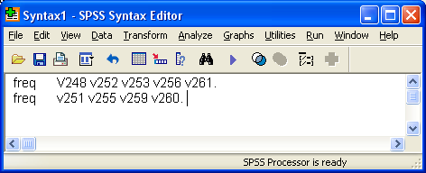

to produce:
Statistics

 |  | Q.33d Women in me'ns jobs | Q.33h Women need to be beautiful | Q.33m Equal pay for same work | Q.33n Beauty contests degrading
N | Valid | 131 | 134 | 136 | 130
N | Missing | 11 | 8 | 6 | 12

As before, the summary table shows the number of valid and missing cases for each of the four variables.

It is followed by separate frequency tables, one for each variable.

Q.33d Women in men's jobs

 |  | Frequency | Percent | Valid Percent | Cumulative Percent
Valid | Strongly disagree | 17 | 12.0 | 13.0 | 13.0
Valid | Disagree | 20 | 14.1 | 15.3 | 28.2
Valid | Agree | 71 | 50.0 | 54.2 | 82.4
Valid | Agree strongly | 23 | 16.2 | 17.6 | 100.0
Valid | Total | 131 | 92.3 | 100.0
Missing | -1 | 11 | 7.7
Total |  | 142 | 100.0

Q.33h Women need to be beautiful

 |  | Frequency | Percent | Valid Percent | Cumulative Percent
Valid | Strongly disagree | 8 | 5.6 | 6.0 | 6.0
Valid | Disagree | 21 | 14.8 | 15.7 | 21.6
Valid | Agree | 74 | 52.1 | 55.2 | 76.9
Valid | Agree strongly | 31 | 21.8 | 23.1 | 100.0
Valid | Total | 134 | 94.4 | 100.0
Missing | -1 | 8 | 5.6
Total |  | 142 | 100.0

Q.33m Equal pay for same work

 |  | Frequency | Percent | Valid Percent | Cumulative Percent
Valid | Strongly disagree | 4 | 2.8 | 2.9 | 2.9
Valid | Disagree | 6 | 4.2 | 4.4 | 7.4
Valid | Agree | 67 | 47.2 | 49.3 | 56.6
Valid | Agree strongly | 59 | 41.5 | 43.4 | 100.0
Valid | Total | 136 | 95.8 | 100.0
Missing | -1 | 6 | 4.2
Total |  | 142 | 100.0

Q.33n Beauty contests degrading

 |  | Frequency | Percent | Valid Percent | Cumulative Percent
Valid | Strongly disagree | 28 | 19.7 | 21.5 | 21.5
Valid | Disagree | 74 | 52.1 | 56.9 | 78.5
Valid | Agree | 20 | 14.1 | 15.4 | 93.8
Valid | Agree strongly | 8 | 5.6 | 6.2 | 100.0
Valid | Total | 130 | 91.5 | 100.0
Missing | -1 | 12 | 8.5
Total |  | 142 | 100.0

You can produce the same tables using the drop-down menus, but this takes a lot longer and can be cumbersome, confusing and frustrating.

You can also produce a summary table using SPSS syntax, but it looks very complicated for beginners (and also for me) so it's easier for now to do it with the menus. Here's the syntax generated by SPSS.

TABLES
/FORMAT BLANK MISSING('.') /TABLES
(LABELS) BY
( v251 + v255 + v259 + v260 )
/STATISTICS COUNT ((F5.0) 'Count' ) .

 | Q.33d Women in men's jobs | Q.33h Women need to be beautiful | Q.33m Equal pay for same work | Q.33n Beauty contests degrading
 | Count | Count | Count | Count
Strongly disagree | 17 | 8 | 4 | 28
Disagree | 20 | 21 | 6 | 74
Agree | 71 | 74 | 67 | 20
Agree strongly | 23 | 31 | 59 | 8

Again it's easier with the drop-down menus, but this time it was more fiddly as the variables were not adjacent in the file, but we've lost the information on missing values. Again for analytical purposes, to compare distributions, we'd be better off with % rather than n in the cells, but this time we're checking frequencies against the user manual.

In this particular data set the variables are all actually still in their original form, but it's important always to carry out such checks when creating derived variables as sometimes the original variables may have been changed or permanently recoded and any derived variables based on them may consequently be rendered meaningless.

For an instance of this actually happening, see the slide show for my repetition of the exercises from Julie Pallant's SPSS Survival Manual (2nd edition 2005) Old Dog, Old Tricks 5: Exercises from SPSS Survival Manual or the full paper Old Dog, Old Tricks: Using SPSS Syntax to Avoid the Mouse Trap (pages 45-76)

The point-and-click way

Here's how to get the same tables using the drop-down menus. Go back to the Data Editor:

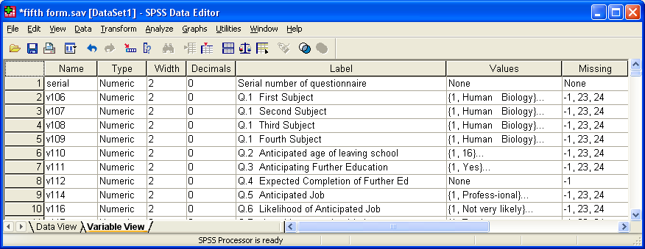

…and scroll to find V248…V261:

Analyze
…Descriptive statistics
…Frequencies

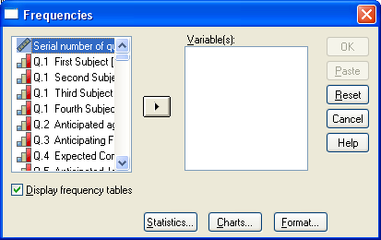

Scroll to find the variables we need:

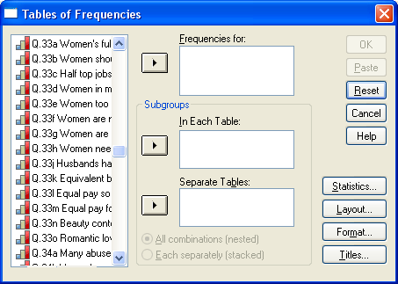

Negative items

The variables are not adjacent, so you need to drag them into the Frequencies for box one at a time or you can hold down [CTRL] and click on each of them to highlight them:

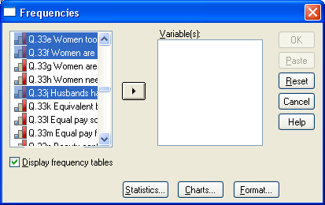

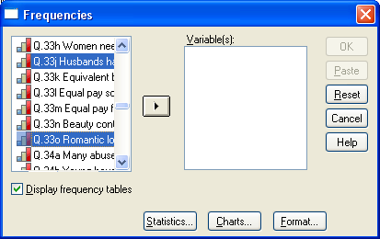

and drag all five across in one go:

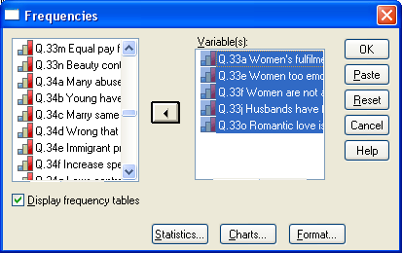

Press OK to run and get tables for the negative items.

Positive items

Analyze
…Descriptive statistics
…Frequencies

The variables are not adjacent, so you need to drag them into the Frequencies for box one at a time or you can hold down [CTRL] and click on each of them to highlight them:

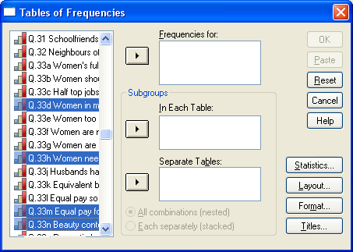

and drag all four across in one go:

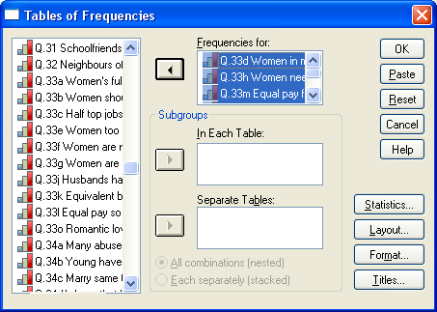 Press OK to get tables.

For the summary table, it's better to do the negative and positive items separately: that way the tables fit in the Viewer (and on an A4 Word page like this one!)

Negative items

Analyze
…Tables
…Tables of Frequencies

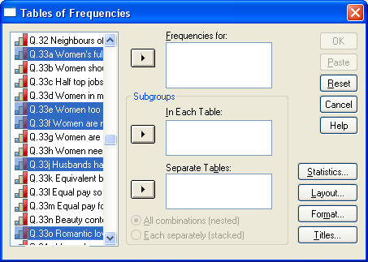

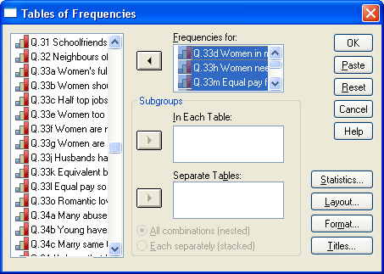 Press OK to get the table.

Positive items

Analyze
…Tables
…Tables of Frequencies

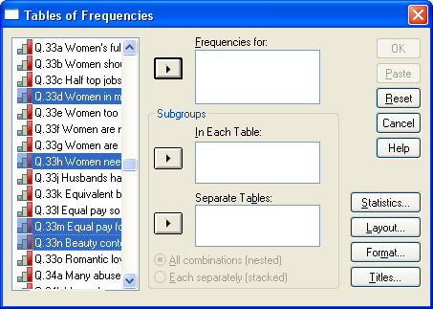

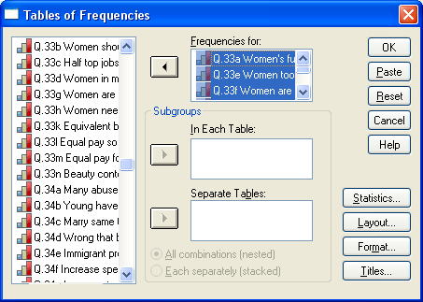

Press OK to get the table.

Again it's easier to produce summary tables with the drop-down menus, but this time it is more fiddly as the variables are not adjacent in the file. For analytical purposes, especially with large samples, we'd be better off with % rather than n in the cells, as % are easier to compare. A useful tool, but you do lose information on missing values.

Next tutorial(s): The COUNT command 2 – Sexism

Feedback on ease of understanding and use of tutorial, please, to: johnfhall@orange.fr

(Last updated: 24 September 2009)

The size of the Data Editor displayed will depend on how it was left when last used. You can drag the corners of the pane to reduce or enlarge it, and the edges up or down and left or right, using the left mouse button. This pane is adjusted to display only the first few variables in the file.

