COUNT and COMPUTE - Preliminary notes Copyright © 2009 John F Hall

Exemplar: Fifth Form Survey
Variables to be derived: Attachment to status quo
Negative attitudes to women ("Sexism")
Source variables: Q.34 (items o,p,q,r);
Q.33 (negative items a,e,f,j,o: positive items d,h,m,n)

In the following exercises we are going to create derived variables containing scores on two simple attitude scales, one to measure teenagers' attachment to the status quo, the other to measure attitudes to women. We shall be using data from a survey of fifth-formers in a North London comprehensive school (11-18 mixed).

This survey was designed and conducted (under my guidance and supervision) by three 2nd year undergraduate students as part of their group research project for BA Applied Social Studies (Social Research) at the then Polytechnic of North London (PNL, now part of London Metropolitan University). The self-completion questionnaire was administered during time-tabled Social Studies classes on a single day in December 1981. It was completed by all fifth form pupils (N=142) present on the day of the survey and, time permitting, was followed by discussion with class teachers and the PNL students of the issues covered.

The questionnaire aimed to discover something about pupils' future expectations and awareness of, and attitudes towards, various current social issues and problems. It replicates various items and scales from other work.

Don't let the date put you off. Resources, time and available technology permitting, this survey was conducted as far as possible to professional standards and in accordance with the Codes of Conduct of the Social Research Association, the British Sociological Association and the Market Research Society. It can serve as a learning aid, especially regarding questionnare design and layout, computer processing and documentation.

You don't actually need it at the moment, but Fifth form questionnaire is a facsimile of the original questionnaire. Because the data were also to be used for teaching, a User Manual was prepared which incidentally serves as a model for similar student projects. It contains a codebook with frequency counts for all variables, basic coding information and a facsimile of the original questionnaire. You can see it on Playground to Politics: Users' Manual (Hall & Walker 1982)

The data from the survey were initially punched on 80-column Hollerith cards. The questionnaire is laid out for data entry on 3 cards, but multipunched responses were later spread out on an additional card to yield 4 cards (records) per case. The SPSS saved file Fifth Form Survey contains all the data with full dictionary information. Positional variable names are used.
Facsimile extracts from the questionnaire

Introduction emphasising voluntary nature of survey and confidentiality.

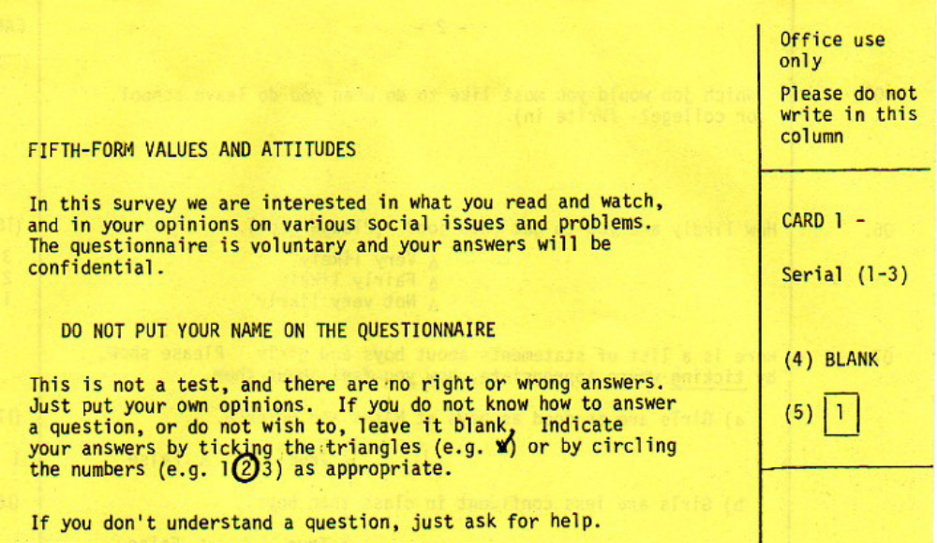

Attachment to status quo
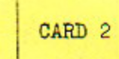
Four items in question Q.34 (items o,p,q,r) are replicated from a scale developed by the late Prof Hilde Himmelweit to measure "attachment to status quo" among teenagers.

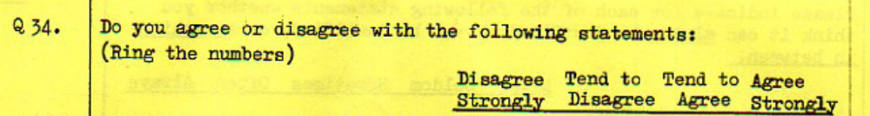

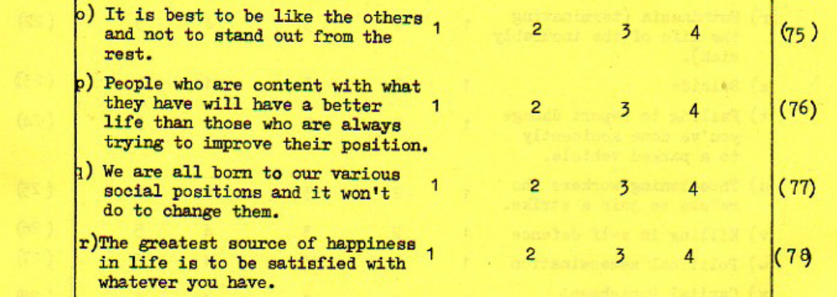

From the questionnaire extract above we can see (in the right hand margin) that the data are to be entered, one column per response, in columns 75 to 78 on record 2. They have therefore been given positional variable names v275 v276 v277 and v278. These variables will be used to create an index of "attachment to status quo".
Negative Attitudes to Women ("Sexism")

Question Q.33 is slightly more complex. It consists of 14 statements measuring opinions about women, some negative, some positive, with which pupils can agree or disagree on a 4-point scale. (Codes 1 to 4 on columns 48 to 61 of record 2, read into SPSS using positional variable naming convention as v248 to v261: SPSS automatically generates intermediate variable names)

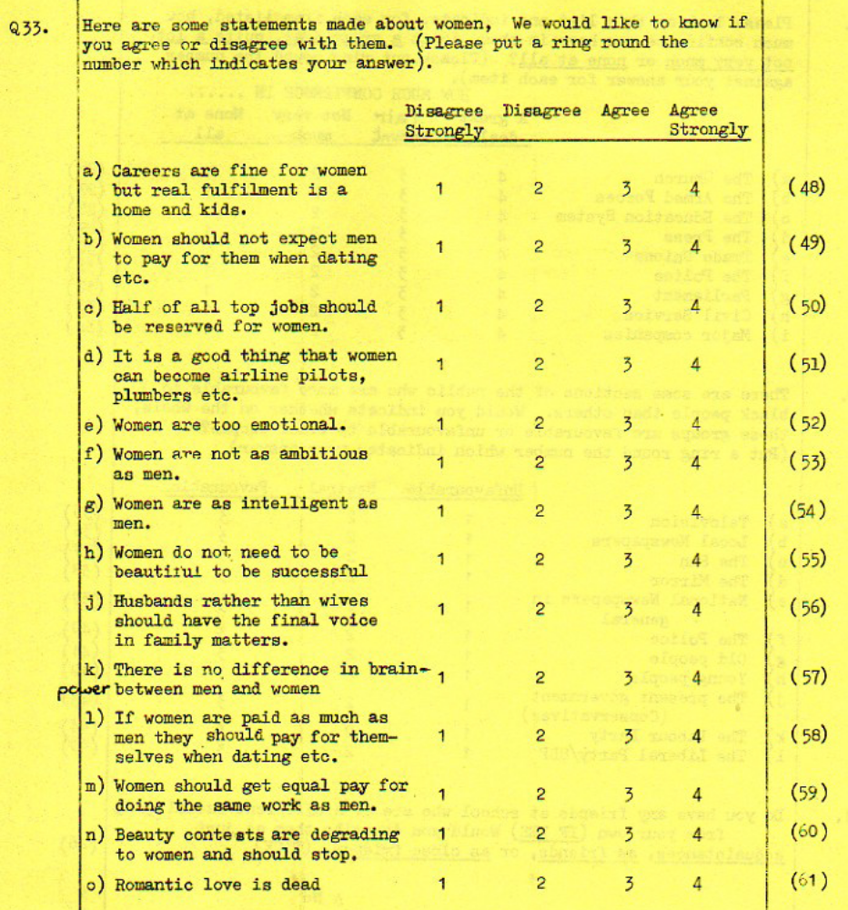

Nine of these items, five of which are negative (a,e,f,j,o) and four positive (d,h,m,n ) will be used to construct an index of "Sexism".

Next tutorials: Data checks 1 – Status quo
Data checks 2 – Sexism

Feedback on ease of understanding and use of tutorial, please, to: johnfhall@orange.fr

(Last updated: 24 September 2009)

Paul Ahmed, Harriet Cain and Alan Cook Playground to Politics: a study of values and attitudes among fifth formers in a North London comprehensive school Report on 2nd year project for BA Applied Social Studies (Social Research) Polytechnic of North London, 1982.
Wilson-Patterson, Neo-conservatism; Bradburn, Affect Balance: Himmelweit, Attachment to status quo etc., some of which were also used in the St Paul's Girls' School Survey 1973 (see: Questionnaire for St Paul's Girls' School survey 1973) and the SSRC Survey Unit Quality of Life Surveys
John Hall and Alison Walker, User manual for Playground to Politics: a study of values and attitudes among fifth formers in a North London comprehensive school Survey Research Unit, Polytechnic of North London 1982 (mimeo 40 pp – codebook, questionnaire, coding notes)
See Conventions for Naming Variables in SPSS for an explanation of this variable naming convention and the reasons for preferring it over the use of mnemonics.
Despite intensive searches, including asking Dave Phillips (one of her original research staff) I can find no trace of a reference in the literature, but the scale was definitely used in a study of teenagers and politics.

