Survey Analysis Workshop Copyright © 2010 John F Hall

Block 2: Analysing one variable Nominal and ordinal variables

2.1.2.9 Homework exercise for nominal and ordinal variables [24 Nov 2010]

Previous sessions: 2.1.2.3 to 2.1.2.7 using nominal and ordinal variables.

Have you done the housekeping in 2.1.2.8? If not, go back to the Block 2 menu and do it now.

Exemplar: British Social Attitudes (1989 survey)

Research questions:

What is the distribution of marital status of the respondent? (Q.900a: Nominal)

What is the distribution of satisfaction-dissatisfaction with the way the
National Health Service runs? (Q.58: Ordinal)

Homework exercise 1: Create an SPSS saved file containing the correct data for the above two questions from the 1989 British Social Attitudes survey, together with an appropriate data dictionary. (See exercises 2.1.2.3 to 2.1.2.7 on the 1986 survey).

Homework exercise 2: Produce a frequency count for marital status of the respondent and a frequency count with barchart for satisfaction-dissatisfaction with the way the NHS runs (see exercise 2.1.2.7 on the 1986 survey).

Marital status is asked at Q.900a [nominal]

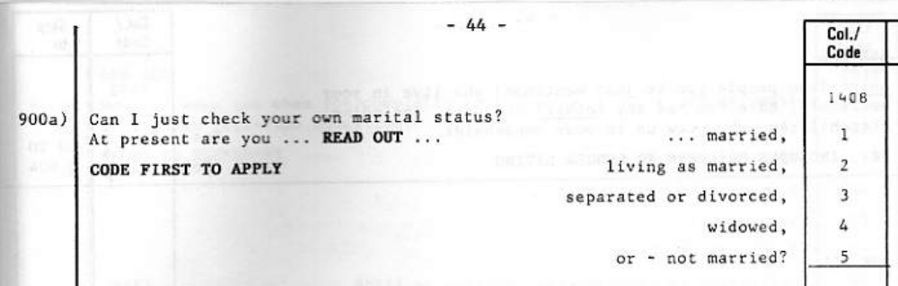

Satisfaction with the way the NHS runs is at Q.72 [ordinal]

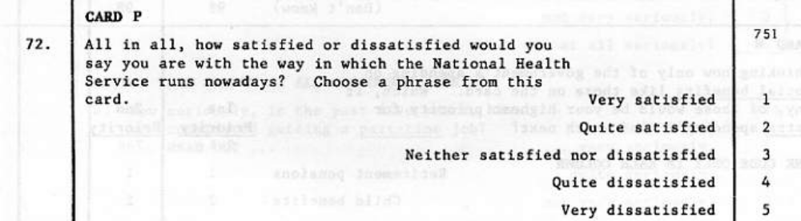
For exercises on the 1989 wave we shall again be starting from scratch with the raw data.

File: bsa89.txt (raw data from the 1989 British Social Attitudes survey)

Go to folder mybsa

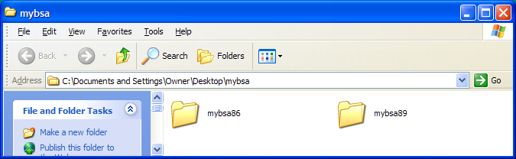

[If you don't already have separate folders mybsa86 and mybsa89, go back to the Block 2 menu and do the housekeeping exercise 2.1.2.8]

Download the raw data file bsa89.txt from this site: it will appear immediately: the screenshot below shows the 23 data records for the first case in the file.

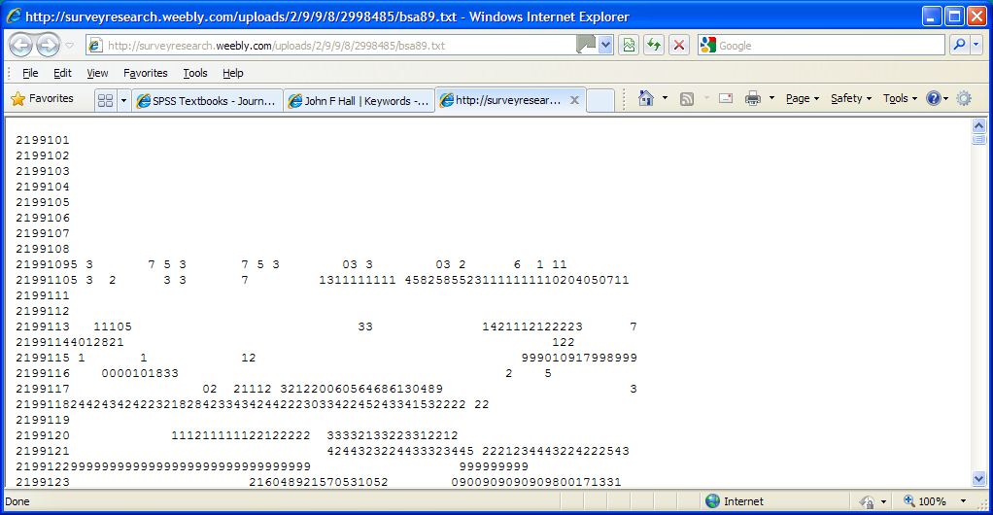

Click on: File > Save As ...

Navigate to folder mybsa89:

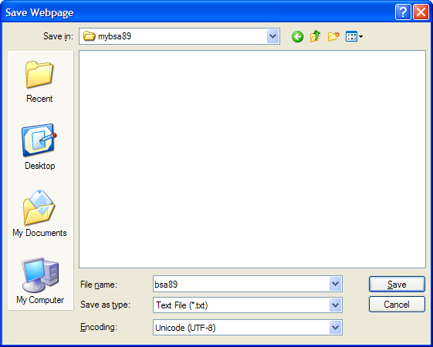

Make sure the Save as type box shows Text File (*.txt) and click on Save .
When the file has been downloaded and saved your folder mybsa89 should look like this:

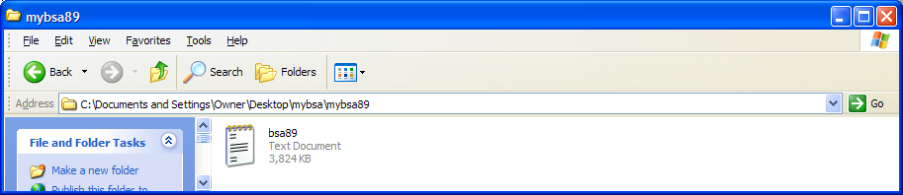

Check your own copy of the file by double-clicking on bsa89.txt: the beginning of the file looks like this . .

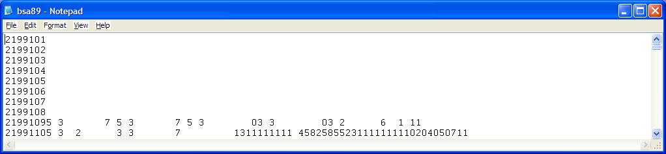

. .and the end like this:

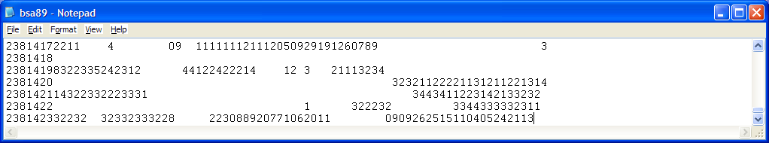

This file is not part of SPSS and is therefore known as an external file. When called by SPSS, it has to be referenced by its full pathname enclosed in single primes.

'C:\Documents and Settings\Owner\Desktop\mybsa\mybsa89\bsa89.txt'

The full pathname is quite long, but you only have to use it once and in any case, when you need it, you can always copy and paste it from this document into your SPSS syntax editor.

Now let's make a start on the homework.

Homework exercise 1:

Write a set of SPSS commands to specify the external file containing the raw data and the number of records per case, to define variables and data positions for both questions, to specify missing values, variable labels and value labels, then to read in the raw data from the external file. Use the positional convention for variable names. There are 23 records per case.

Satisfaction with the way NHS runs (Q.72; record 7 column 51)
Marital status (Q900a; record 14, column 8)

According to the Technical Report missing values have been coded as follows:

Satisfaction with the way NHS runs 8 Don't know 9 No answer
Marital status 8 Don't know 9 No answer
Complete the partial syntax below:

ti__________ ' _______________________________________________ ' .
da____ li____
fi_________ ' ___________________________________________ '
re_________ ___
/ ___ ___________ ___
/ ___ ___________ ___ .
mi__________ v___________
__________ ( ___ )
__________ ( ___ ) .
var________ la__________
__________ ' ___________________________________ '
/ __________ ' ___________________________________ ' .
val________ la__________
v_______ ___ '___________________ '
___ '___________________ '
___ '___________________ '
___ '___________________ '
___ '___________________ '
/ v_______ ___ '___________________ '
___ '___________________ '
___ '___________________ '
___ '___________________ '
___ '___________________ ' .
ex________ .
di_________ la__________ .

li _________ / ca__________ 10 .

Call up SPSS by clicking on the icon, or however your local system works:

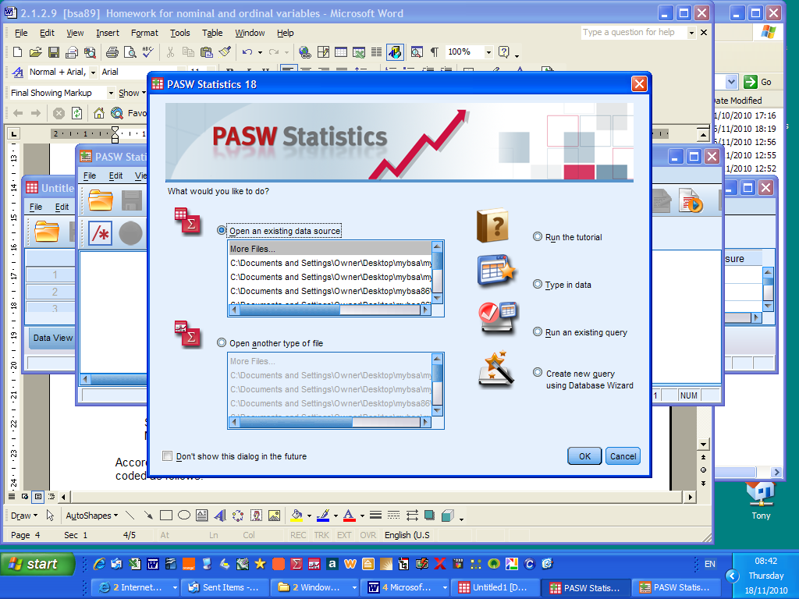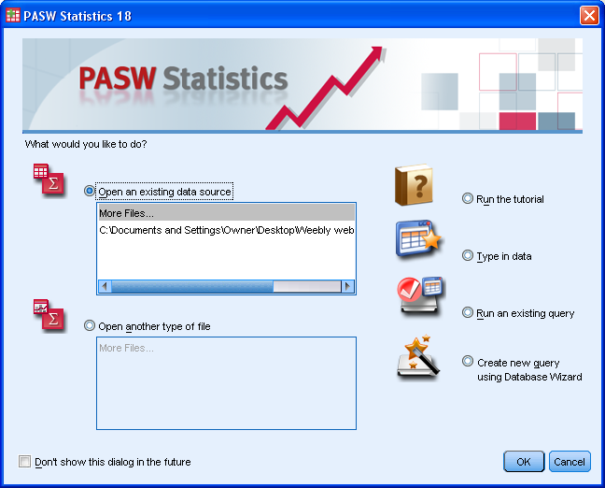
Screenshot after launching SPSS Opening screen for PASW18

Click on the Cancel button (bottom right) to display the blank Data Editor:

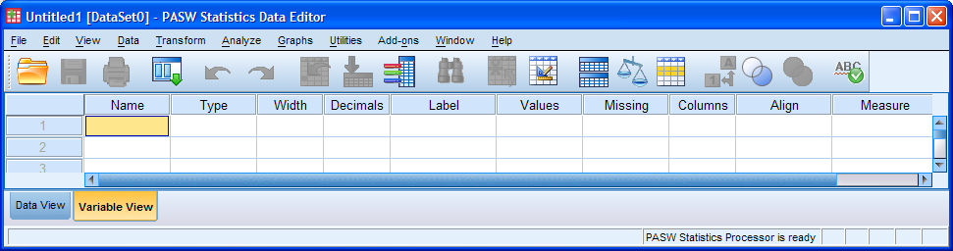

[NB: I have changed my SPSS settings at launch to open a blank syntax editor as well as a blank data editor: this saves having to use File > New > Syntax to open a new SPSS syntax editor every time I launch SPSS. From the data editor click on Edit > Options. A screen appears with the General tab open:

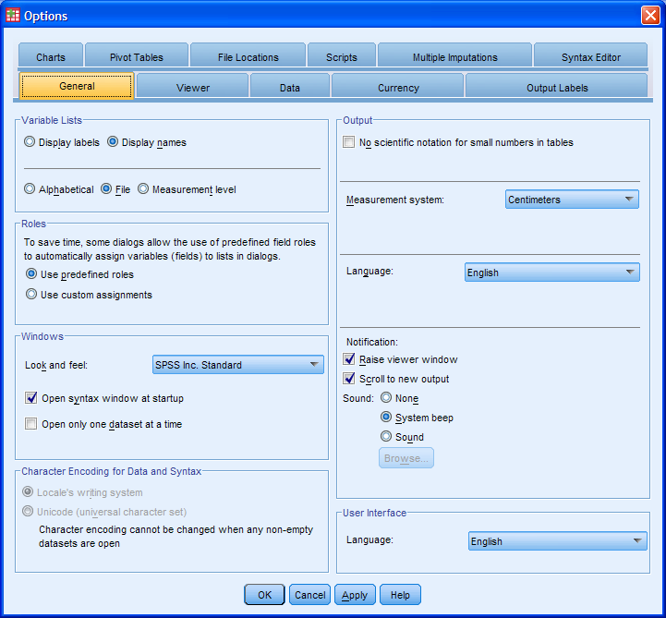

check the Open syntax window at startup box. I also like to have more than one data editor open at a time: if you want to do the same (and if your version allows it) uncheck the Open only one data set at a time box and click on the Apply button to save the new settings.]

In the data editor, make sure you are in Variable View (this one has been adjusted by shrinking it to three rows) and click on File > New > Syntax

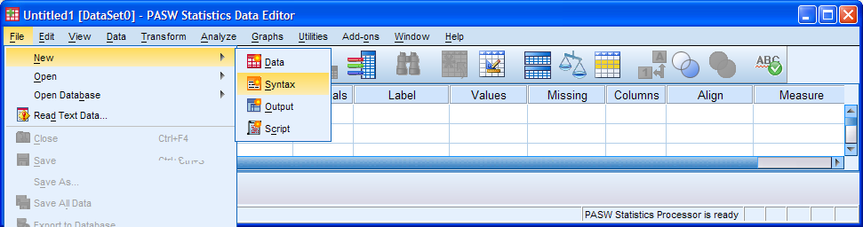

. . . to open a new SPSS syntax editor:

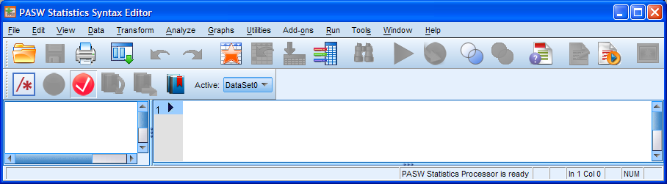

Carefully type in your SPSS commands. If you make a grammatical mistake or a command is incomplete, part or all of your command will still be in red. You can run each command as you type it in by clicking on the green ► , but if you feel confident you can type in the complete set of commands and then run the whole job by clicking on Run > All . Don't forget the primes, brackets, slashes or full stops!

Try to do this exercise yourself, but if you can't there's a specimen answer in 2.1.2.10. If you struggle to do the exercise, even after using the crib, go back and do it again, and again (and also the earlier exercises until you are confident with managing files and using basic syntax in SPSS).

If you are happy with your work, save the Data Editor containing these two variables by clicking on File > Save As ...

Navigate to your folder mybsa89 and choose your own filename (eg bsa89_1.sav). You will need to access this file in later exercises. You should also save the syntax file. Go back to your syntax file and click on File > Save As ..., navigate to your folder mybsa89 and choose your own filename (eg bsa89_1.sps). The syntax file header will change from Syntax1.sps to bsa89_1.sps . If you want, you can also save the output file, but this is not really necessary as you can always run the job again, and it may well be full of warning and error messages anyway!

My personal practice is always to have the same filename prefix for related files: thus bsa89_1.sps will be the syntax file which generates the saved file bsa89_1.sav and the output file bsa89_1.spo. I also keep all files related to the same survey in the same folder, in this case mybsa89 (eg British Social Attitudes 1989). Once you have generated the initial *.sps and *.sav files, SPSS will normally stay within the same folder from which files are opened (by double-clicking) when generating subsequent files.

Practice makes perfect and you need to be able to open, write, execute and save files almost as second nature, otherwise you will always have problems with the mechanics and never get to grips with the logic and theory underpinning the analyses you will be doing later.

Homework exercise 2:

Use FREQUENCIES to obtain:

1: Marital status frequency count

2: Satisfaction with NHS frequency count and barchart

End of session

Next sessions: 2.1.2.10 Specimen answer for homework exercise 1
2.1.2.11 Homework exercise 1 - Checking your file contents
2.1.2.12 Specimen answer for homework exercise 2

[Back to Block 2 menu]

See http://www.data-archive.ac.uk/findingData/snDescription.asp?sn=2723 for details and for access requirements.
Lindsay Brook, Bridget Taylor and Gillian Prior, British Social Attitudes 1989 Survey: Technical report (Social and Community Plannning Research, November 1990)

